花蓮縣花蓮市明義國民小學105學年度第二學期四年級英語科期中定期評量試卷
Class：四年____班 Name（中文姓名）：_________ Number（座號）：_____ 家長簽名___________
A. Listen and Check (16%)（勾選聽到的單字圖片）
1. | 2. | 3. | 4.
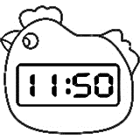  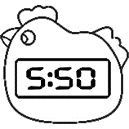  □ □ | 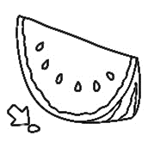  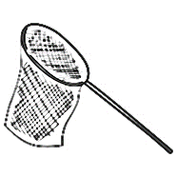  □ □ | 23 29  □ □ | 13 17  □ □
5. | 6. | 7. | 8.
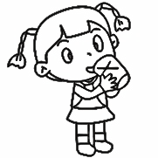  □ □ | 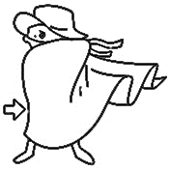  □ □ | 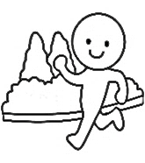  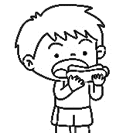  □ □ | 25 35  □ □
B. Listen, Nmber and Check (15%)（聽老師念，填入正確的順序及勾選正確的發音）
( ) | ( ) | ( ) | ( ) | ( )
 | 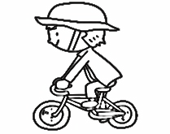 |  | 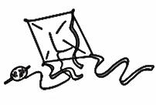 | 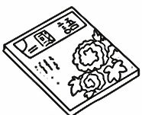
- a_e  - e_e  - i_e | - a_e  - e_e  - i_e | - a_e  - e_e  - i_e | - a_e  - e_e  - i_e | - a_e  - e_e  - i_e
C. Listen and Cross Out (8%)（仔細聽，發音與其他兩個不同者，在圖片上打叉）
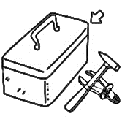  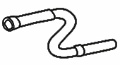  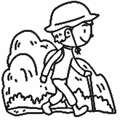  1. | 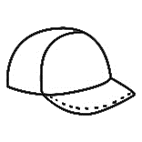  2.
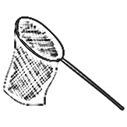  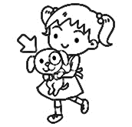  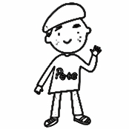  3. | 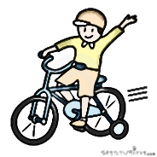  4.
D. Listen and Mark (10%)（仔細聽，聽到的內容與圖片相符打，不符的打）
1. | 2. | 3. | 4. | 5.
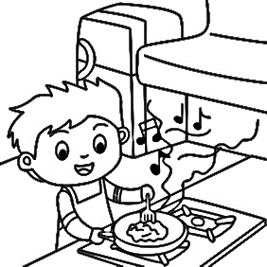  ( ) | 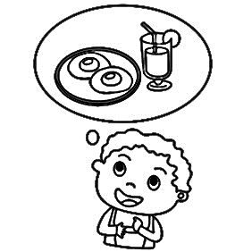  ( ) | 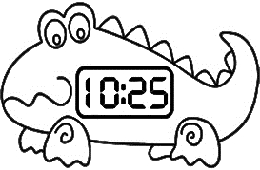  ( ) | 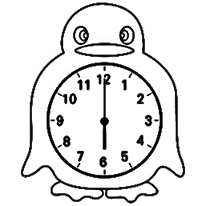  ( ) | 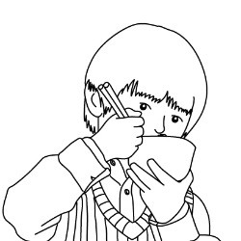  ( )
E. Write (21%)（看圖完成句子）
1. | 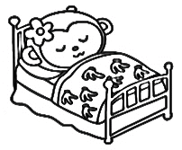 | What’s _____ doing?  She’s ___________. | 4. | 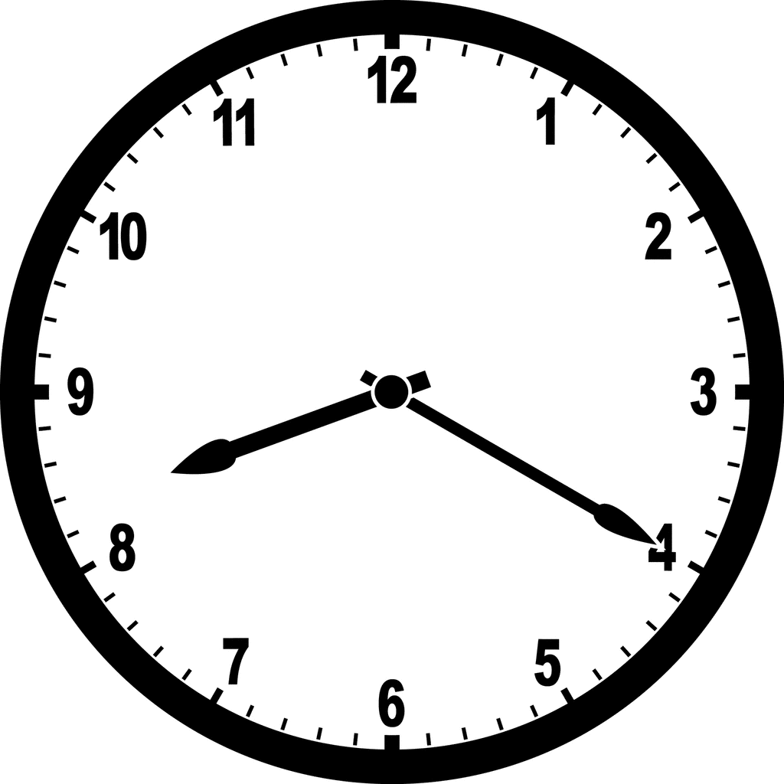 | What time is it?  It’s ______ ________.
2. | 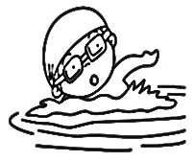 | What’s _____ doing?  He’s ____________. | 5. | 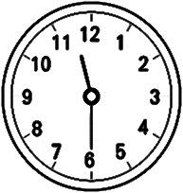 | What time is it?  It’s ______ ________.
3. | 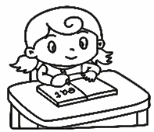 | What are ____ doing?  I’m _____________. | 6. | 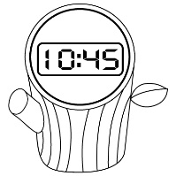 | What time is it?  It’s _____ _________.
F. Read and Write (20%)（仔細看圖，並填入正確答案）
is | drinking | twelve | am | eating
he | are | running | o’clock | time

(1) | 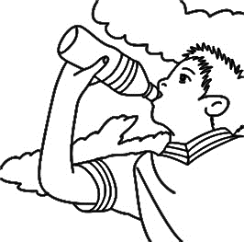  A: What _______________ you doing?  B: I _______________ _______________. | 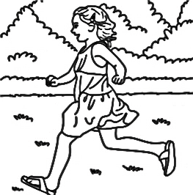
(2) | A: What _______________ she doing?  B: She’s _______________.
(3) | A: What’s _______________ doing?  B: He’s _______________. | 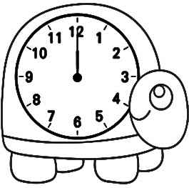
(4) | A: What _______________ is it?  B: It’s _______________ _______________.
G. Choose the sentences (10%)（填入相符的句子代號）
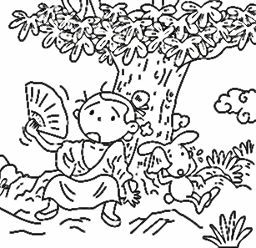 | 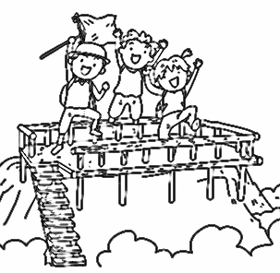 |  | 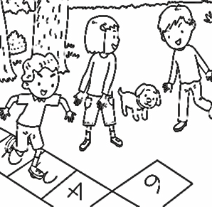  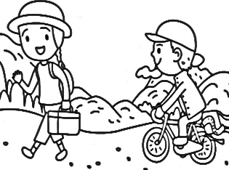
( ) | ( ) | ( ) | ( ) | ( )

(A) Let’s hike and ride! | (B) Come and join us. | (C) Eve has a pet, too.
(D) Take a rest. | (E) Hooray!

