花蓮縣花蓮市明義國民小學105學年度第一學期四年級英語科期中定期評量試卷
Class：四年____班 Name（中文姓名）：_________ Number（座號）：_____ 家長簽名___________
A. Listen and check (16%)（勾選聽到的單字圖片）
1. | 2. | 3. | 4.
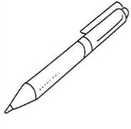  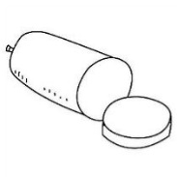  □ □ | 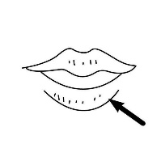  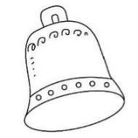  □ □ | 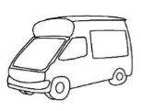  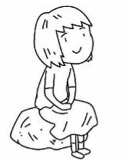  □ □ | 15 19  □ □
5. | 6. | 7. | 8.
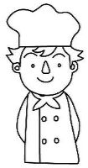  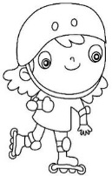  □ □ | 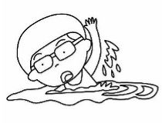  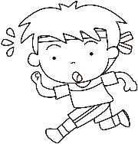  □ □ | 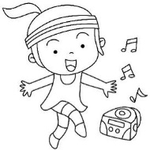  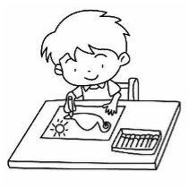  □ □ | 20 11  □ □
B. Listen, write and number (15%)（聽老師念，填入正確的順序及開頭字母）
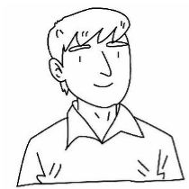 |  | 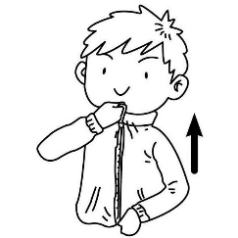 |  | 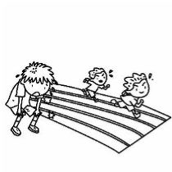
( ) | ( ) | ( ) | ( ) | ( )
__an | __en | __ip | __ell | __uit
C. Listen and number (10%)（聽老師念，填入正確的順序）
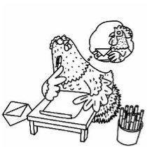 | 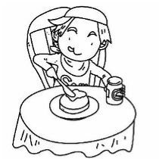 | 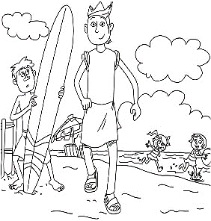 | 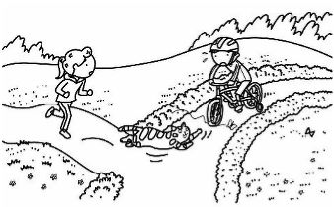 | 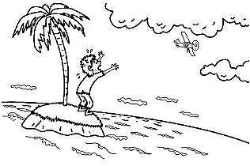
( ) | ( ) | ( ) | ( ) | ( )
D. Listen and number (10%)（聽老師念，填入正確的順序）
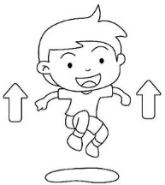 | 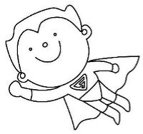 | 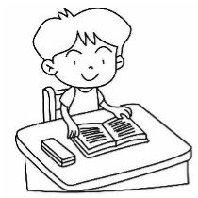 | 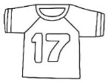
( ) | ( ) | ( ) | ( ) | ( )
E. Write (24%)（看圖完成句子）
1. |  | 2.
 | Can she _____?  ___, _________. | 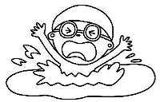 | Can you _____?  ___, _________.
3. |  | 4.
 | What can he do?  ___ ___ ______. | 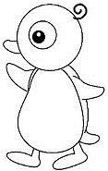 | What can it do? (走)  ___ ___ ______.
F. Match (15%)（選出最適當的回應句子，在空格填上代號）
1. | Nice to meet you. | ． ． | She can dance.
2. | What can she do ? | ． ． | Nice to meet you, too!
3. | Is your brother a cook? | ． ． | Yes, he is.
4. | What can you do? | ． ． | No, I can’t.
5. | Can you roller-skate? | ． ． | I can cook.
F. Choose the sentences (10%)（圖文配對）
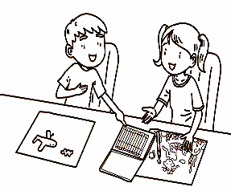 | 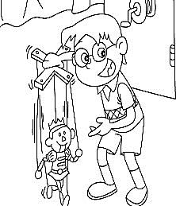 | 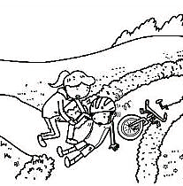 | 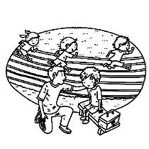 | 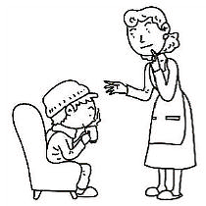
( ) | ( ) | ( ) | ( ) | ( )

(A) Look at my puppet! | (B) May I? Of course!
(C) You can sit by the kit. | (D) Zip your lip and sip your tea.
(E) Are you ok?

