花蓮縣花蓮市明義國民小學107學年度第一學期四年級英語科期中定期評量試卷

Class：四年____班 Name（中文姓名）：_________ Number（座號）：_____ 家長簽名___________

A. Listen and Check (16%)（**勾選**聽到的單字圖片）

|  |  |  |  |
| --- | --- | --- | --- |
| 1. | ãgoat outlineãçåçæå°çµæ2. | 3. | 4. |
| **12-336-1**  □ □ | 17-5  □ □ | 11:50 11:15  □ □ | ç¸éåçç¸éåç  □ □ |
| 5. | 6. | 7. | 8. |
| ç¸éåç**36-411-8**  □ □ | **31-6**  □ □ | 2:17 3:47  □ □ | ãrailway clock outlineãçåçæå°çµæç¸éåç  □ □ |

B. Listen, Number and Write (15%)（仔細聽，填入順序及開頭字母）

|  |  |  |  |  |
| --- | --- | --- | --- | --- |
| **39-1**( ) ___ap | ç¸éåç( ) ___en | **39-4**( ) ___oat | **31-5**( ) ___ot | 17-2( ) ___at |

C. Listen and Circle (4%)（圈出**韻尾不同**的單字）

|  |  |  |  |  |  |  |  |
| --- | --- | --- | --- | --- | --- | --- | --- |
| 1. | 31-1 | ãpen outlineãçåçæå°çµæ | ãpig outlineãçåçæå°çµæ | 2. | 39-5 | **31-3** | **31-4** |

D. Listen, Check and Match (15%)（勾選**正確的回應**及連取圖片）

|  |  |  |  |  |
| --- | --- | --- | --- | --- |
| 1. | 2. | 3. | 4. | 5. |
| □It’s OK.  □No problem. | □Yes, I can.  □Yes, I can’t. | □Try again.  □That’s OK. | □Thank you!  □Hurry up! | □It’s six ten.  □Its’ red. |
| ● | ● | ● | ● | ● |
| ● | ç¸éåç● | **29-1**● | ● | ● |
| **29-2** |  |  | ç¸éåç | ç¸éåç |

E. Match (8%)（填入相符的**句子代號**）

|  |  |  |  |
| --- | --- | --- | --- |
| ① Louder, please. | ② A fox is in the den. | ③ Try again. | ④ Ben has a pig. |

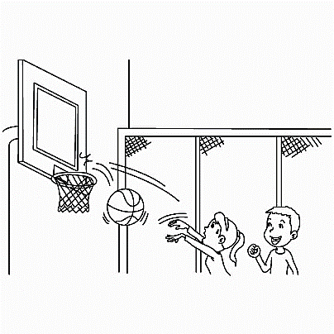**32**

|  |  |  |  |
| --- | --- | --- | --- |
|  | **6-2** | 18 |  |
| ( ) | ( ) | ( ) | ( ) |

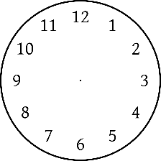F. Write (8%)（句子重組）

|  |  |
| --- | --- |
| 1. | ten / It / sixteen / is / . |
|  | |  | | --- | |  | |  | |  |   並用尺畫出時間→ |
| 2. | can / draw / He / sing / and / . |
|  | |  | | --- | |  | |  | |  | |

G. Write (20%)（完成句子）

|  |  |  |  |  |  |
| --- | --- | --- | --- | --- | --- |
| 1 | ç¸éåç | Can he _______________.  _______, _______ can. | **11-3**3 |  | Can ______ _______ (跳舞).  No, she ________. |
| 2 | 9:35 | It’s ______ ___________. | 4 | 6:20 | It’s _______ __________. |

G. Write (14%)（仔細看句子，選出正確的單字填入）

|  |  |  |  |
| --- | --- | --- | --- |
| late | Thank | can’t | it |
| o’ clock | I | time | swim |

(On the way home. 回家路上)

|  |  |  |  |
| --- | --- | --- | --- |
| Tina:  Jack:  Tina:  Jack: | Can you __________?  No, __________ __________.  ç¸éåçI can teach(教) you at the school pool(游泳池) !  __________ you! | Tina:  Jack:  Tina: | What __________ is it?  It’s eight __________.  ç¸éåçOh no! I am __________ for dinner. |