花蓮縣花蓮市明義國民小學105學年度第一學期四年級英語科期末定期評量試卷
Class：四年____班 Name（中文姓名）：_________ Number（座號）：_____ 家長簽名___________
A. Listen and check (16%)（勾選聽到的單字圖片）
1. | 2. | 3. | 4.
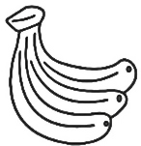  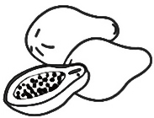  □ □ | 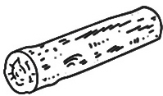  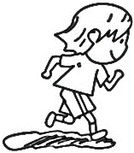  □ □ | 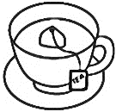  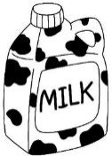  □ □ | 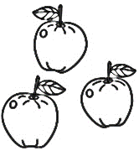  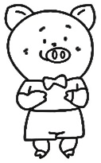  □ □
5. | 6. | 7. | 8.
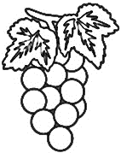  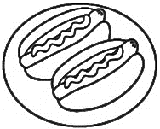  □ □ | 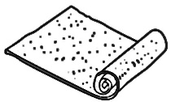  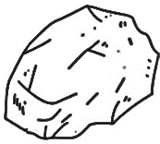  □ □ | 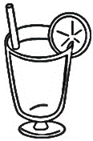  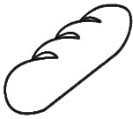  □ □ | 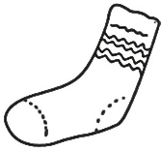    □ □
B. Listen, number and circle (15%)（聽老師念，填入正確的順序及圈選正確的單字）
( ) |  | ( ) |  | ( ) |  | ( ) |  | ( )
jump | jog | bug | bun | rug | rock | sock | sun | fog | fun
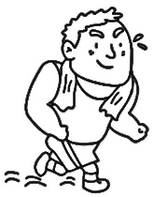 |  | 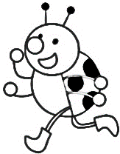 |  | 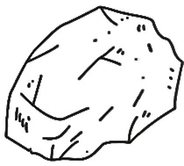 |  | 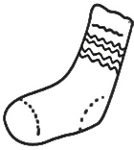 |  | 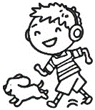
C. Listen and number (10%)（聽老師念，填入正確的順序）
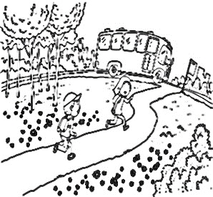 | 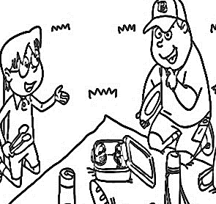 | 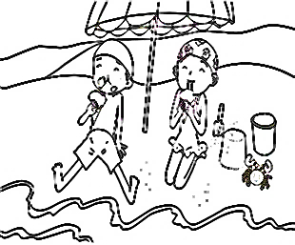 | 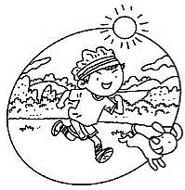 | 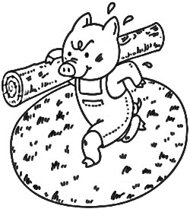
( ) | ( ) | ( ) | ( ) | ( )
D. Listen and mark (10%)（仔細聽，聽到的內容與圖片相符打，不符的打）
1. | 2. | 3. | 4. | 5.
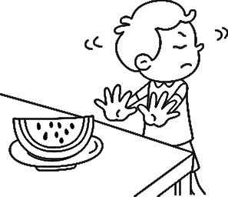  ( ) | 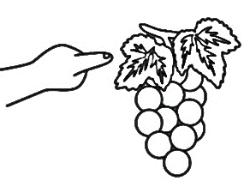  ( ) | 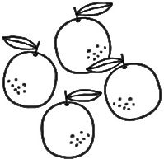  ( ) | 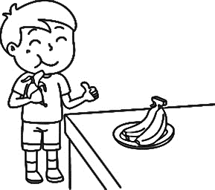  ( ) | 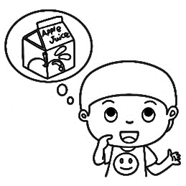  ( )
E. Write (19%)（看圖完成句子，請注意距離、單複數，以及可數不可數名詞的差異）
1. |  | 2.
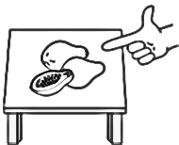 | What are ______?  They’re ________. | 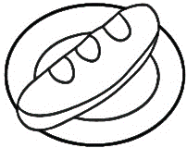 | What do you want?  I want ____ _____.
3. |  | 4.
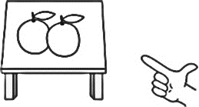 | What are ______?  They’re ________. | 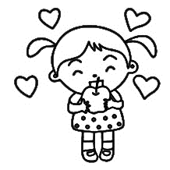 | Do you like ______?  ____, ____ _____.
F. Look and circle (16%)（看圖圈選出正確的數量及物品）
1. |  |  | 2.
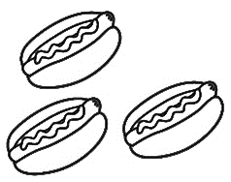 |  a   three   two |  hot dogs   grapes   bananas | 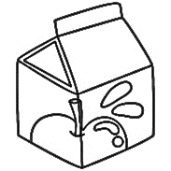 |  some   one   an |  tea   juice   apple
3. |  |  | 4.
 |  an   a   some |  milk   grape   cupcake | 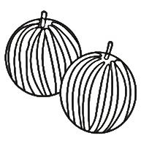 |  an   three   two |  cupcakes   watermelons   eggs
G. Write a or an (4%)（填入a 或 an）
1. | 2. | 3. | 4.
_____ ox | _____ marker | _____ contest | _____ egg
H. Choose the sentences (10%)（填入相符的句子代號）
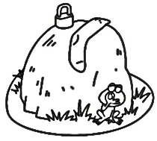 | 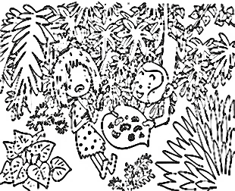 | 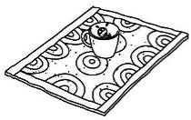 | 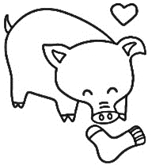 | 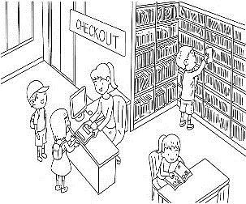
( ) | ( ) | ( ) | ( ) | ( )

(A) The lock and the sock are on a rock. | (B) The mug is on the rug.
(C) Yuck! | (D) The hog likes the sock.
(E) Here you are.

