花蓮縣花蓮市明義國民小學105學年度第一學期五年級英語科期末定期評量試卷
班級(Class) 姓名(Name) 座號(Number) 家長簽名__________
- Listen and Circle.(仔細聽, 把正確的圖片圈起來) 18%
1. | 2. | 3.
4. | 5. | 6.
B. Listen and Circle.(仔細聽,圈出正確的發音 ) 12%
1. hard g soft g | 2. hard c soft c | 3. hard g soft g
4. hard c soft c | 5. hard c soft c | 6. hard g soft g
C. Listen, read and circle.(仔細聽，仔細讀，圈出正確的答案) 8%
Today is (Sunny/ Sunday). It’s sunny and hot. My dad, my mom and I go on a picnic at the park. The birds are (singing/ sitting). Some students are (painting / playing). Look! The dog is (snoozing/ sleeping) under the tree.
D. Listen and Write. (仔細聽並寫出正確的單字) 18%

1. |  |  | 2. | 
3. |  |  | 4. | 
5. |  |  | 6.

E. Read and Write. (看圖完成句子) 24%
- A: What’s she ___________?
B: She’s ___________.
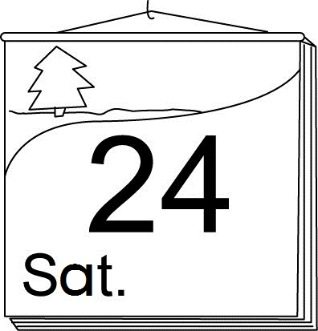 | - A: What ________ is _____________?  B: It’s _____________.
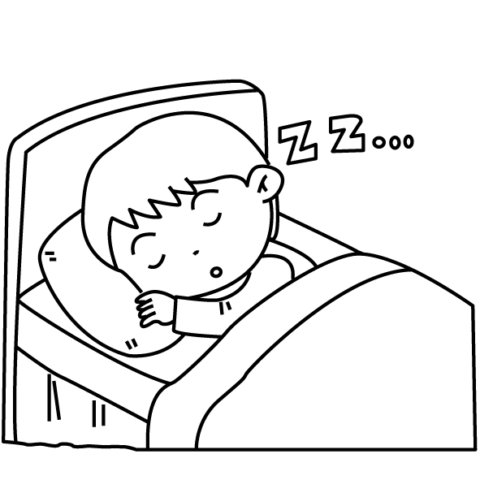 | - A: What are ________ doing?  B: I’m _____________.
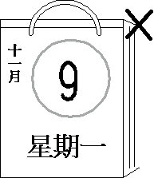  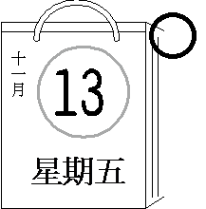 | - A: Is today ______________?  B: No, it isn’t. It’s _______________.
- A: What ________ they doing?

B: ________ are ____________.

F. Unscramble the Sentences. (重組句子) 20%
1. job / ! / everyone /, / Good
___________________________________
2. meet / , / Nice / you / . / to / too
___________________________________
3. my / . / Time / for / class / English
____________________________________
4. a / is / He / . / sleeping / log / like
____________________________________

