花蓮縣花蓮市明義國民小學106學年度第一學期五年級英語科期中定期評量試卷
Class（班級）：____ 年 班 Name（中文和英文姓名）：__________________Seat Number（座號）：_____
分  數 | 100  分 | 90  分 | 80  分 | 70  分 | 60分 | 60  以下 | 家 長  簽 名
人
數
A .Listen and Check. 仔細聽，並在圖片下的方格內打ˇ。（24%）
1. | 2. | 3 | 4.
  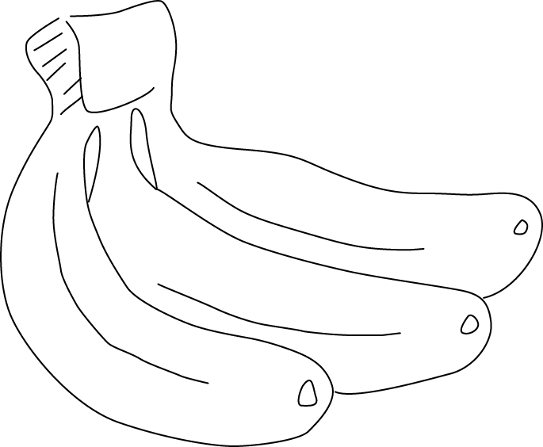  □ | 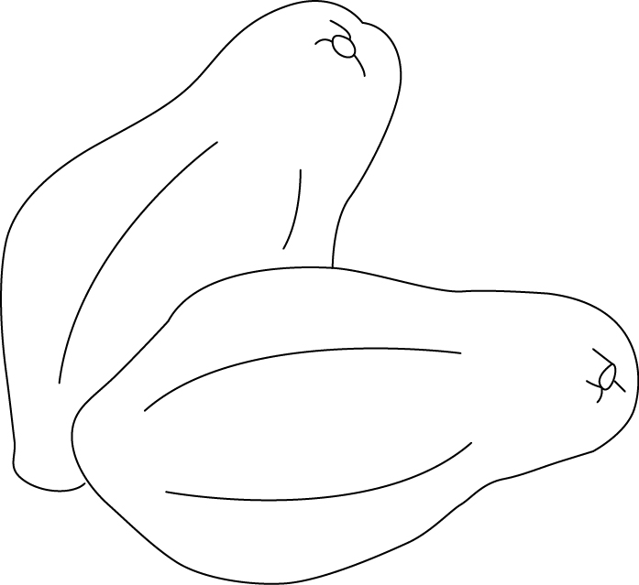  □
  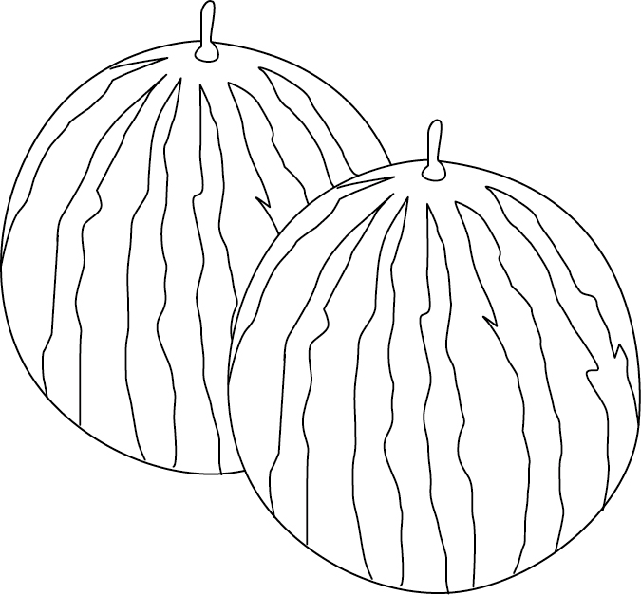  □ | 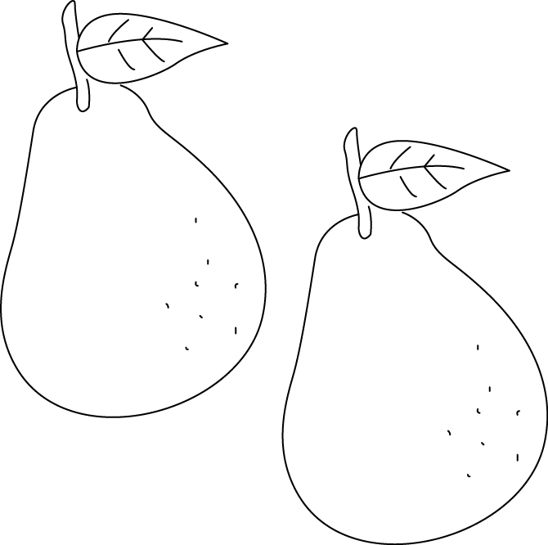  □
  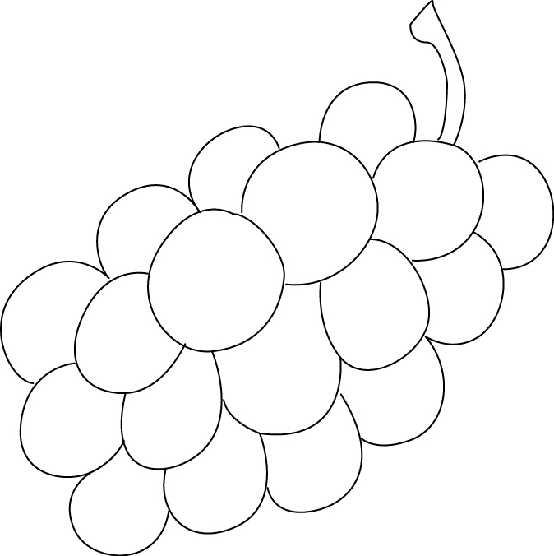  □ | 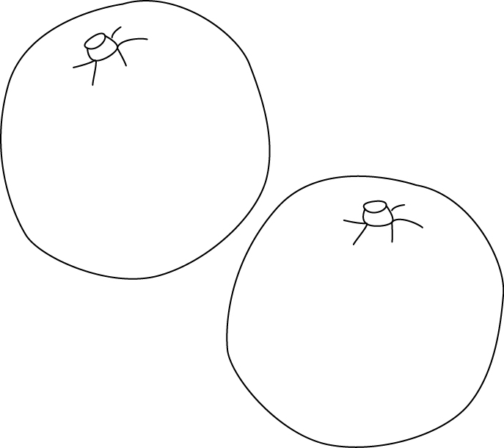  □
    □ |   □
5. | 6. | 7. | 8.
  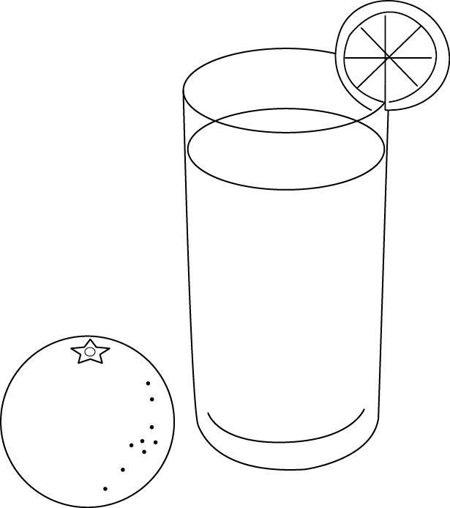□ | 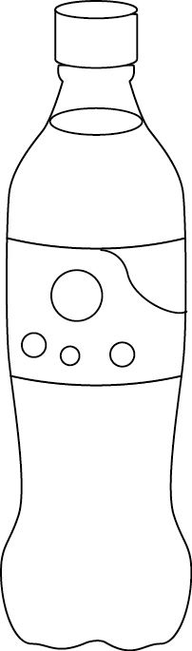  □
  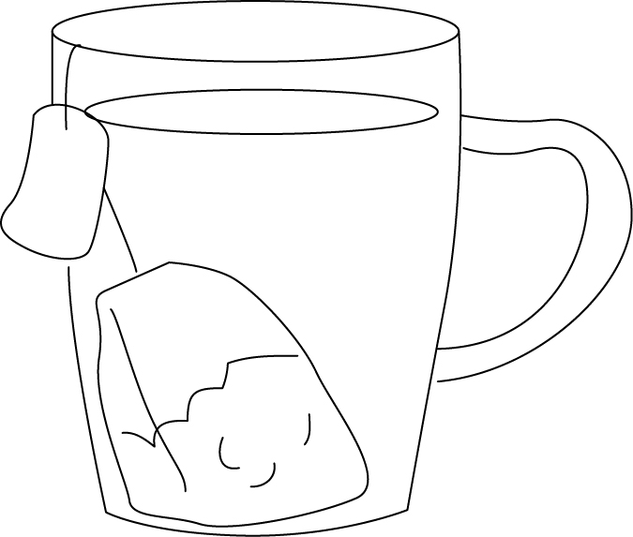  □ | 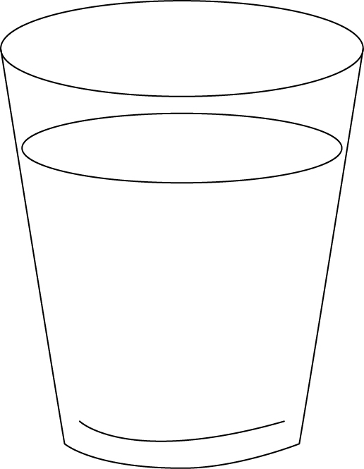  □
  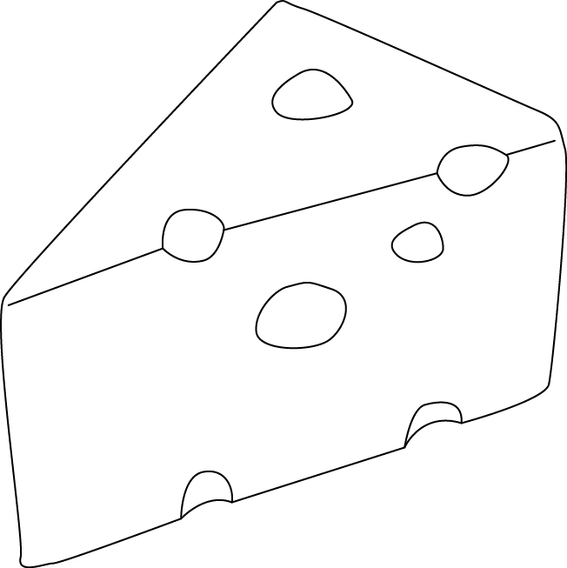  □ |   □
    □ |   □
9. | 10. | 11. | 12.
  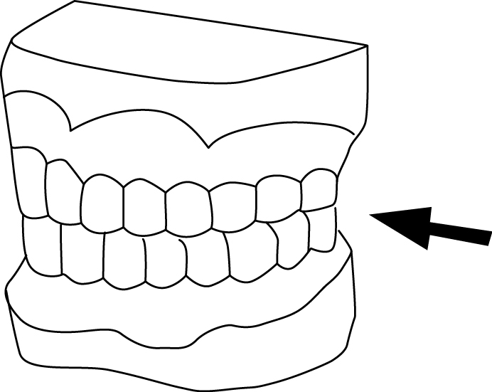  □ | 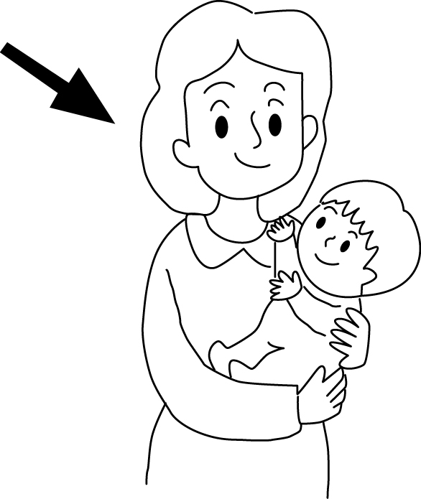  □
  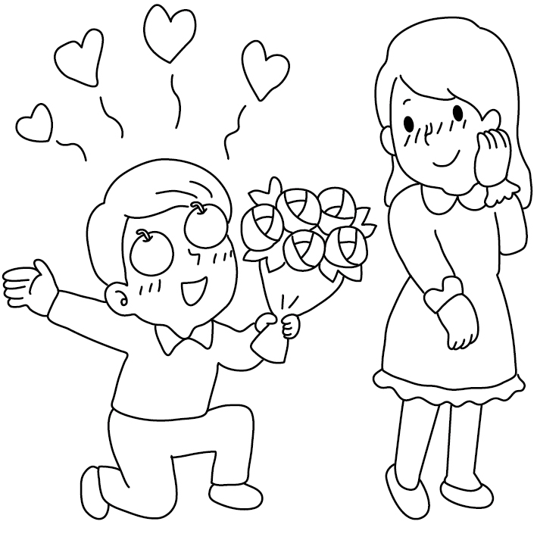  □ | 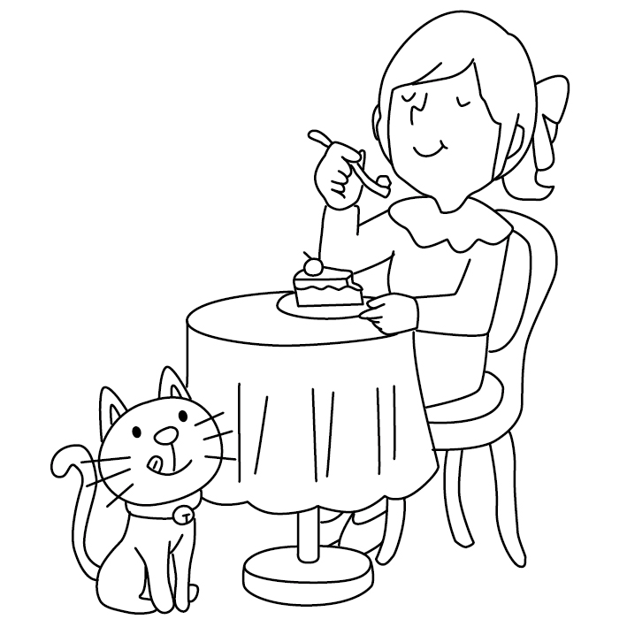  □
  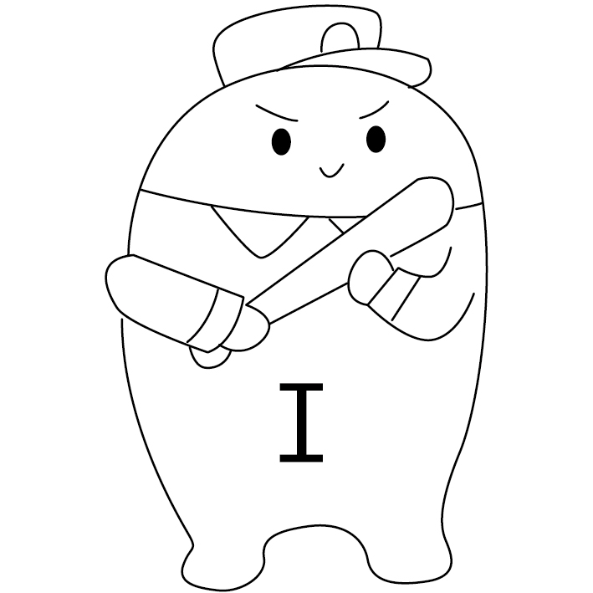□ | □
  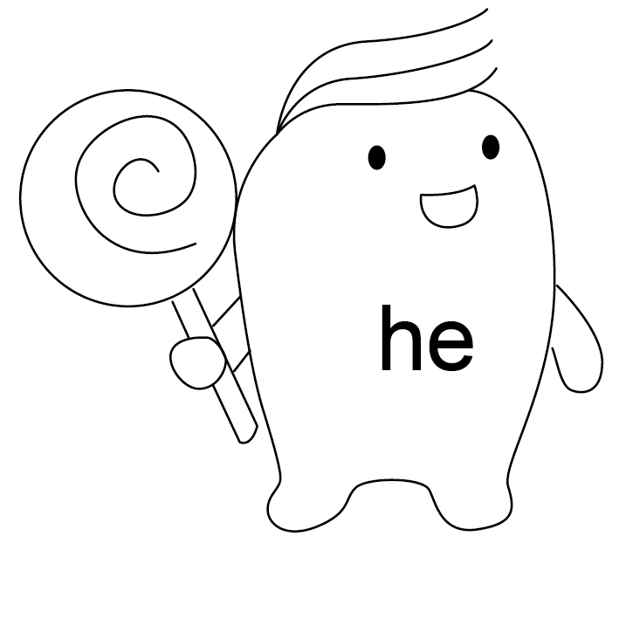  □ |   □
B. Listen and Spell. 仔細聽，並拼寫出英文單字。（8%）
1.  （ _____________ ） | 2.  （ ） | 3.  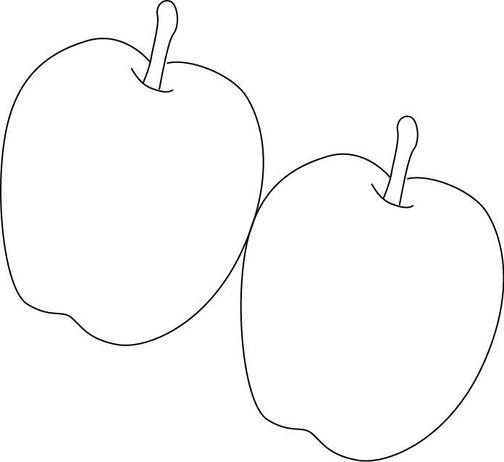（ ______________ ） | 4.  （ ）
5. 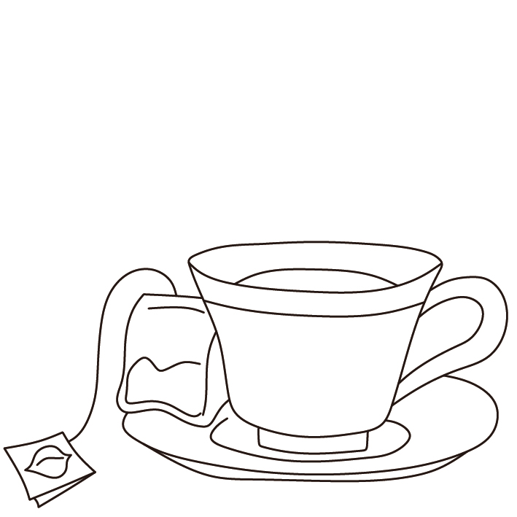  （ ____________ ） | 6. 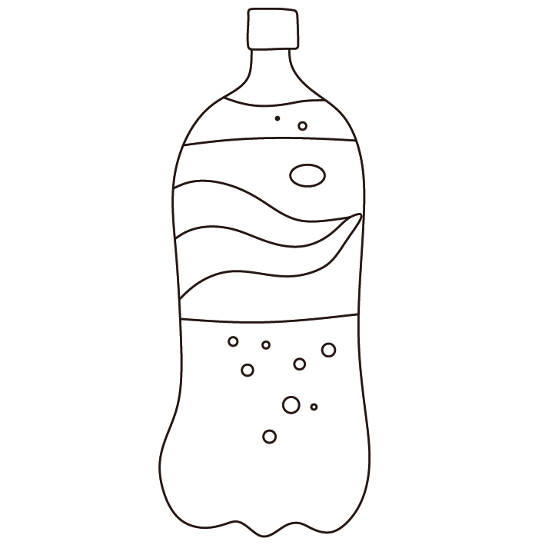  （ _____________ ） | 7. 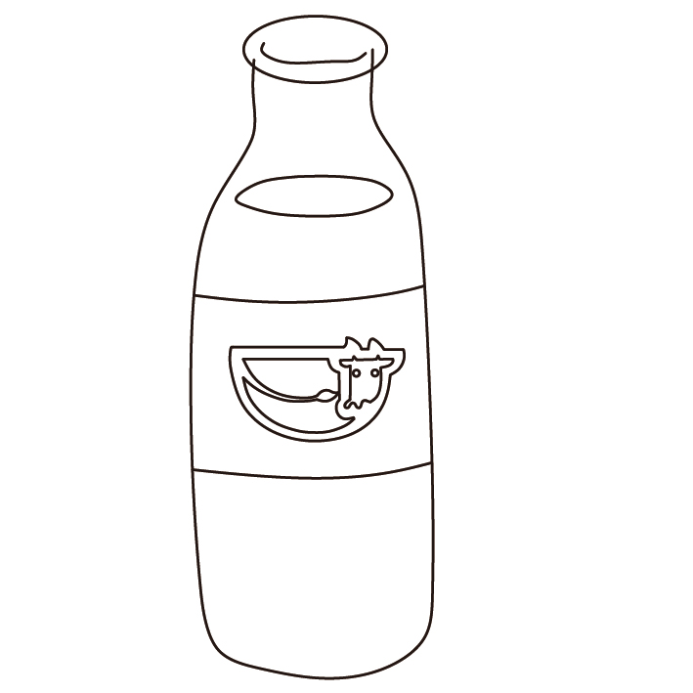  （ ） | 8.  （ ______________ ）
C. Listen and Circle. 仔細聽發音，並圈出正確的字母。（8%）
1.  ch sh | 2.  ch sh | 3.  wh ph | 4.  wh ph
5.  th sh | 6.  th ch | 7.  th wh | 8.  th ph

※※※※ 請翻到背面繼續做答（Please turn to the next page. ） P.1 ※※※※※
D. Listen and Check. 英語護照聽寫專區，勾出正確的句子。（8%）
1 □ Maybe next time.  □ Where is the library ? | 2. □ Which way should I go ？  □ What time is it ？
3. □ It’s next to the bank.  □ Go straight and then turn right. | 4. □ Where are you going ？  □ What time is it ？

E. Listen and Number. 仔細聽，並寫出正確的號碼。（8%）
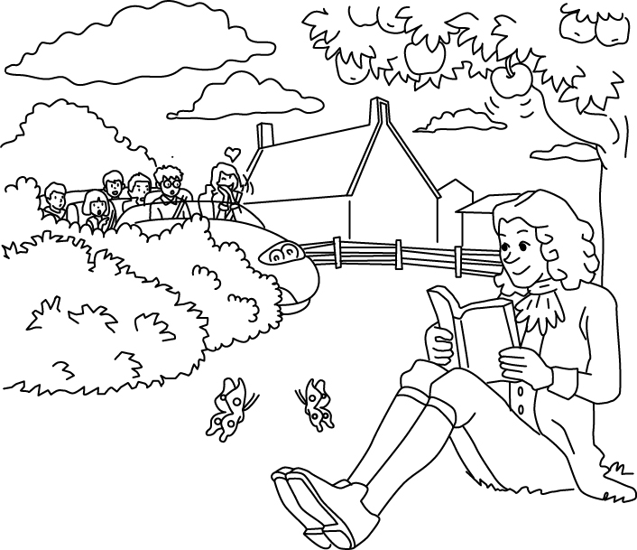 | 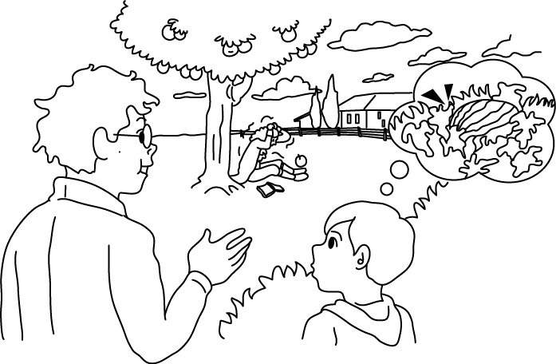 | 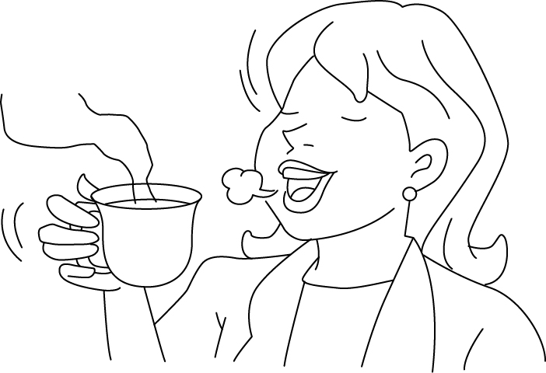 | 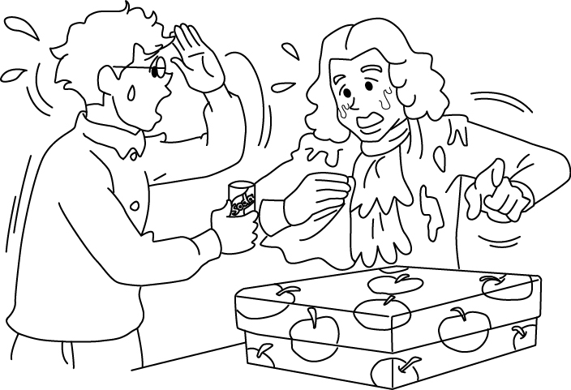
【 】 | 【 】 | 【 】 | 【 】

F. Look and Check看圖，勾選正確的句子 (8%)
1. 2.
( ) She likes grapes. ( ) My brother likes papayas.
( ) She doesn’t like grapes. ( ) My brother doesn’t like papayas.

3. 4.
( ) I want some coffee. ( ) I like summer.
( ) I want some juice. ( ) I like fall.

G. Find the Right Answer. 請仔細閱讀，並選出適當的代號。(16 %)
( ) 1. He ______ spring. (A) like (B) likes (C) is

( ) 2. A: I want some orange juice. B: Me, ______.
(A) please (B) to (C) too

( ) 3. A: Does Joyce ________ pears? B: No, she ______.
(A) like, doesn’t (B) likes, doesn’t (C) like, does

( ) 4. A: _______ do you want to drink? B: Coffee, please.
(A) Who (B) What (C) Where
※※※※ 請翻到下一頁繼續做答（Please turn to the next page. ） P.2 ※※※※※

( ) 5. What ______ Amy want to drink ? (A) do (B) is (C) does

( ) 6. I want _________ hot chocolate. (A) to drink (B) drink (C) drinks

( ) 7. Mike doesn’t_______ grapes. (A) likes (B) like (C) to like

( ) 8. My dad ______ some coffee. (A) want to (B) want (C) wants

H. Unscramble the Sentences. 重組句子。（10%）

drink / does / want to / Dad / What / ? （5％）

grapes / Amy / like / Does / ? （5％）

I. Read and Choose.閱讀完右邊的對話,選出正確的答案。（10%）

( ) 1. Does Vivian like guavas ?
Vivian: Can I eat the guava on the desk ?
Nat: Sure, do you like guavas ?
Vivian: No, I don’t. I am just hungry.
Nat: What fruit do you like?
Vivian: I like mangos and peaches. How about you?
Nat: I like pineapples and tangerines.
Are you thirsty? I have some
yogurt drink and cola.
Vivian: Oh, great! I want some yogurt drink,
please.

* fruit 水果、have 有
(A) Yes, she does.
(B) No, she doesn’t.
(C) We don’t know.

( A ) 2. What fruit does Vivian like?
(A) Mangos and peaches.
(B) Mangos and pineapples.
(C) Pineapples and tangerines.

( A ) 3. Nat likes .
(A) pineapples and tangerines
(B) pineapples and mangos
(C) mangos and peaches

( A ) 4. What does Vivian want to drink?
(A) Soybean milk.
(B) Cola.
(C) Yogurt drink.

( A ) 5. How many kinds of fruit do Vivian and Nat mention(提到) above ?
(A) Four. (B) Five. (C) Six.

※※※※※※ Don’t forget to check your answer again！ 作答完要再檢查喔 ! P.3 ※※※※※※

