花蓮縣花蓮市明義國民小學107學年度第二學期六年級英語科期中評量試卷
Class（班級）：_______ Name（姓名）：__________________ Seat Number（座號）：_____ 家長簽名：_______________
- Listen and Check. 仔細聽，並在正確圖片下的方格內打V。（每題2分。16%）
1.  □ □ | 2.  □ □ | 3. | 4.
  □ | □
  □ | □
5.  □ □ | 6. | 7. $590 $490  □ □ | 8.
  □ | □
  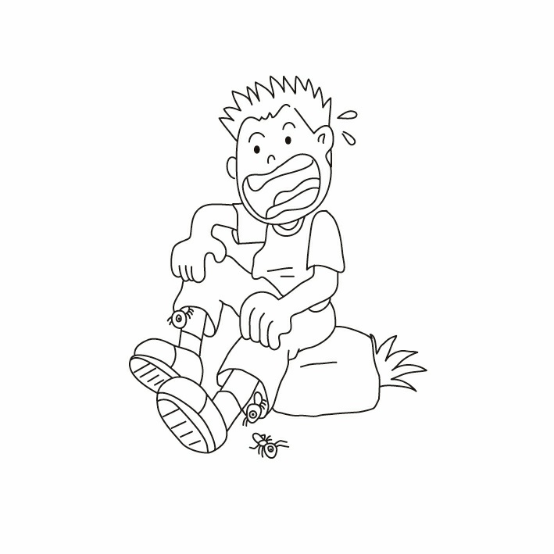  □ | 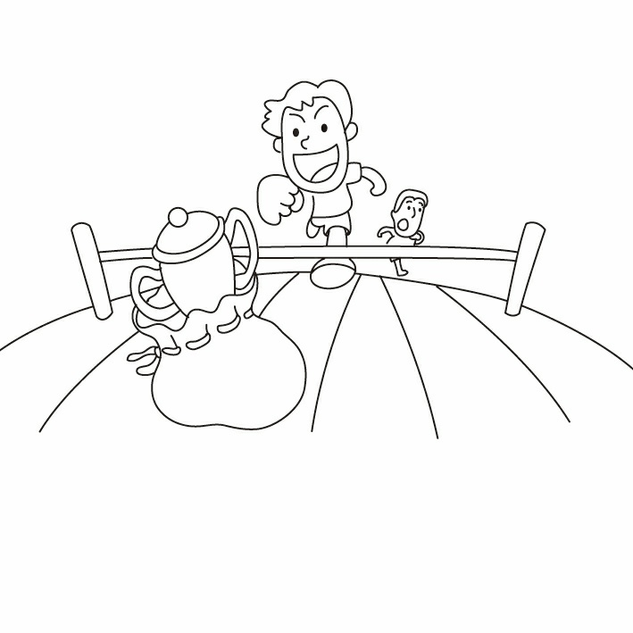  □
- Listen and Write. 仔細聽，並填上英文單字。（22% 每格2分，錯一字母扣1分，扣完為止。）

(1)~(4)

(5) (6) (7) (8)

(1) The _________ is one and dollars. | (5) My sister likes to .
(2) Those _____________ are on sale this weekend. | (6) I in my free time.
(3) I like the _________. It’s very cheap. | (6) They in free time.
(4) How much are those __________? | (8) Peter ____________________ in summer.
- Listen and Write. 仔細聽，並以阿拉伯數字寫出正確的價錢。（每題1分。4%）
- $ | - $ | - $ | - $
- Listen and Circle. 仔細聽發音，並圈出正確的字母。（每題2分。16%）
※Bonus (加分題) 2%
1.  ow oi | 2.  o ou | 3.  ou ue | 4.  oa oy
5.  ou oy | 6.  oy ow | 7.  ow oa | 8.  ai oi
1. 她很著急。 2.我們一起去浮潛。
E. Read and Choose. 仔細讀，選出正確的答案。(每題2分。12%)

1. ( ) A: How much is shirt ?  B: ________ five hundred dollars.  (A) that , It’s (B) this , They’re  $500 (C) those ,They’re | 2. ( ) kevin _______ to buy _______ markers.  (A) want, these  (B) wants, this  (C) wants, these
- ( ) A: _________ notebook is it?  B: It’s _______ notebook.  (A) Who , her  (B) Whose , his  (C) Whose, she | - ( ) A: What does Tina _____ after school?  （請翻面繼續作答）  B: She _______ basketball with her friends.  (A) does, plays  (B) do, plays  (C) go, play
- ( ) A: What does Jordan do every morning?  B: He _______ biking.  (A) go (B)does (C) goes | - ( ) Does Harry ____ camping in his free time?  (A)go (B) goes (C) going

- Read and Answer. 仔細讀並回答問題。(每題3分。14% )

Peggy, what do you do in your free time?

I go shopping.
Me, too. Let’s go shopping this Saturday!
Great!
At the store
How much are those socks? They are cool.
They’re four hundred dollars. Ken, that sweater is nice. How much is it?
It’s one thousand dollars.
Uh-oh. I only have five hundred dollars.
- What does Peggy do in her free time ? →She .(4%)
- What does Ken do in his free time ? → (3%)
- How much are the socks ? → hundred dollars.(4%)
- How much is the sweater ? → (3%)
- Unscramble the Sentences. 重組句子。（每題4分。16%）
in / The / ! / bag/ game / the / is go / in / Ken / time / free /? / camping /Does/ his

much / is / ? / shirt / How / that basketball / to / the / Welcome / . / camp

