花蓮縣花蓮市明義國民小學107學年度第二學期三年級英語科期末定期評量試卷
Class：三年 班 Name（中文姓名）__________Number（座號）_____ 家長簽名__________
- Listen and Check (16%)（勾選出老師所念的圖片）
1 | 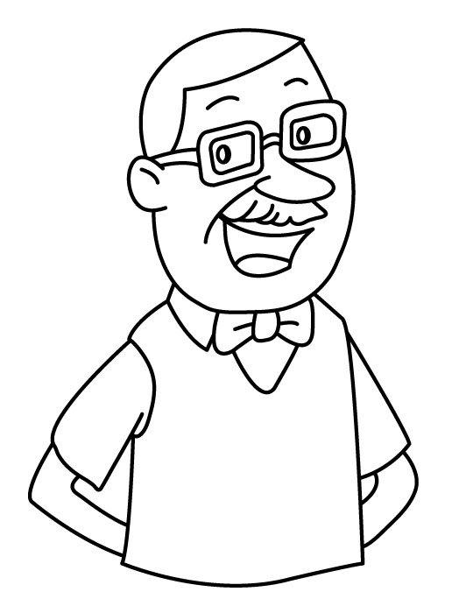  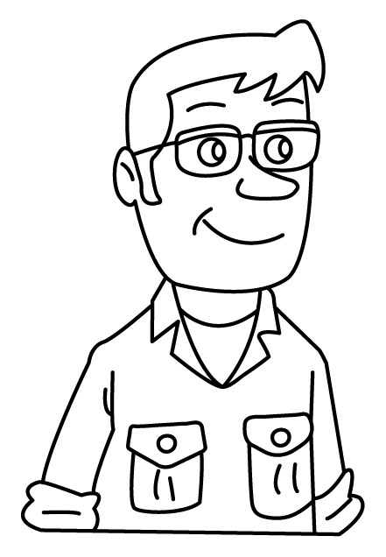  □ □ | 2 | 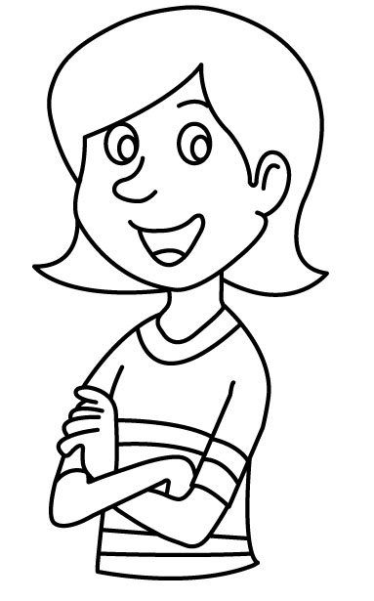  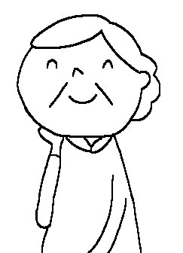  □ □ | 3 | 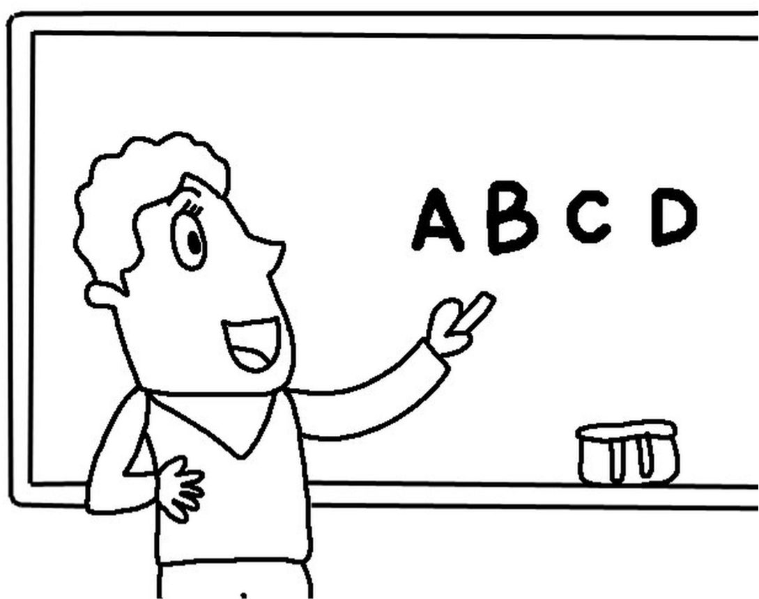  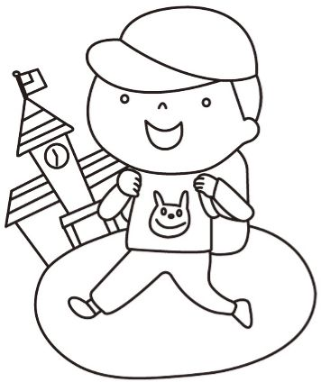  □ □ | 4 | 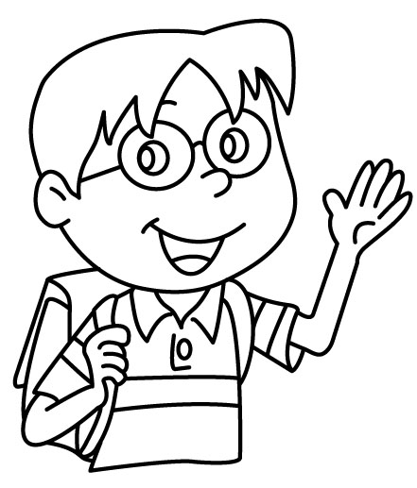  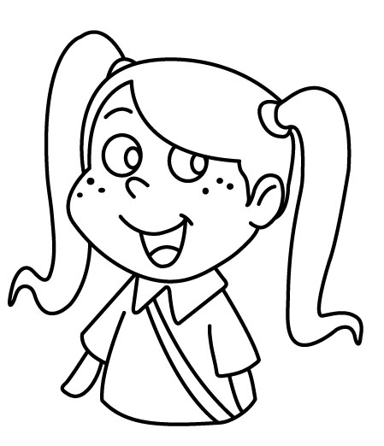  □ □
5 | 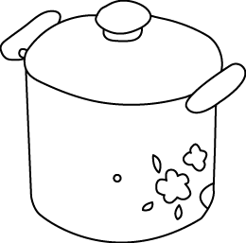  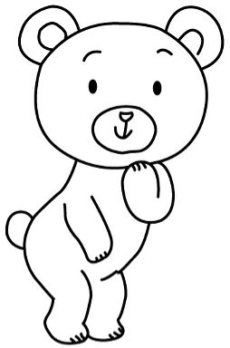  □ □ | 6 | 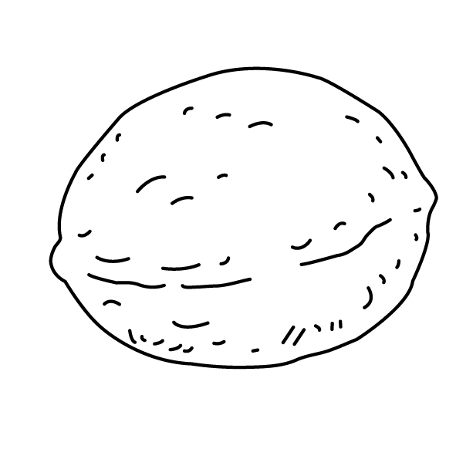  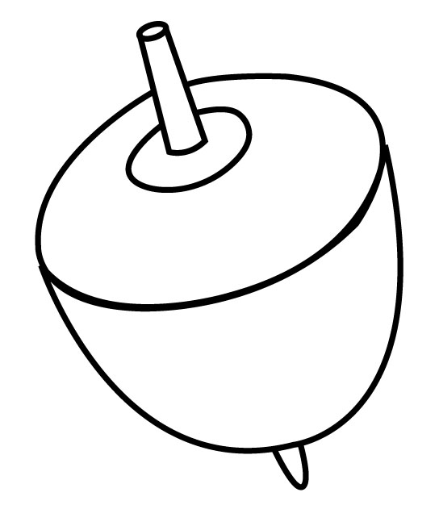  □ □ | 7 | 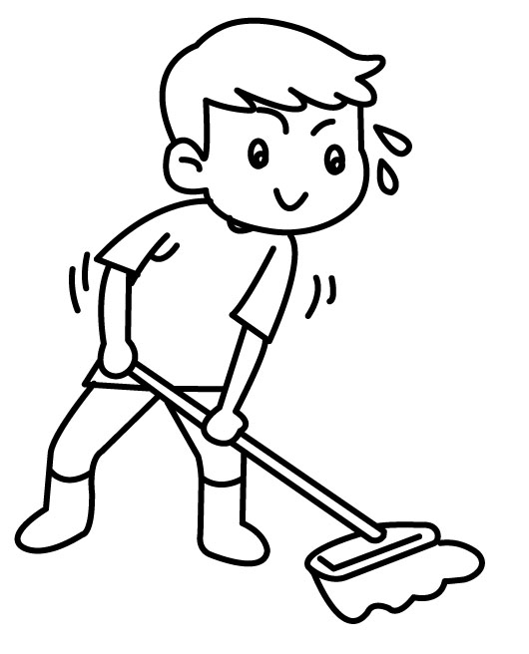  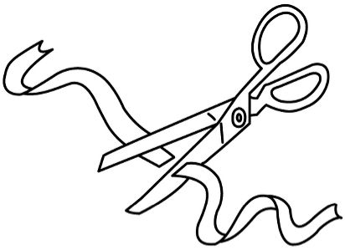  □ □ | 8 | 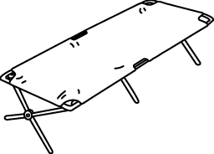  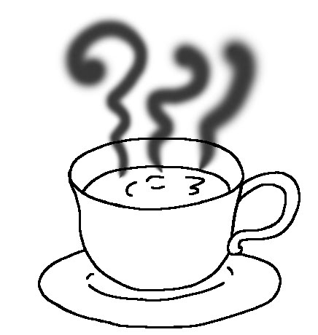  □ □

B. Listen and Spell (24%)（聽老師念，填順序並拼出單字）
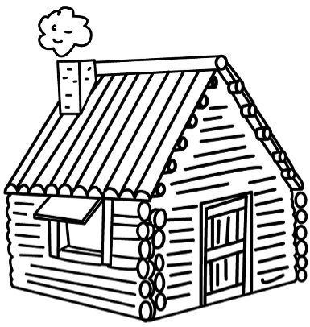  __ut | 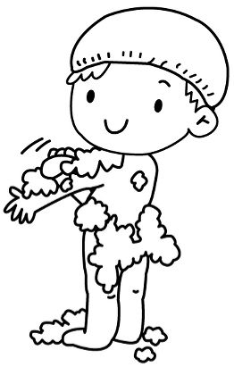  __ub | __op | __o__ | 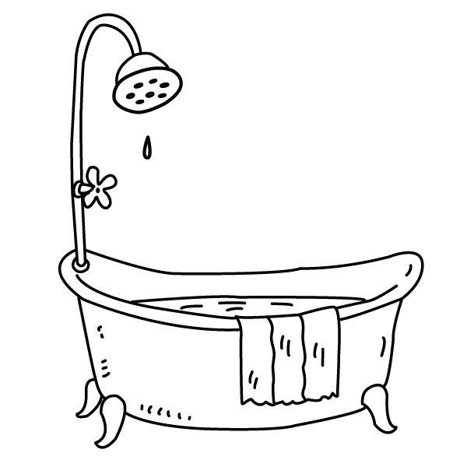  __u__ | __o__

C. Listen, Write and Check (20%)（聽老師念，完成句子並勾出正確回答）
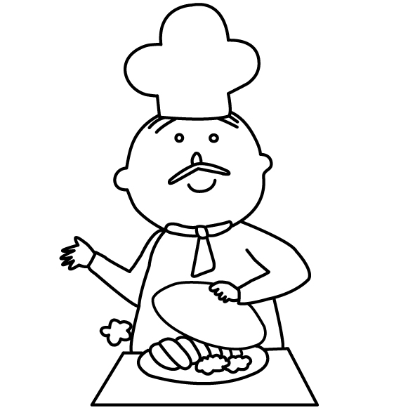  1. |  | 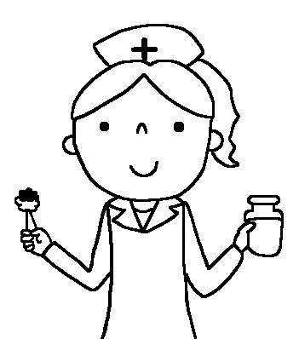  2. | 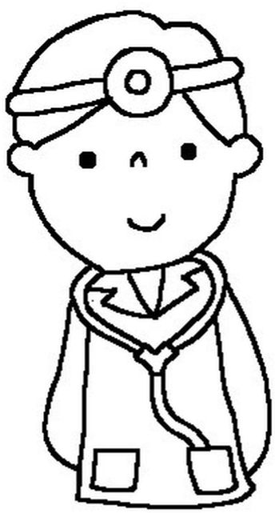  3. | 4.
 | Is he __ ________?  □ Yes, she is.  □ No, she isn’t.  □ Yes, he is.  □ No, he isn’t. | Is she __ _____?  □ Yes, she is.  □ No, she isn’t.  □ Yes, I am.  □ No, I’m not. | Are you __ _______?  □ Yes, he is.  □ No, he isn’t.  □ Yes, I am.  □ No, I’m not. | Are you __ _______?  □ Yes, I am.  □ No, I’m not.  □ Yes, he is.  □ No, he isn’t.
- Read and Choose (16%)（依圖示完成對話，請填句子的代號至空格內）
(1) What’s this? (2) I’m tall. (3) This is for you. (4) Nice to meet you.
(5) Me, too. (6) Thank you. (7) Nice to meet you, too. (8) I don’t know.
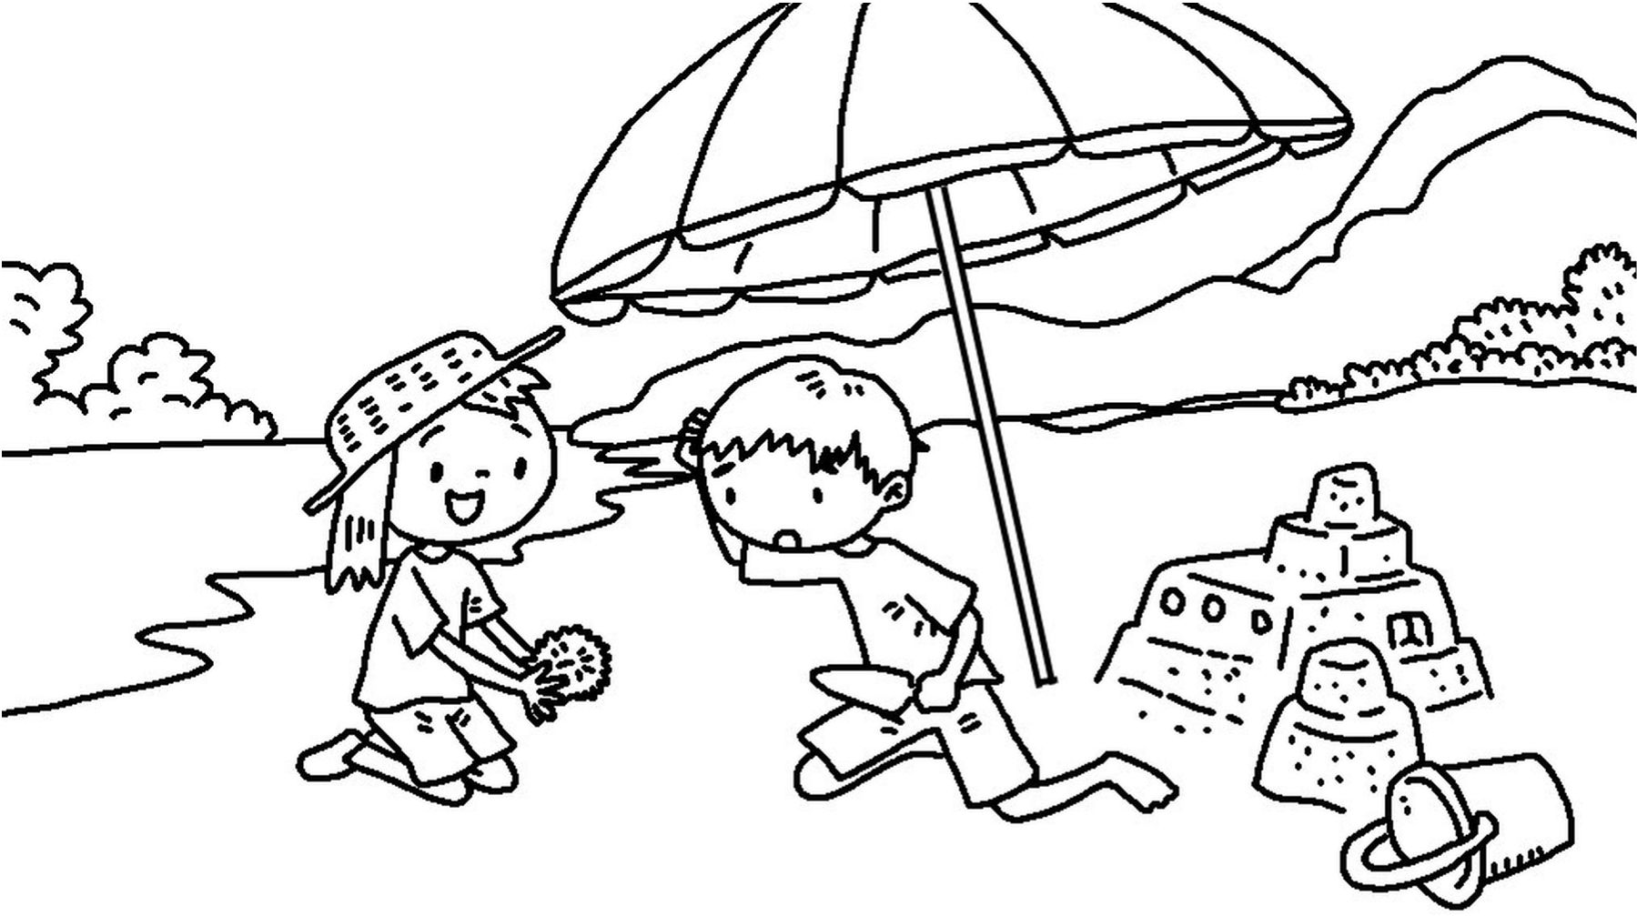 | 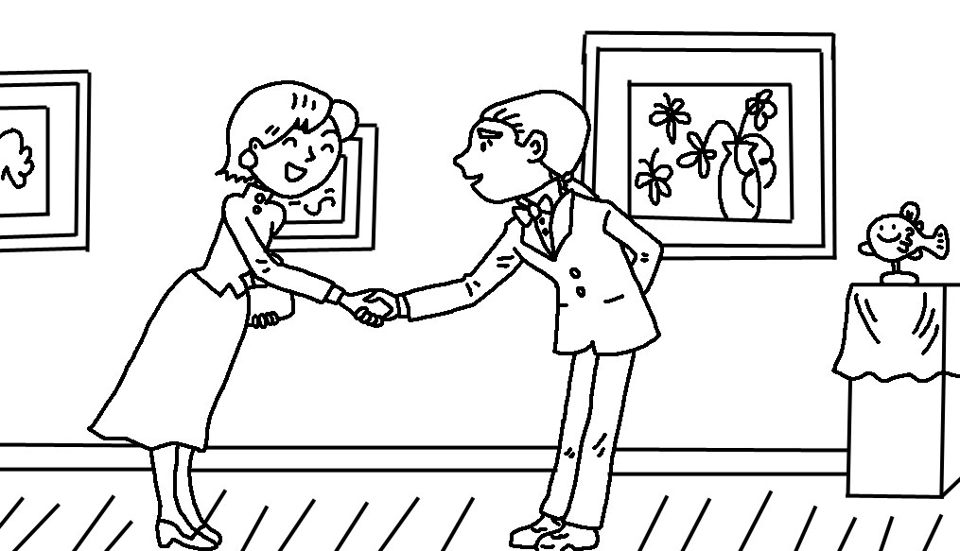 | 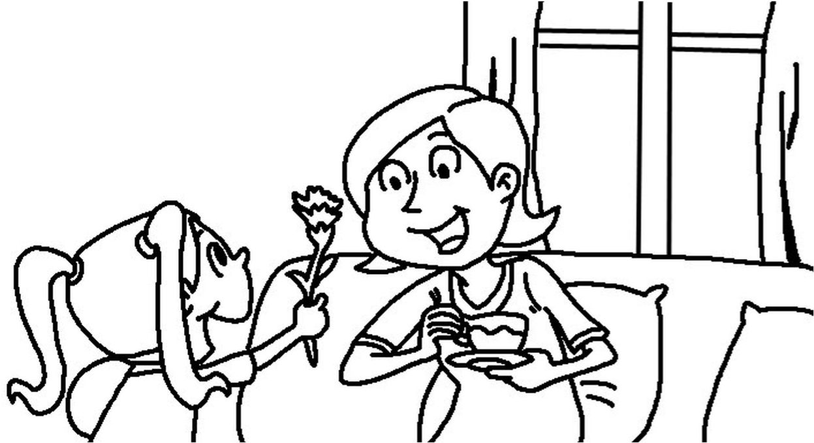 | 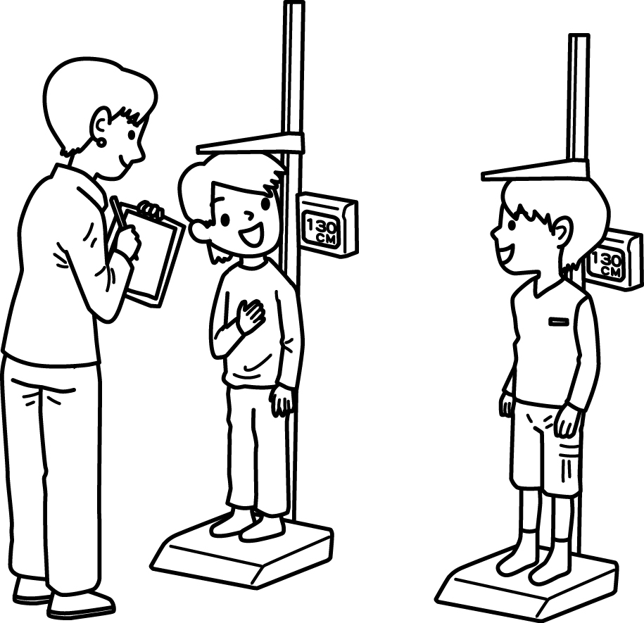
A:________  B:________ | A:________  B:________ | A:________  B:________ | A:________  B:________
- Read and Write (14%)（看圖完成句子）
- ______’s she?
She’s my ________. (妹妹)
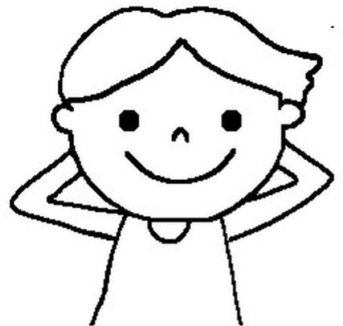 | - He’s my _________. (哥哥)
 | - She’s my ___________. (母親)
 | - He’s my ___________. (祖父)
- This is my ________.(父親)
He’s a ________.

F. Read and Match (10%)（找出對應的回答句子並將代號填入空格中）
1. How are you? ______ A: I’m Owen.
2. What color is it? ______ B: I’m fine.
3. How old are you? ______ C: It’s a bed.
4. What’s that? ______ D: I’m five.
5. What’s your name? ______ E: It’s red.

