花蓮縣花蓮市明義國民小學106學年度第一學期五年級英語科期末定期評量試卷
Class（班級）：____ 年 班 Name（中文和英文姓名）：__________________Seat Number（座號）：_____
- Listen and Check. 仔細聽，並在圖片下
分  數 | 100  分 | 90-99  分 | 80-89  分 | 70-79  分 | 60-69 分 | 60分  以下 | 家 長  簽 名
人
數
的方格內打ˇ。（24%）
1. | 2. | 3 | 4.
  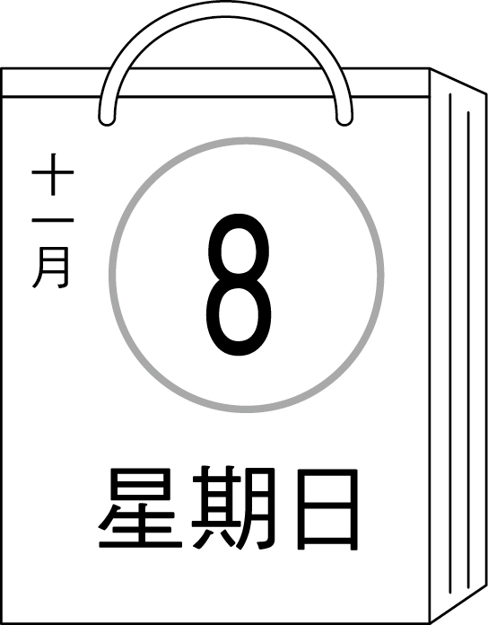  □ | 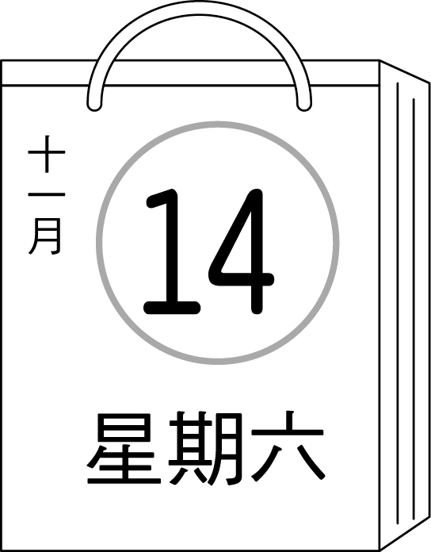  □
  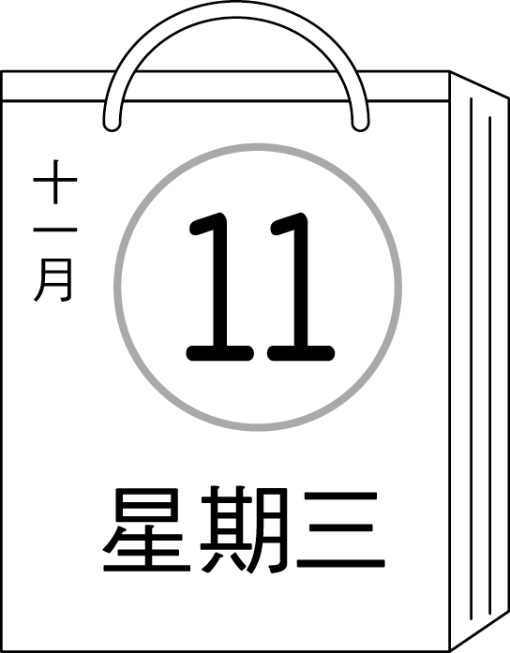  □ | 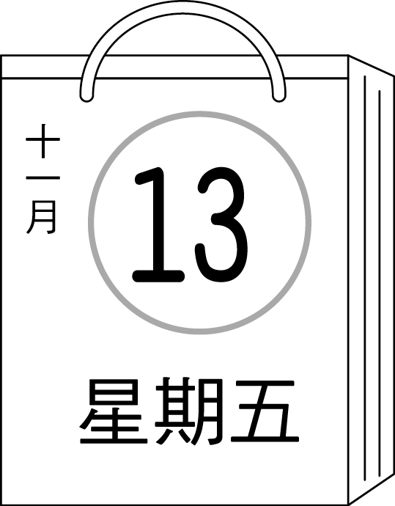  □
  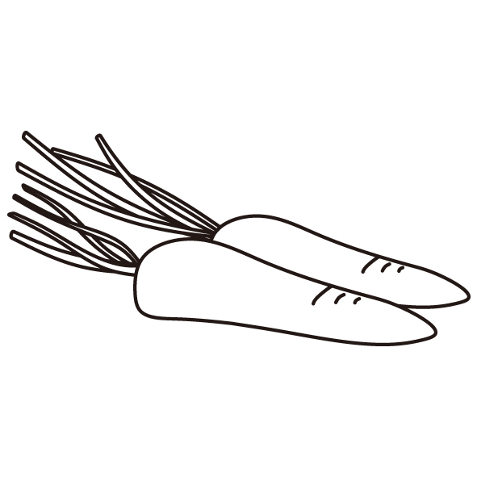  □ | 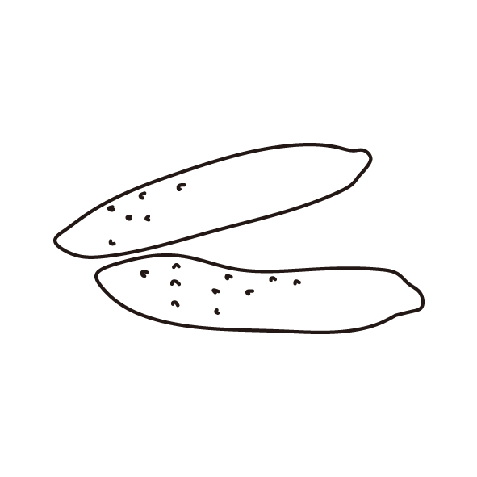  □
  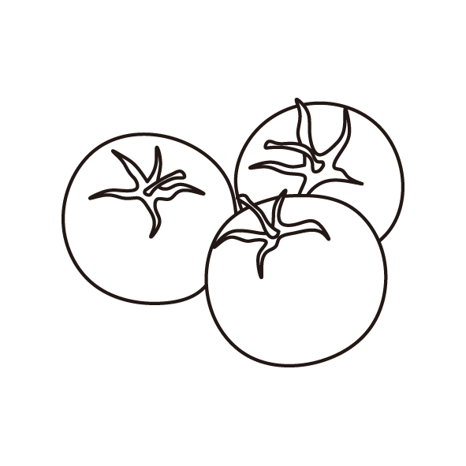  □ | 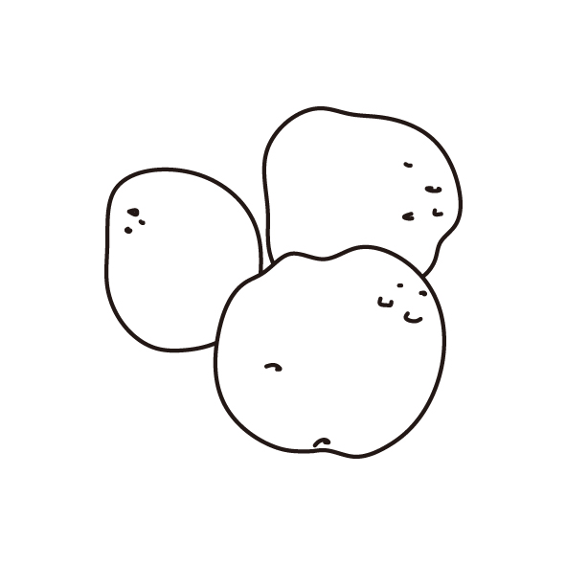  □
5. | 6. | 7. | 8.
  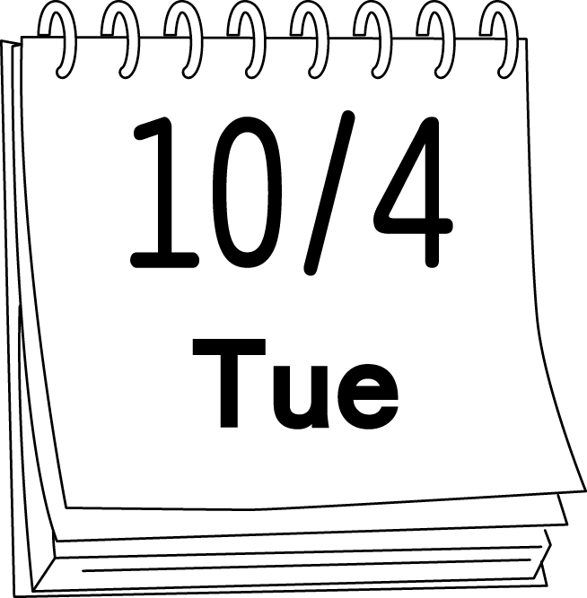  □ | 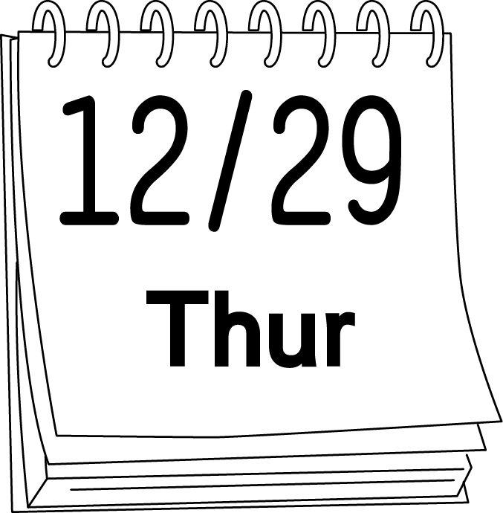  □
  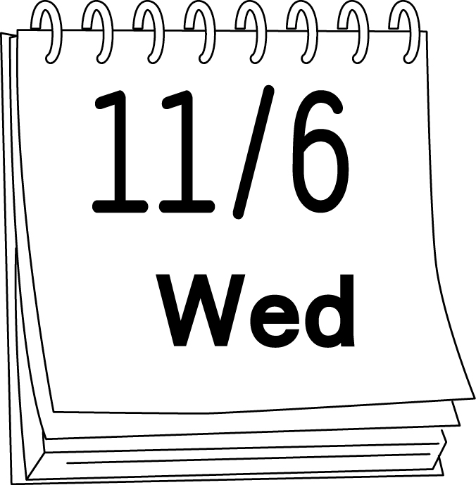  □ | □
  □ | □
  □ | □
9. | 10. | 11. | 12.
  □ | □
  □ | □
  □ | □
  □ | □
B. Listen and Spell. 仔細聽，並拼寫出英文單字。（8%）
1.（ ） | 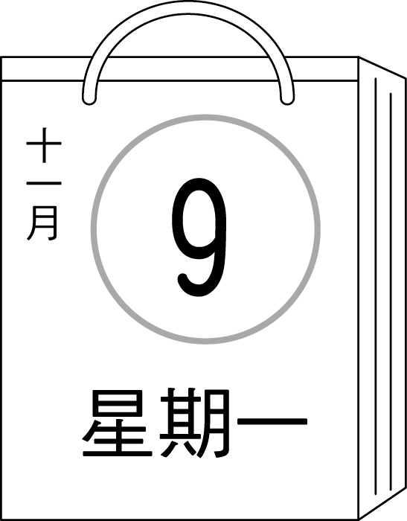  2.（ ） | 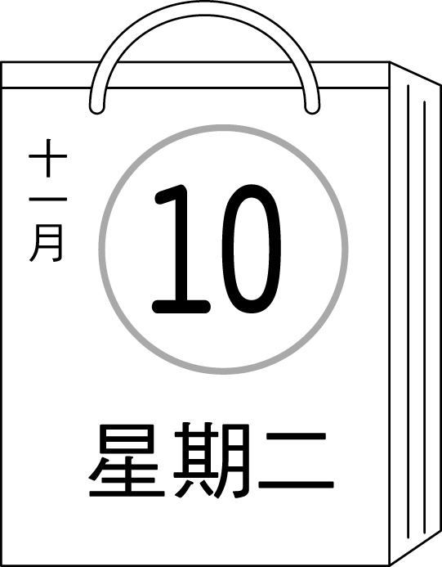  3.（ ） | 4.（ ）
5.（ ） | 6.（ ） | 7.（ ） | 8.（ ）
C. Listen and Circle. 仔細聽發音，並圈出正確的字母。（8%）
1.  cat cent | 2.  Candy Cindy | 3.  cute city | 4.  cape cipe
5.  gum gem | 6.  gale gel | 7.  goat gym | 8.  maga magic

※※※※ 請翻到背面繼續做答（Please turn to the next page. ） P.1 ※※※※※
D. Listen and Check. 英語護照聽寫專區，勾選正確的句子。（8%）

1 □ Let’s go to the movies.  □ Let’s go shopping. | 2. □ Where is the library ？  □ Where are you going ？
3. □ Maybe next time！  □ May I come in ？ | 4. □ Sure, please take off your shoes first.  □ I have to do my homework.

E. Listen and Number. 仔細聽，並寫出正確的號碼。（8%）

 |  | 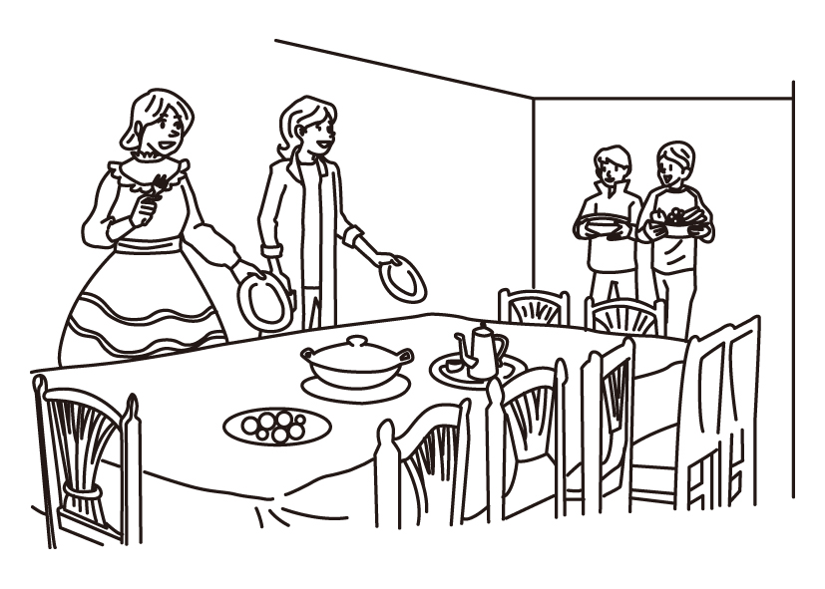 | 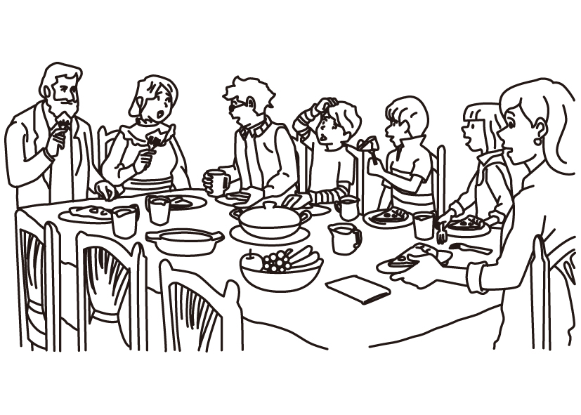
【 】 | 【 】 | 【 】 | 【 】

F. Look and Circle.看圖，圈選出錯誤的單字,每題有2個錯誤。 (8%)

1. Is today thursday ? No, it is. | 2. How many orange do Mom need ?
3. They needs four cucumber. | 4. Does you need potato ?

G. Find the Right Answer. 請仔細閱讀，並選出適當的代號。(10 %)
( A ) 1. A: What day is today? B: Thursday.
(A) I’m (B) It (C) It’s

( A ) 2. A: today Sunday? B: Yes, .
(A) What, it’s (B) Is, it doesn’t (C) Is, it is

( A ) 3. Gina five potatoes.
(A) needs (B) need (C) to need

( A ) 4. Lucy and her friend three .
(A) need, cucumber (B) need, cucumbers (C) needs, cucumbers

( A ) 5. A: What a mess ! B: It’s my !
(A) doesn’t, day (B) not, day (C) isn’t, today

※※※※ 請翻到下一頁繼續做答（Please turn to the next page. ） P.2 ※※※※※
Class（班級）：____ 年 班 Name（中文和英文姓名）：__________________Seat Number（座號）：_____

H. Unscramble the Sentences. 重組句子。（10%）

my / Time / . / class / for / painting （5％）

cucumbers / many / do / need / ? / How / you （5％）

- Read and Write.回答問題,寫出完整的句子。（6%）
  - What day is today ?

  - How many potatoes does Kevin need ?

J. Read and Choose.根據文字和右圖,選出正確的答案。（10%）

Today is Sunday. It’s rainy. Sam and Tina are making lunch at home.
Look at the picture, and answer the following questions.
Sam
Tina
( ) 1. What day is today ?
(A) It’s Sunday. (B) It’s rainy. (C) It’s cloudy.
( ) 2. How many carrots does Tina need ?
(A) She needs two carrot. (B) She need two carrots.
(C) She needs two carrots.
( ) 3. Does Sam need potatoes ?
(A) Yes, she does. (B) Yes, he does. (C) No, he doesn’t.
( ) 4. Does Tina need cucumbers ?
(A) Yes, she does. (B) No, he doesn’t. (C) No, she doesn’t.
( ) 5. Which one is true ?
- Sam needs three cucumbers. (B) They both need potatoes.
(C) Tina needs three carrots.

K. Bouns.加分題(寫出正確的英文句子) （2%）

1. 一星期有7天。

2.他們看起來很像。

※※※※※※ Don’t forget to check your answer again！ 別忘了要再檢查喔 ! P.3 ※※※※※※

