花蓮縣花蓮市明義國民小學112學年度第二學期四年級英語科期中定期評量試卷
Class：四年 班 Name（中文姓名）：_____________ Number （座號）：_____ 家長簽名__________
- Listen and Check (16%) (勾選聽到的圖片)
1 | 20 30  □ □ | 2 | 45 55  □ □ | 3 |     □ □ | 4 | 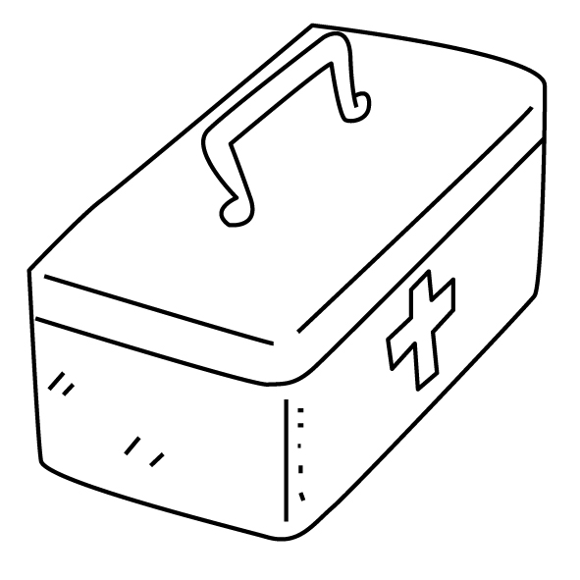    □ □
5 | 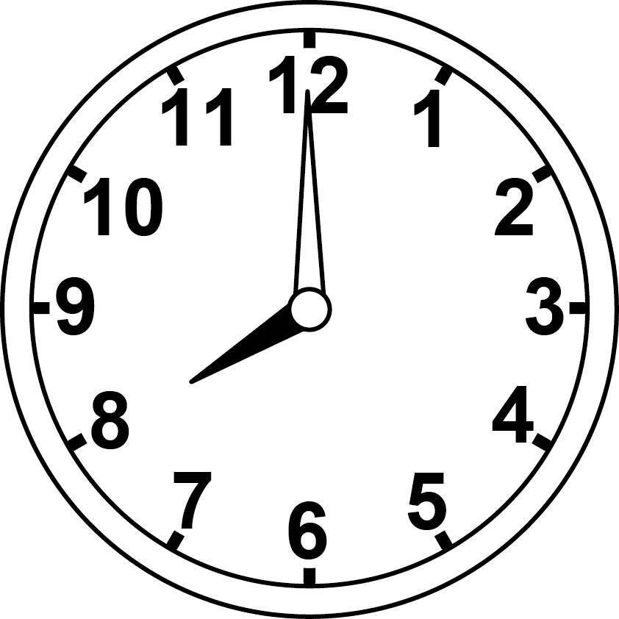  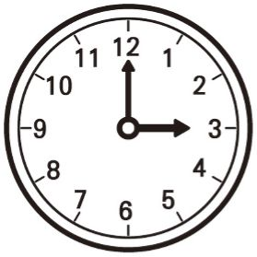  □ □ | 6 |   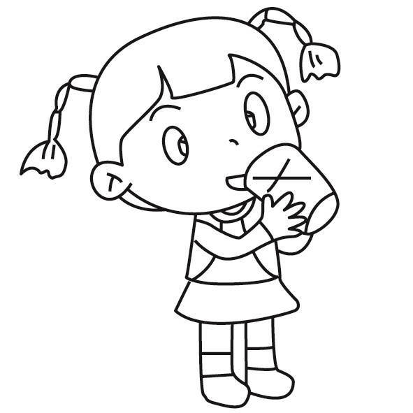  □ □ | 7 | 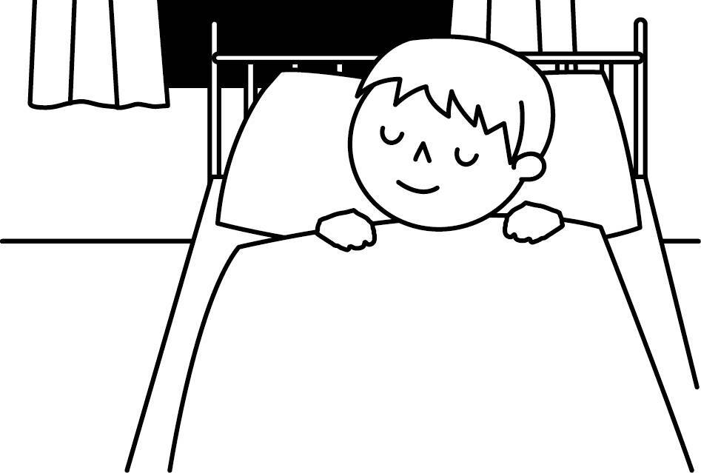    □ □ | 8 |   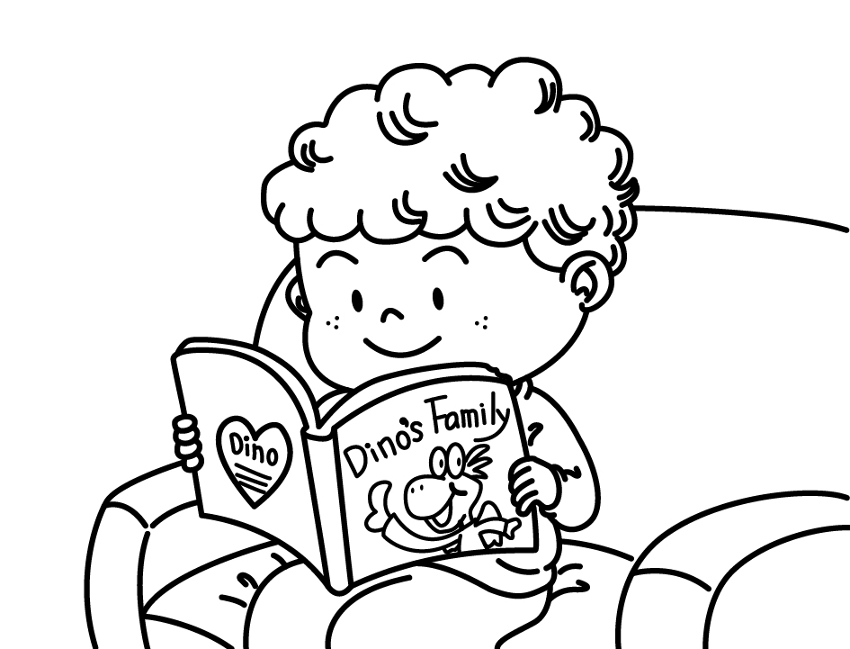  □ □

- Listen and Number (10%) (仔細聽並將圖片編號)
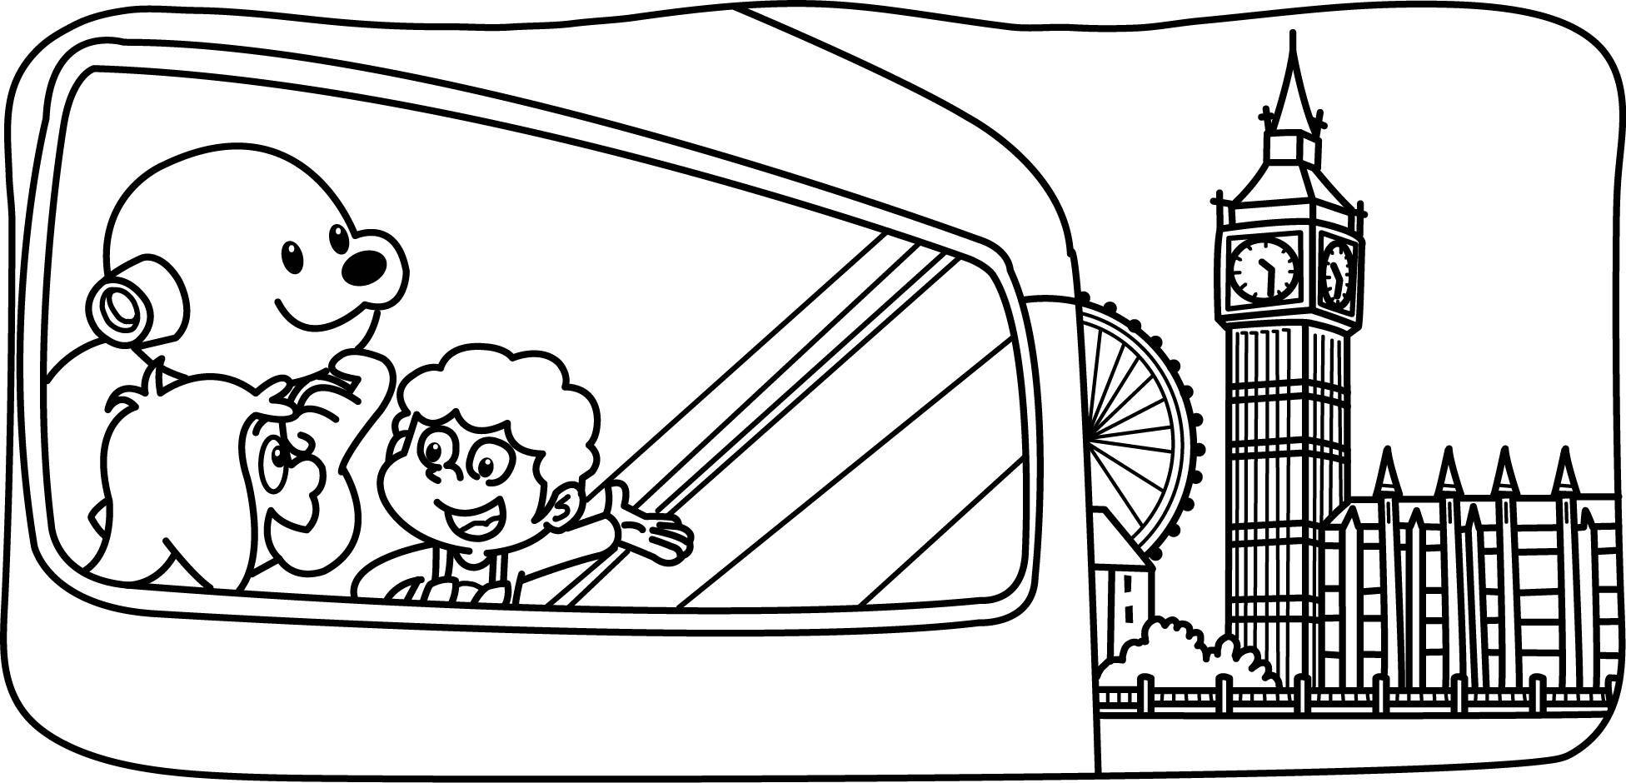 |  | 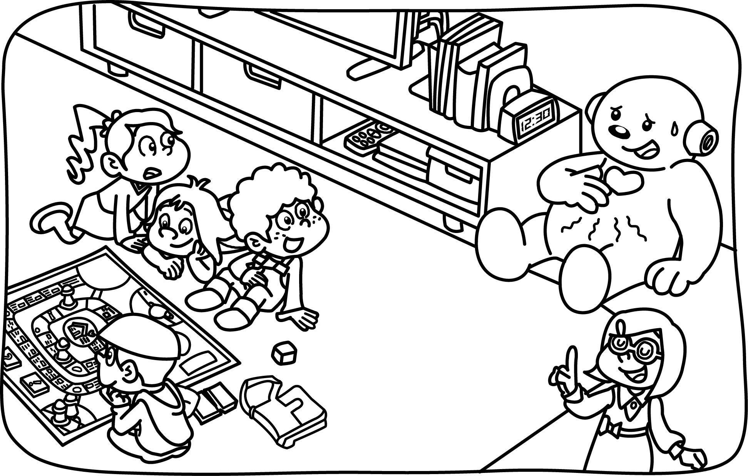  有個好主意 | 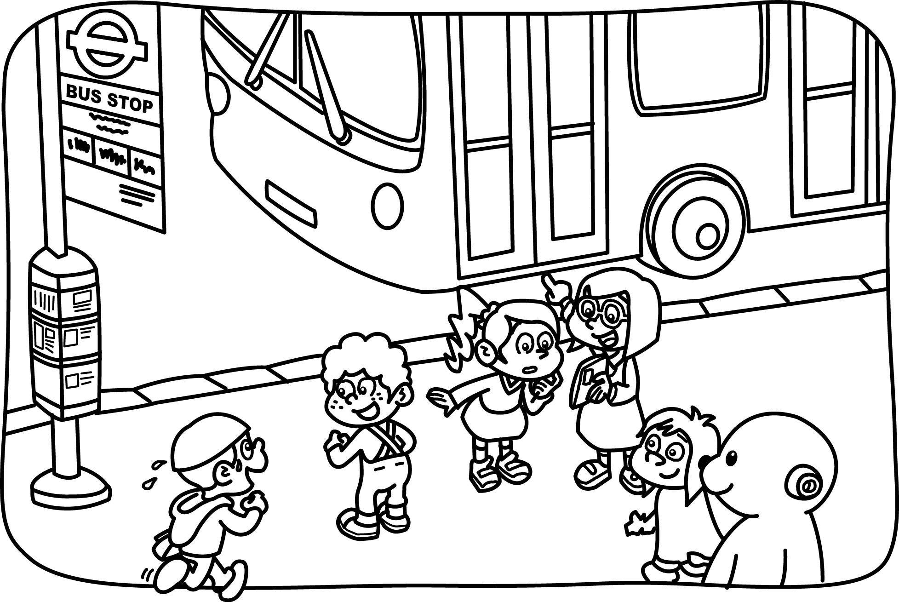 | 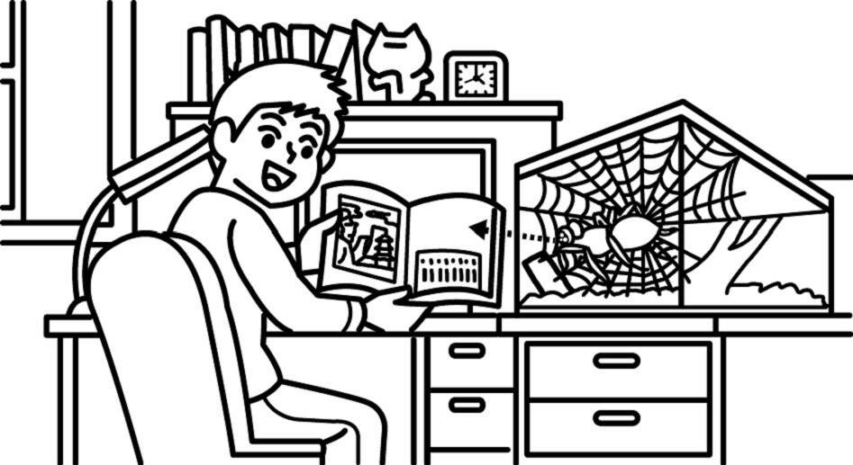
( ) | ( ) | ( ) | ( ) | ( )
- Listen and Write (16%)（把聽到的時間寫下來）
(1) | (2) | (3) | (4)
What time is it ?  _____：______ | What time is it ?  _____：______ | What time is it ?  _____：______ | What time is it ?  _____：______

- Listen, Number and Write (15%)（填入聽到的順序並完成單字）
( ) | ( ) | ( ) | ( ) | ( ) | ( )
 | 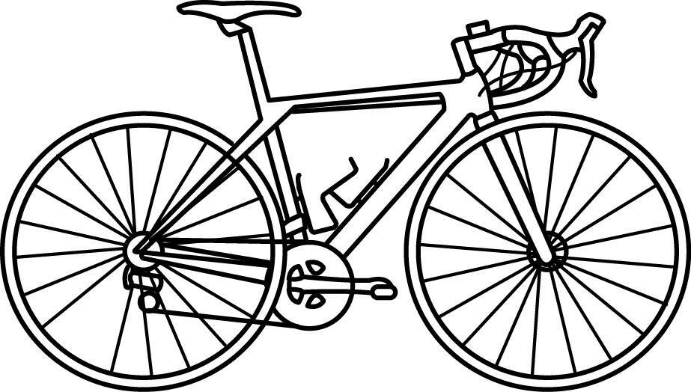 |  | 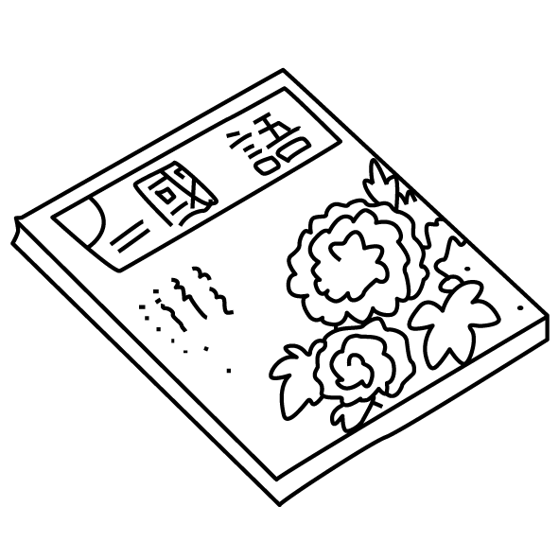 | 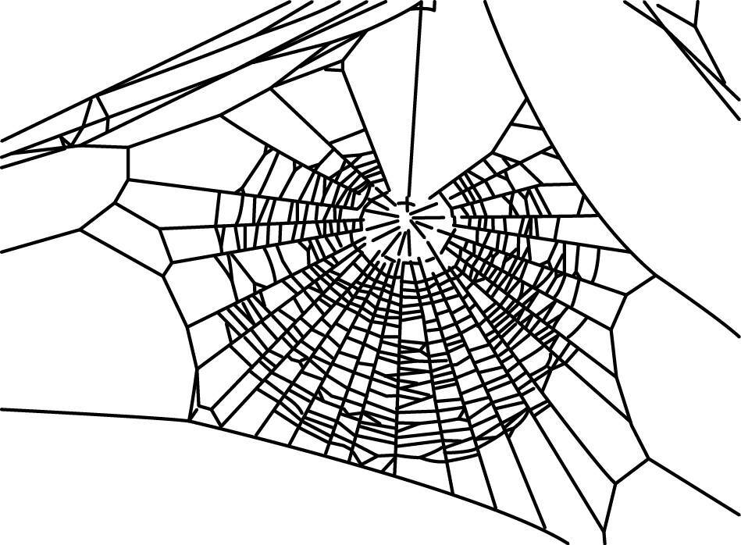 | 
c_p | b_k_ | k_t | Chin__s__ | w_b | s_m_

- Read and Mark (12%)（依圖示填代號完成對話）
- Oh, no! We’re back. (2) Sorry, I’m late. (3) Do you want some fish?
(4) Yes, please. (5) Here we go. (6) Now we’re really hungry.

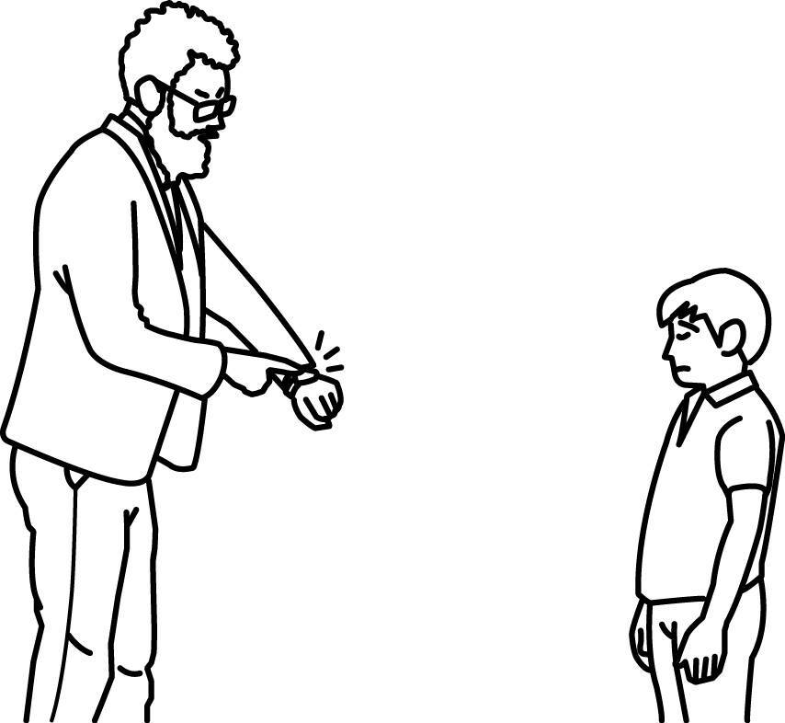 | _______ | 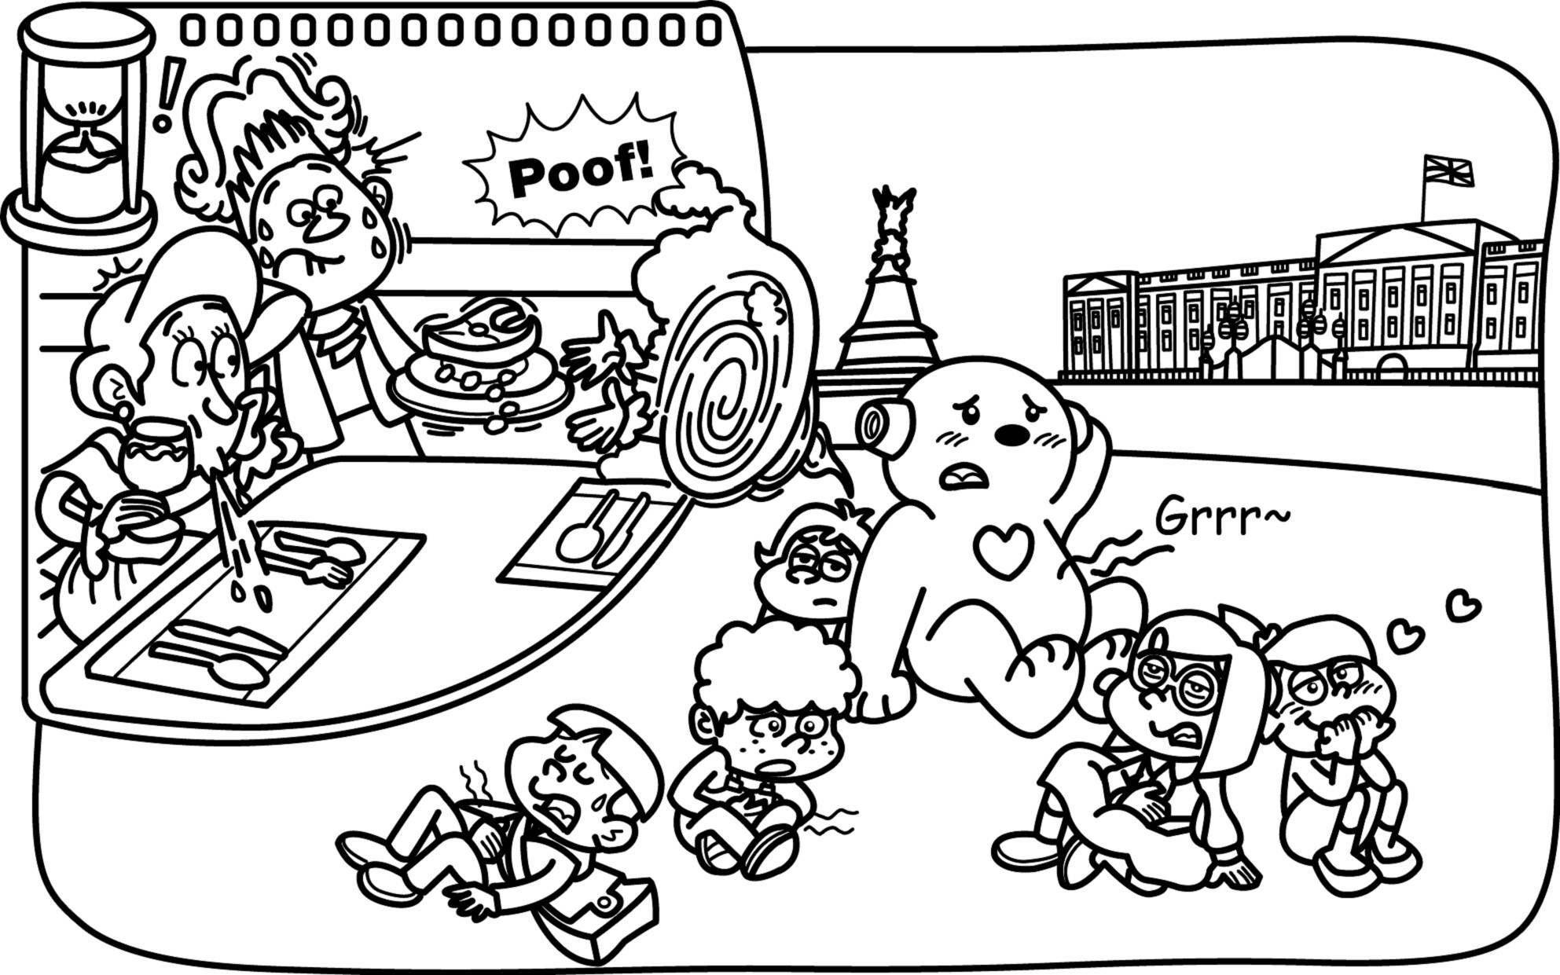 | A: ______  B: ______
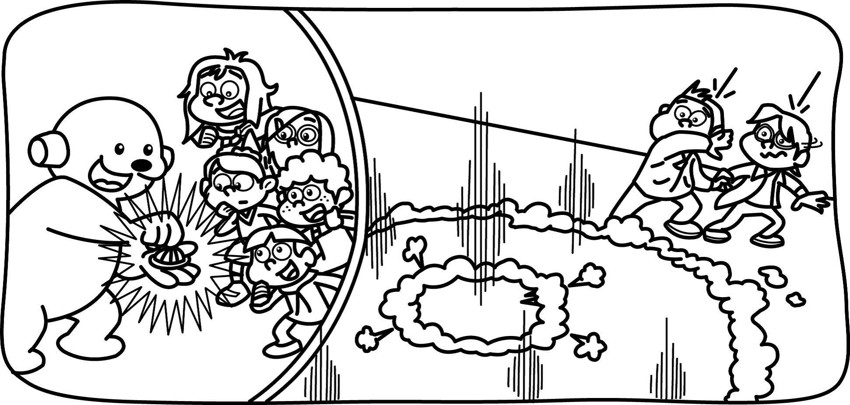我們出發吧 | _______ | 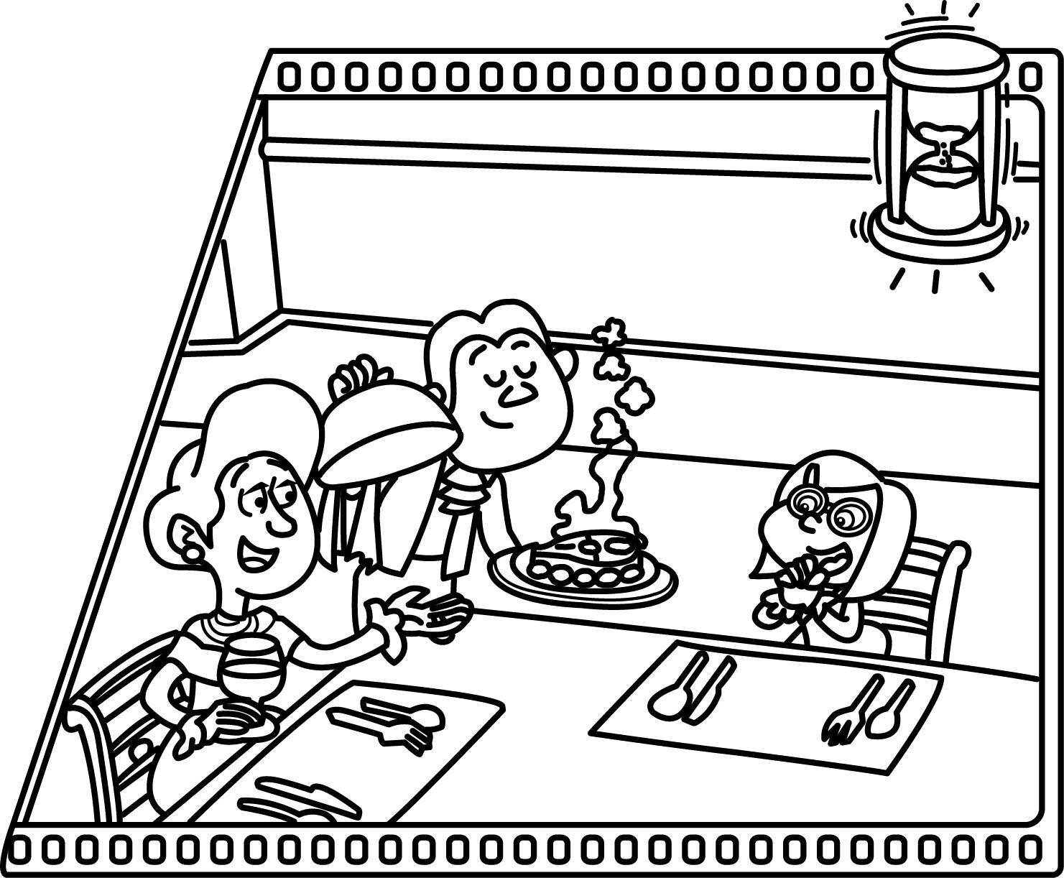 | A: ______  B: ______

- Read and Write (17%)（看圖完成句子）
參考單字：two twelve am are is o’clock
12:00 | - What time is it?  It’s ______________ | 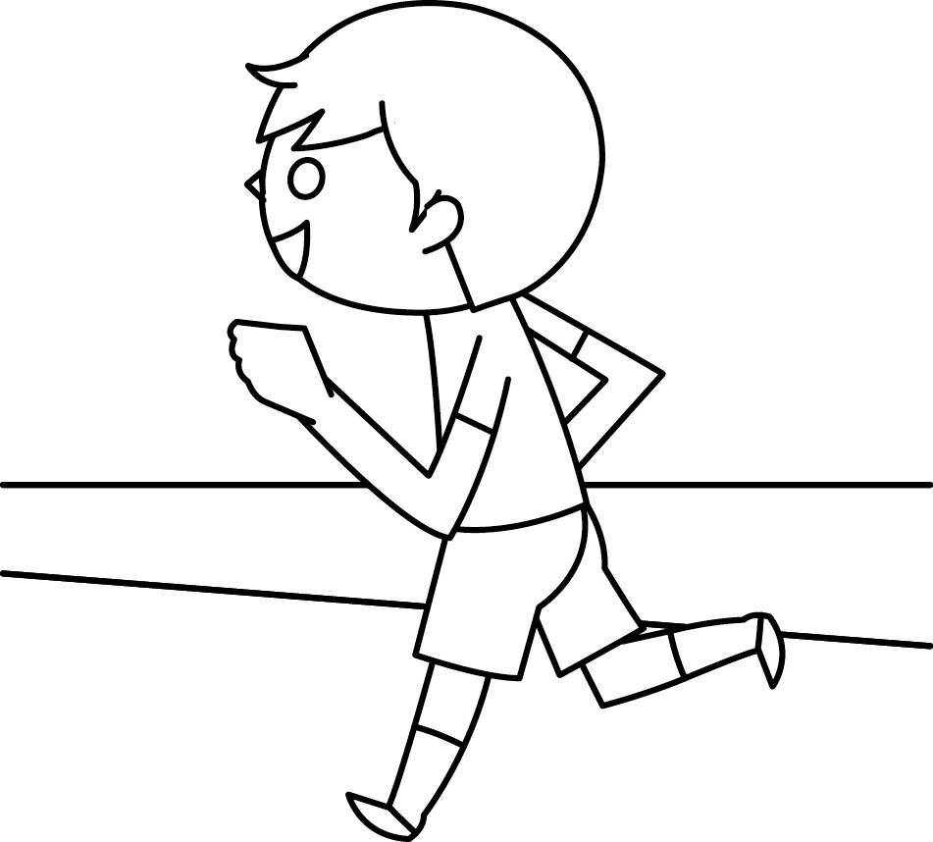 | - What ____ you doing?  I ________________
02:55 | - What time is it?  It’s ______________ |  | - What’s _____ doing?  She _______________
 | 5. What’s _____ doing?  He _____________ | 加分題 | We _____________ now.

G. Unscramble the Sentences (14%)（句子重組，請填代號）
1. ( ) ①minute ② a ③Wait .
2. ( ) ①for ② Time ③lunch .
3. ( ) ① Let’s ②fun ③ have ④ some .
4. ( ) ① now ②right ③ riding ④They’re .

