花蓮縣花蓮市明義國民小學113年度第一學期四年級英語科期末定期評量試卷
Class：四年 班 Name（中文姓名）：_____________ Number （座號）：_____ 家長簽名__________
- Listen and Check (12%) (勾選聽到的圖片)
1 | 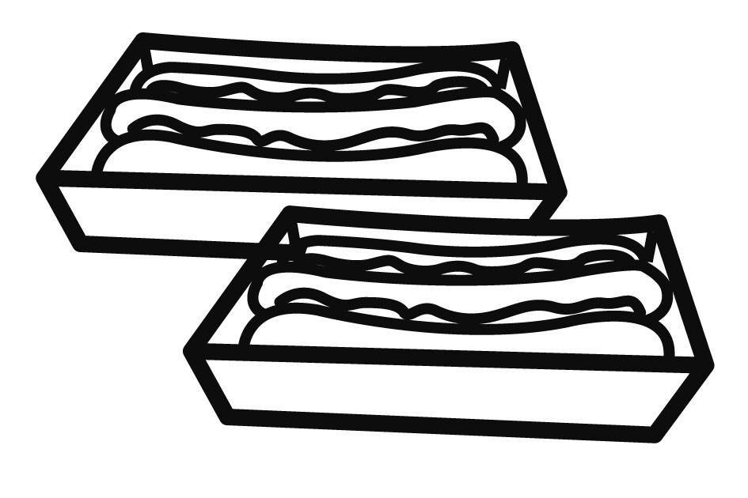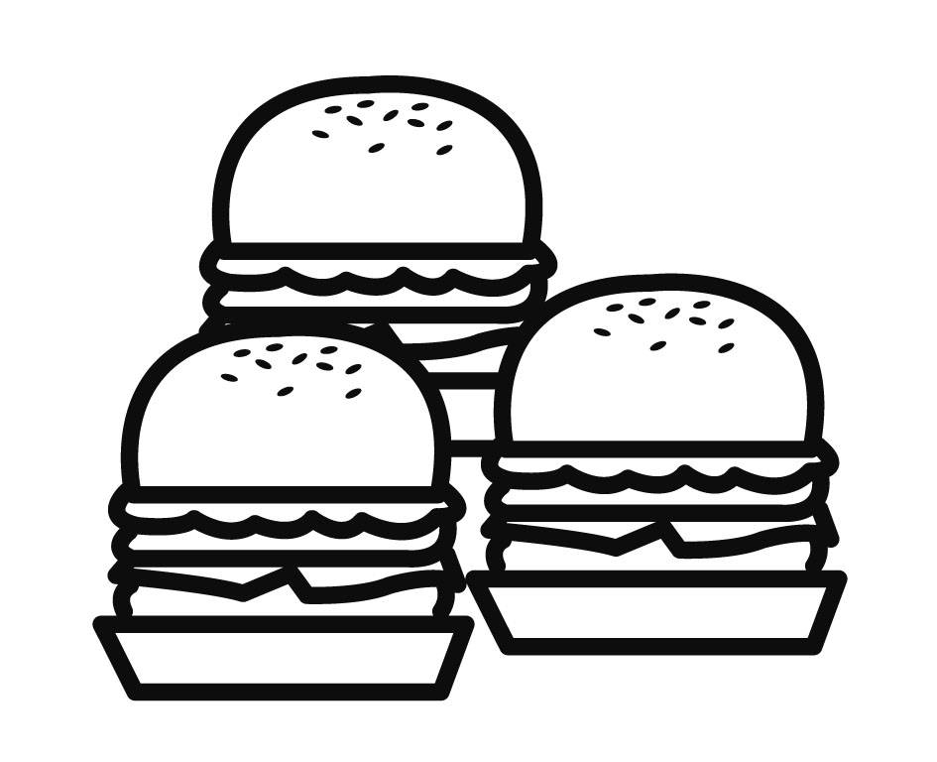 □ □ | 2 | 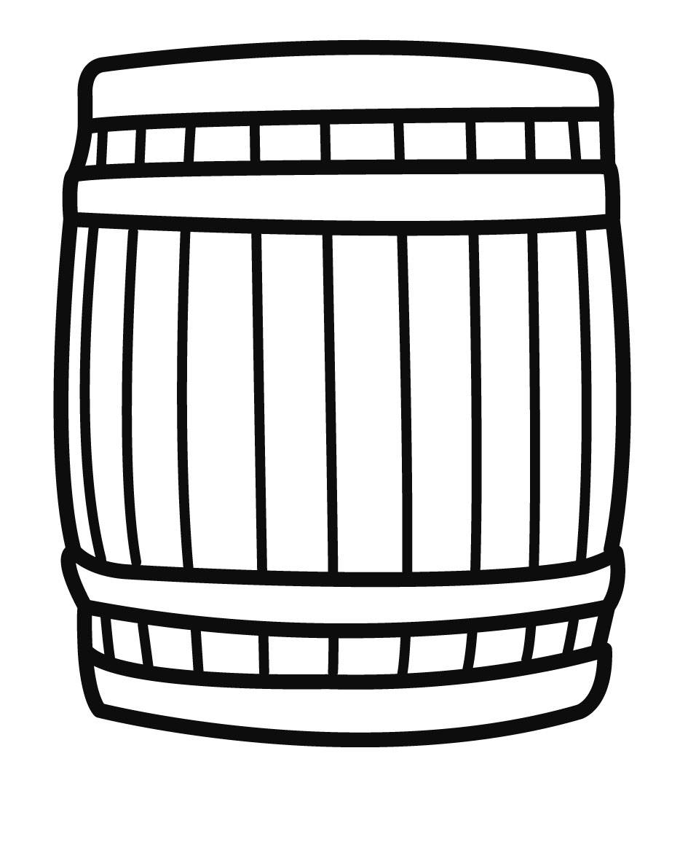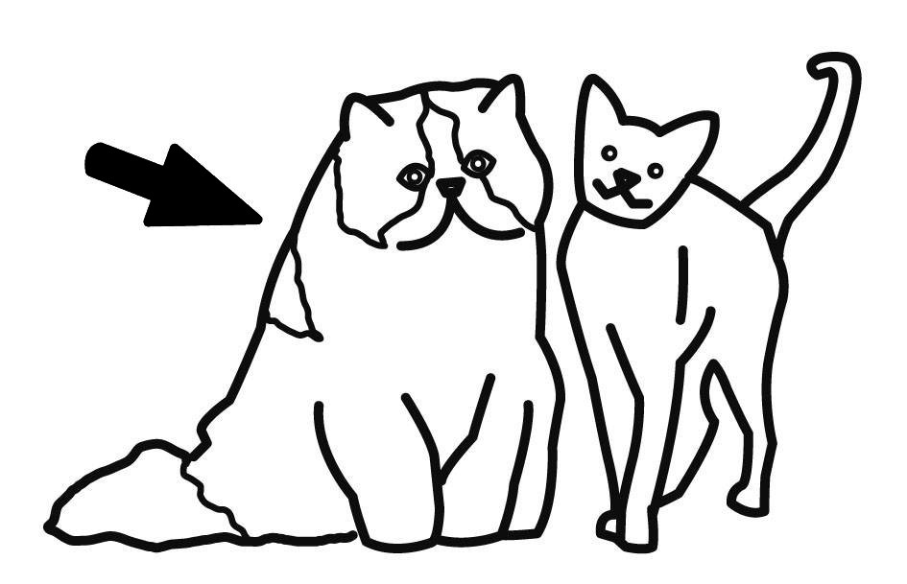  □ □ | 3 |   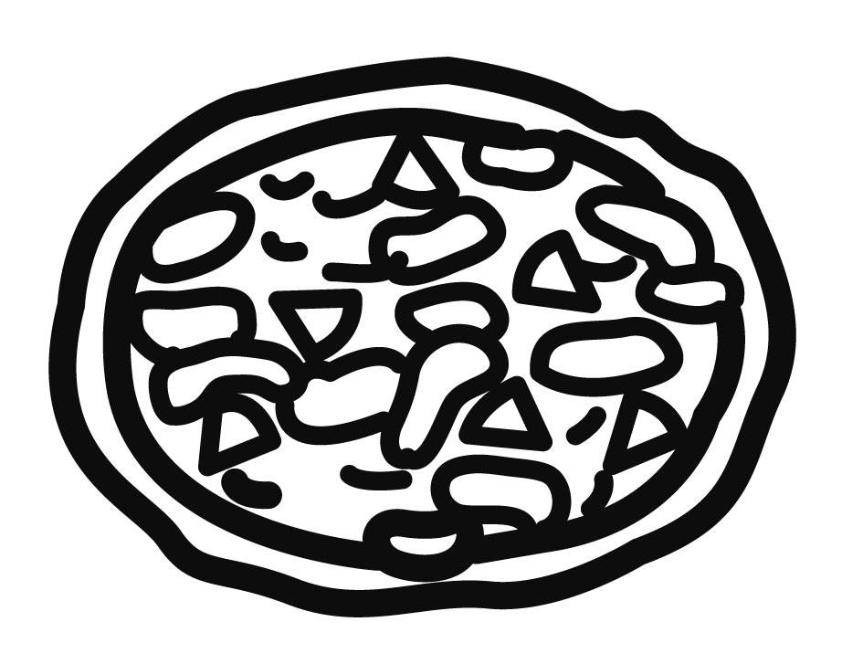  □ □
4 | 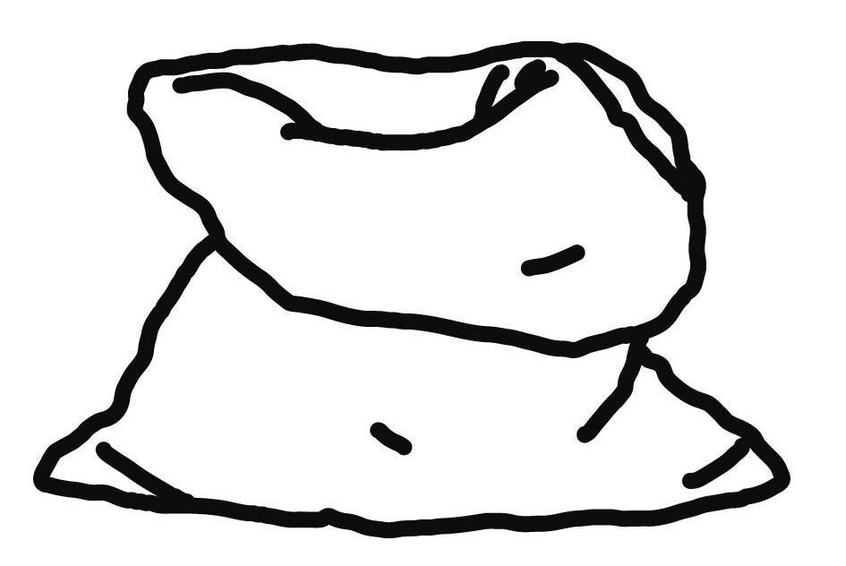  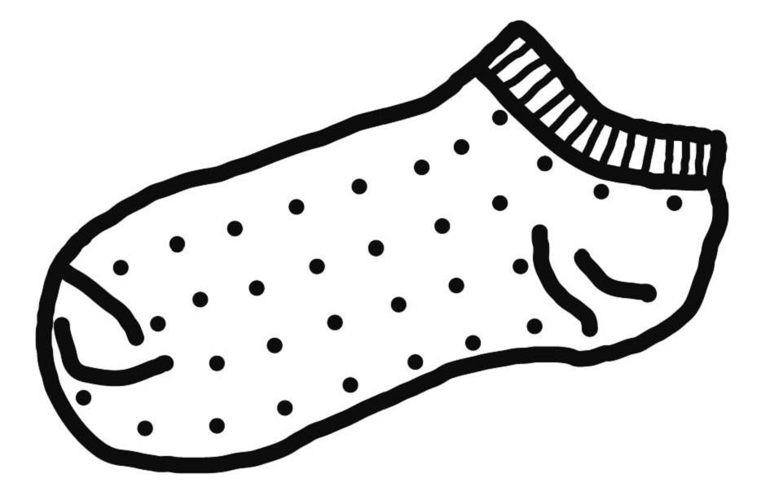  □ □ | 5 | 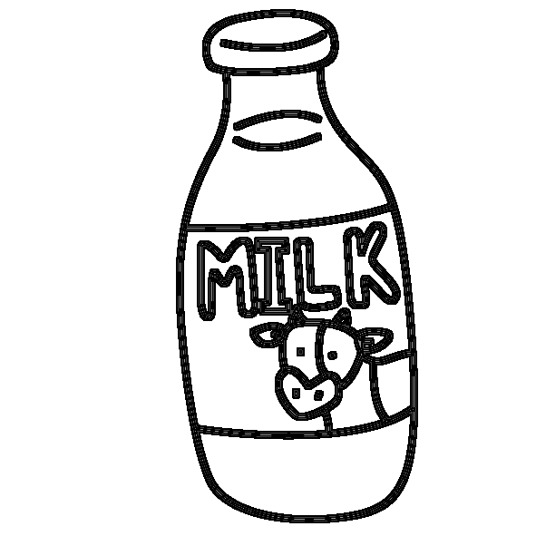  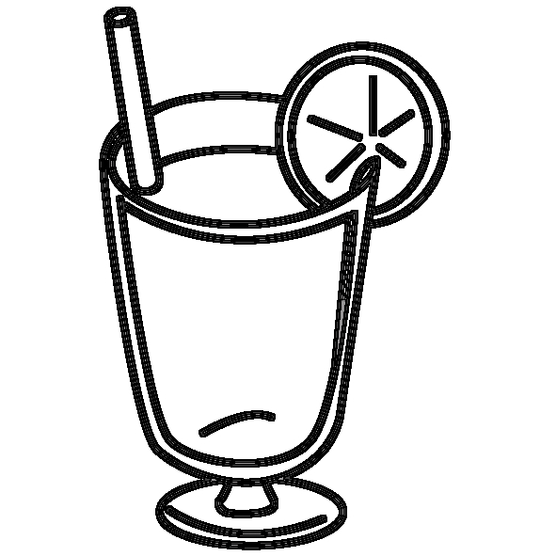  □ □ | 6 | 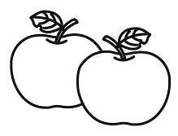  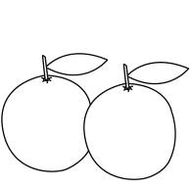  □ □
- Listen and Number (10%) (仔細聽，將圖片填入編號)
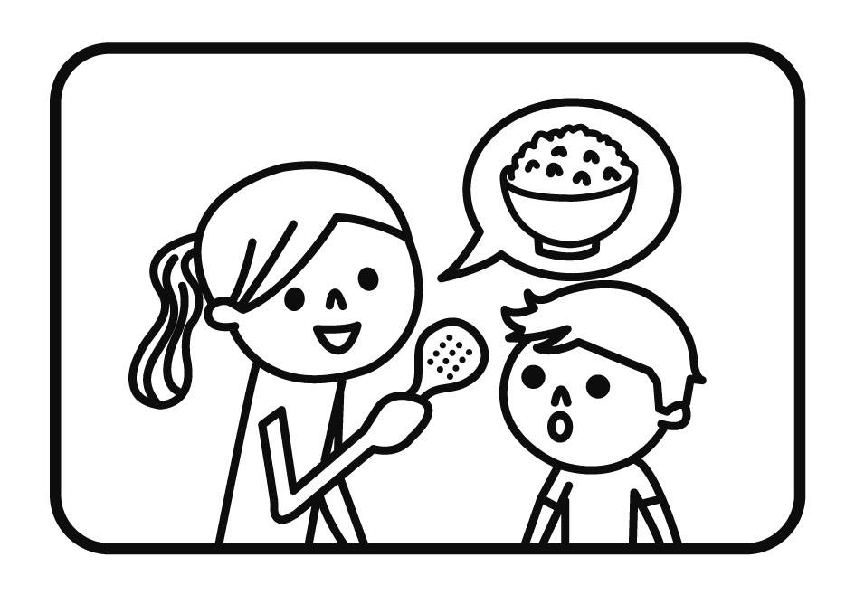 | 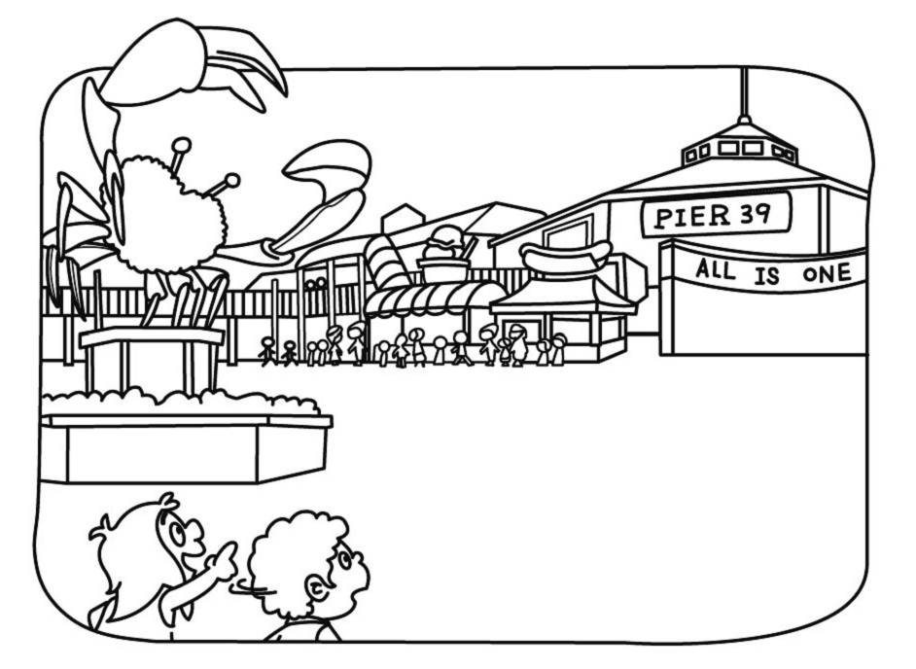 | 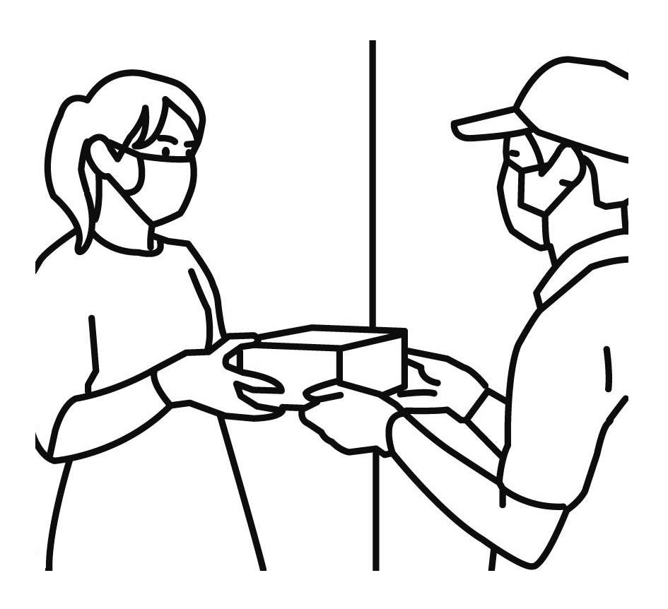 | 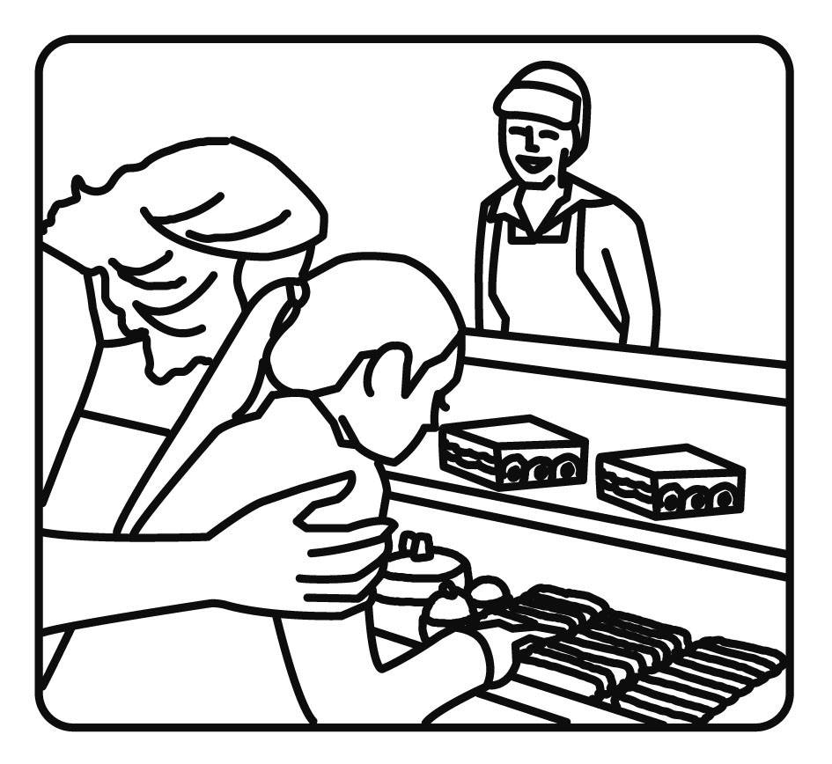 | 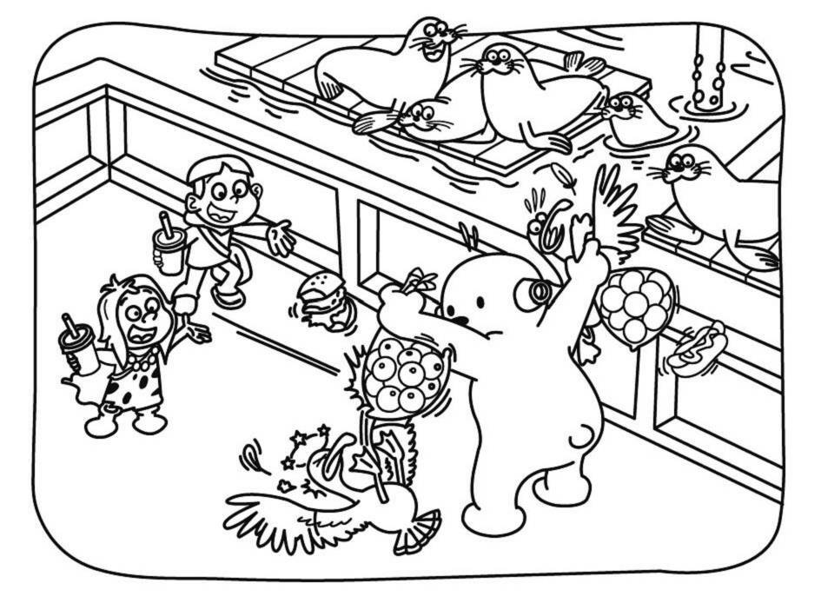
( ) | ( ) | ( ) | ( ) | ( )
- Listen, Number and Mark (18%) (填入聽到的順序和數量或圈選O或X)
 | ( ) | ( ) | ( ) | ( ) | ( ) | ( )
 | 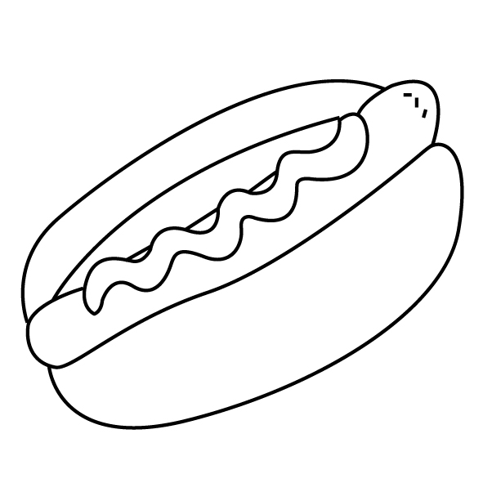 | 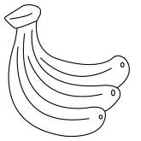 | 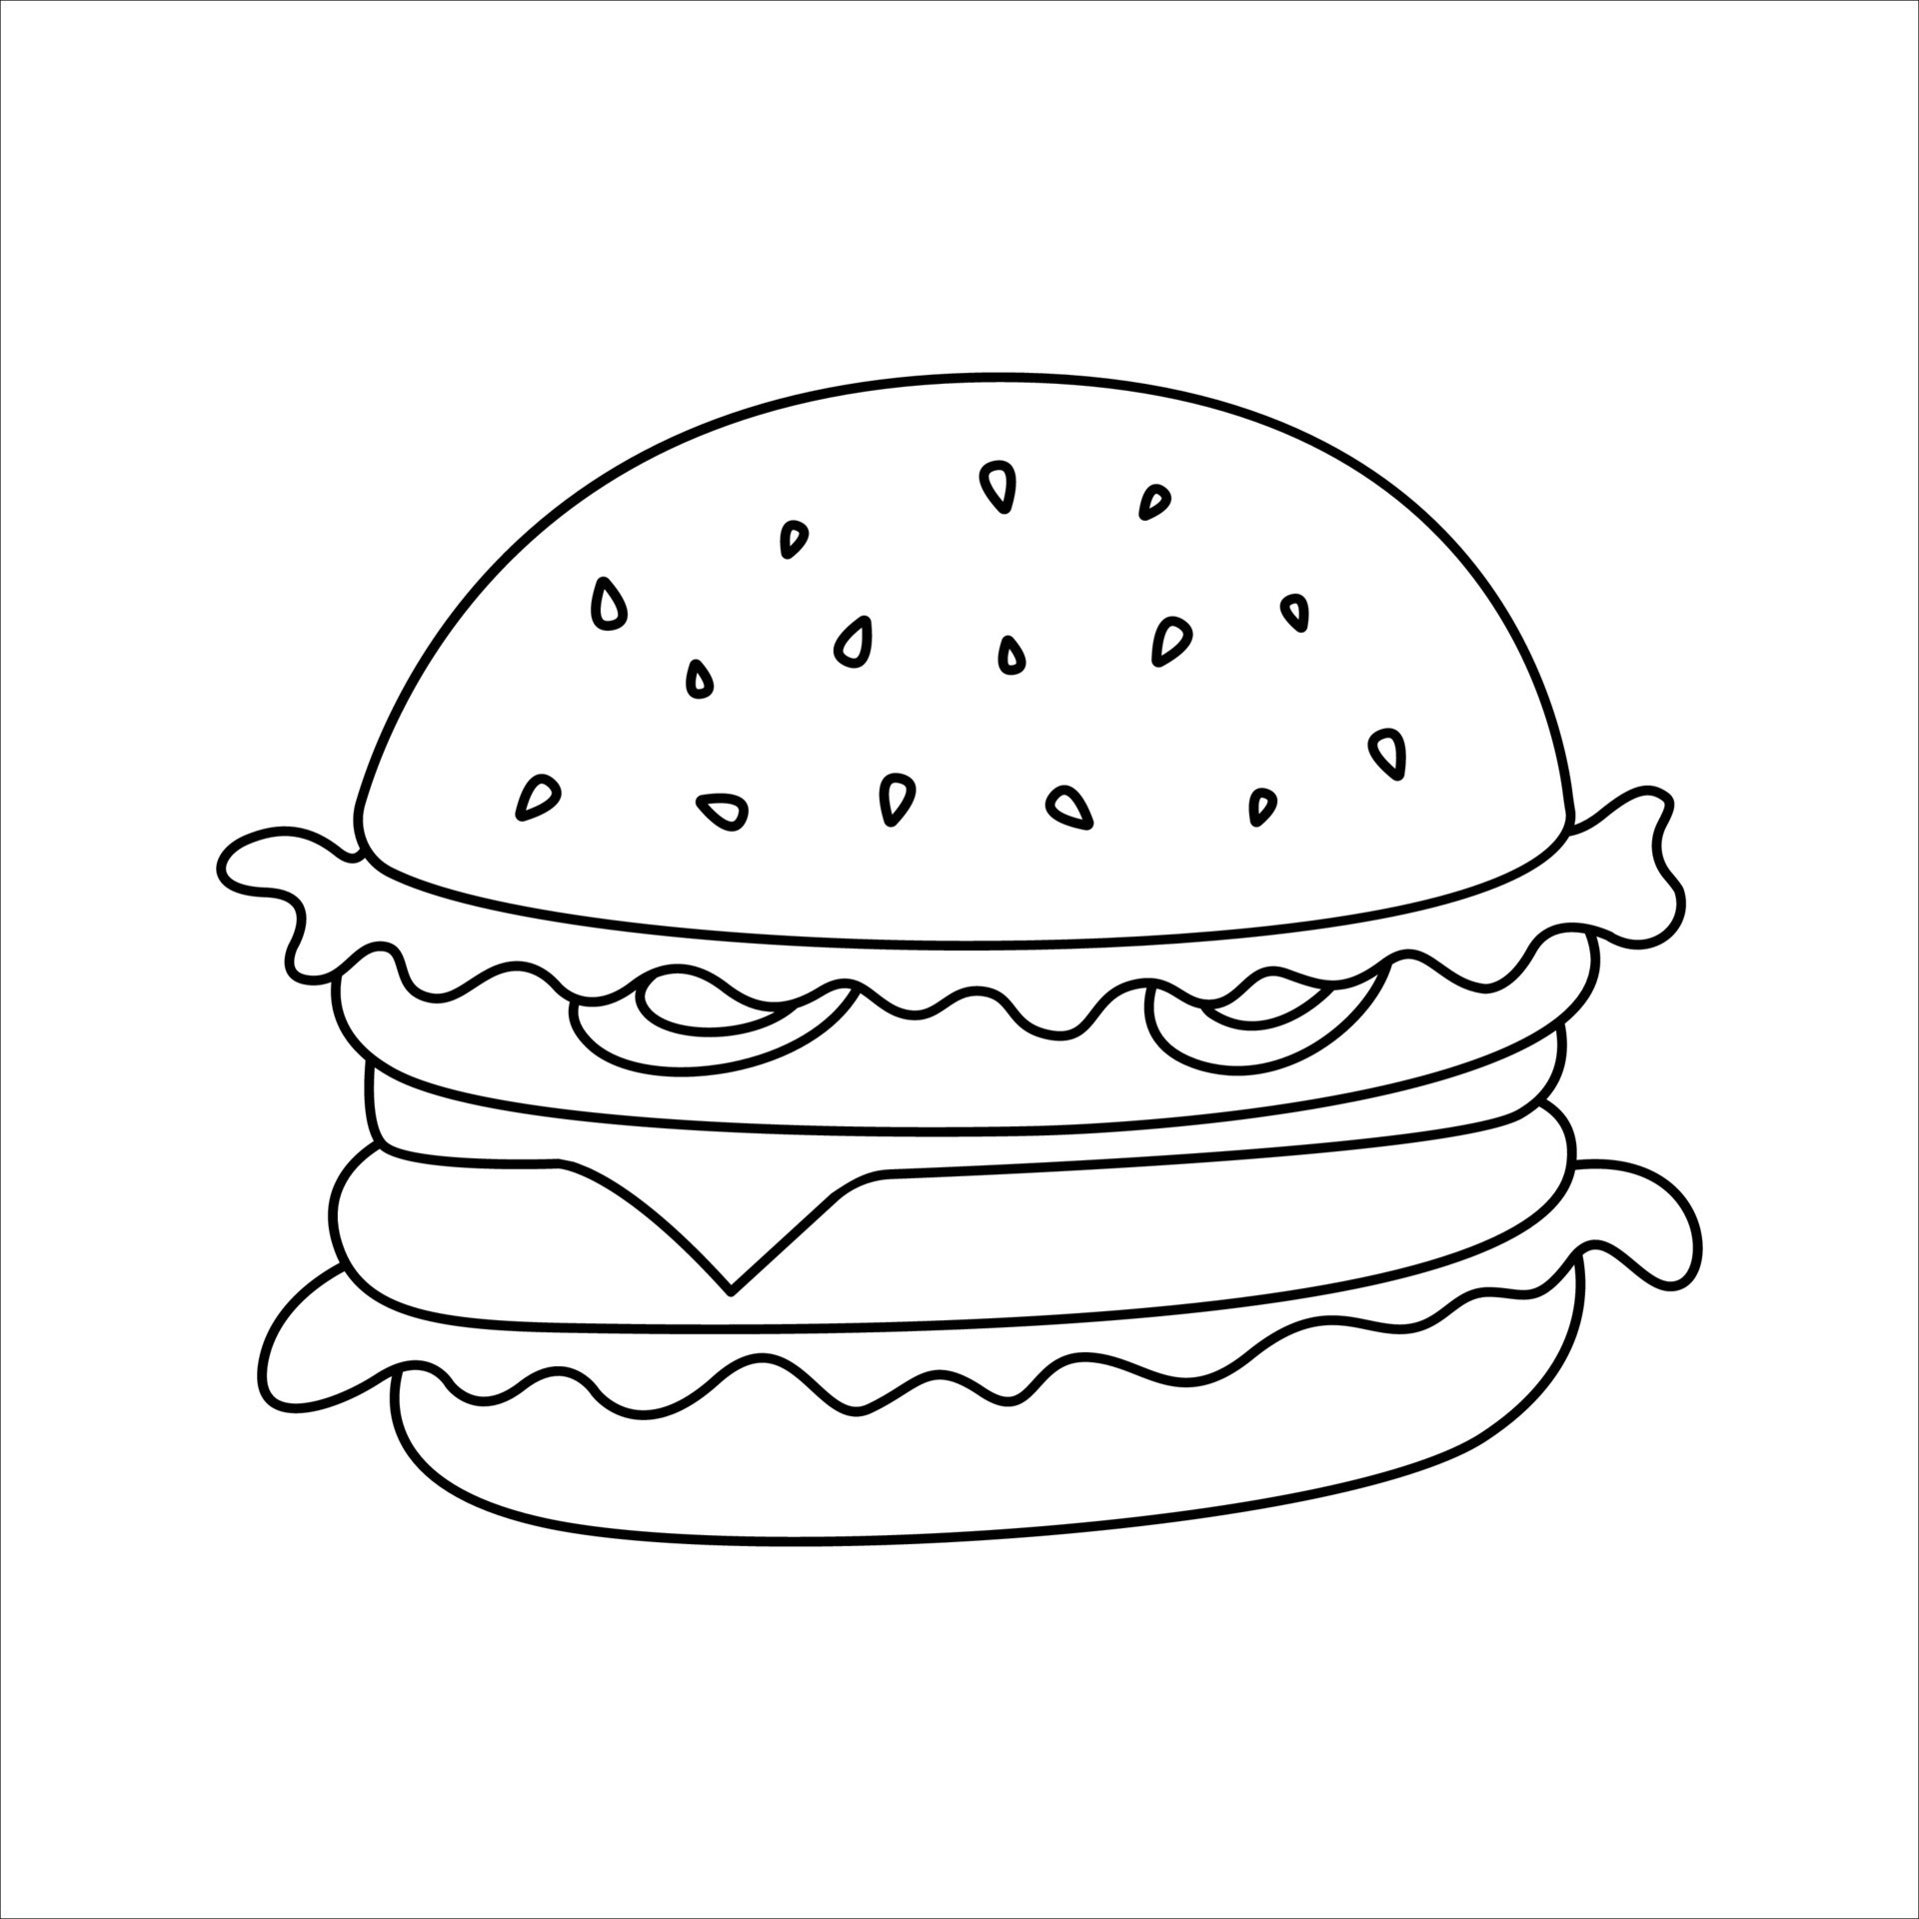 | 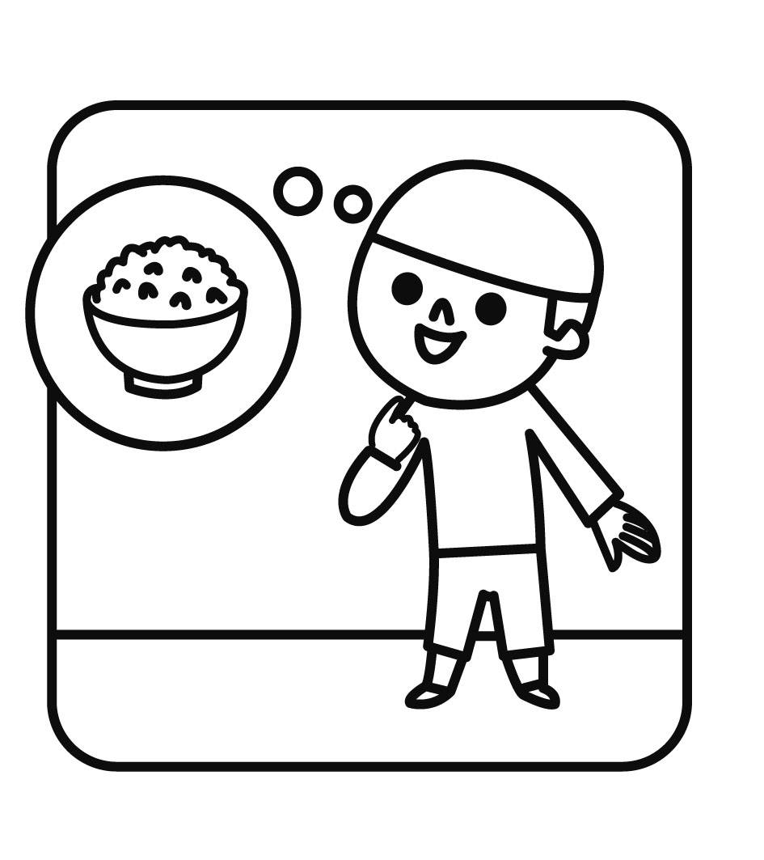 | 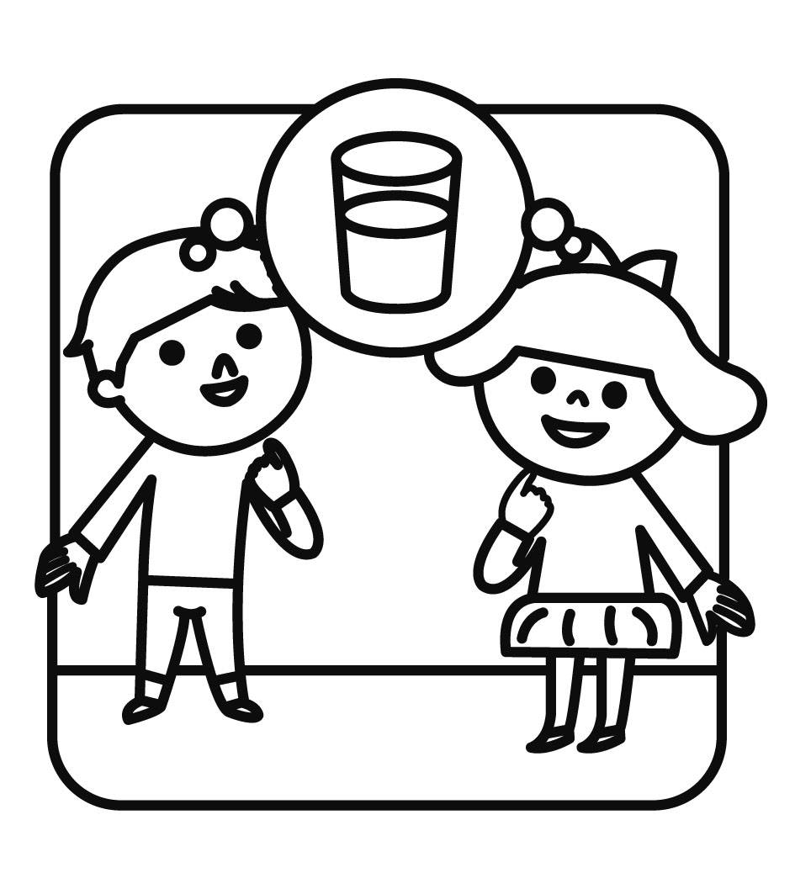 | 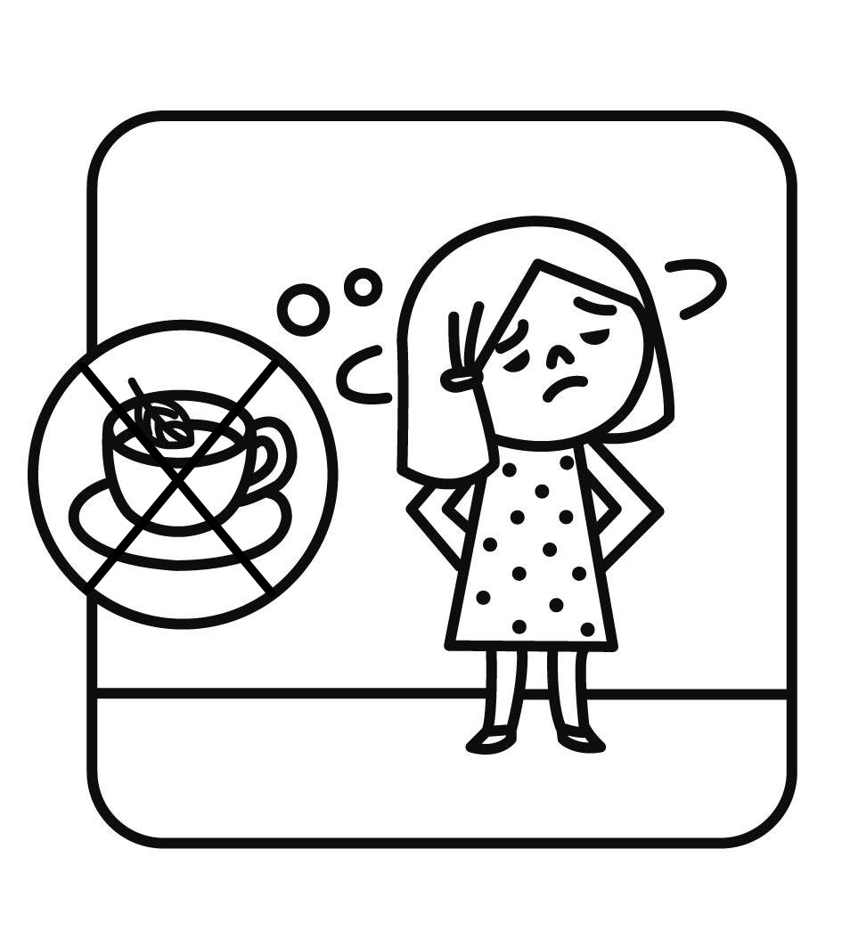
數量 | _______ | ________ | _______ | O X | O X | O X
- Listen, Number and Write (16%)（填入聽到的順序並完成單字）
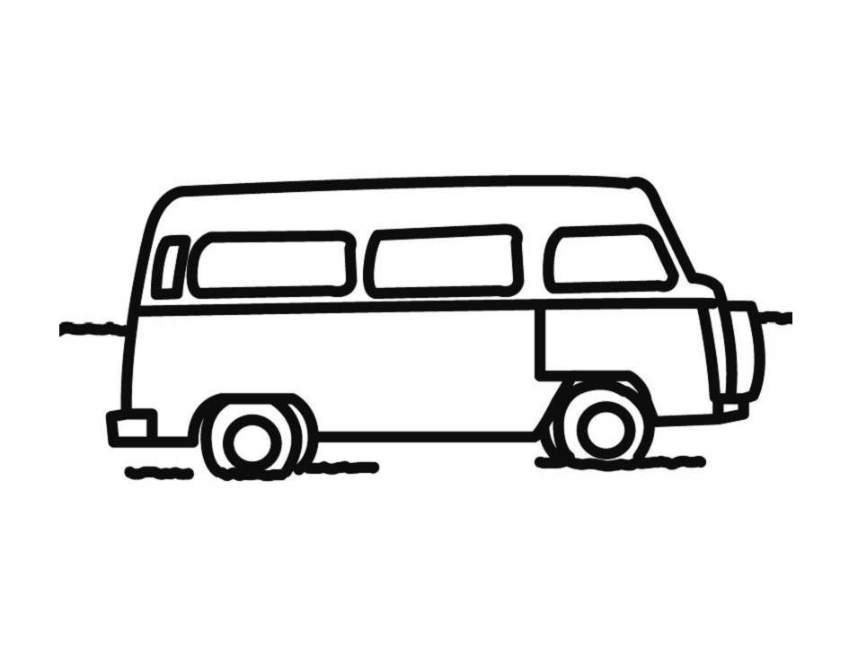 |  | 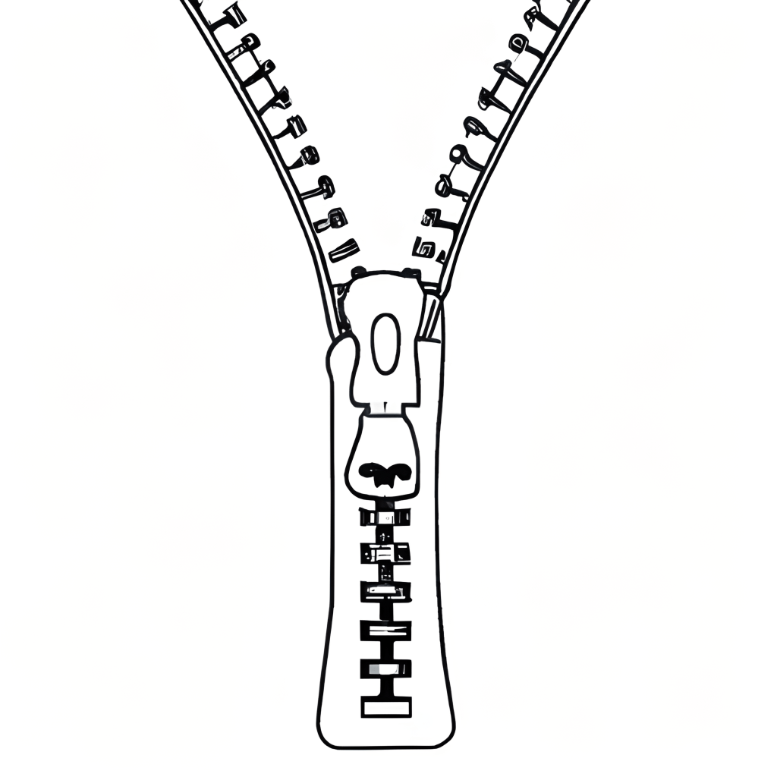 | 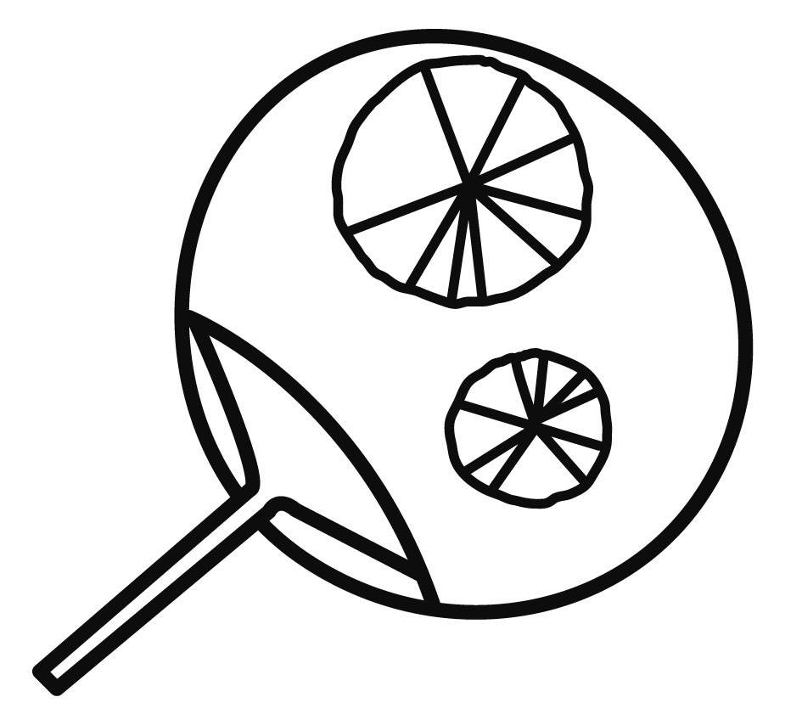 | 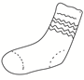
( ) | ( ) | ( ) | ( ) | ( )
_us | _at | _ip | _an | _ _ck
- Read and Match (12%)（依圖示填代號完成對話）
- They’re oranges. (2) I want some cake. (3) Come on.
(4) What are these? (5) Here you are. (6) Me, too.

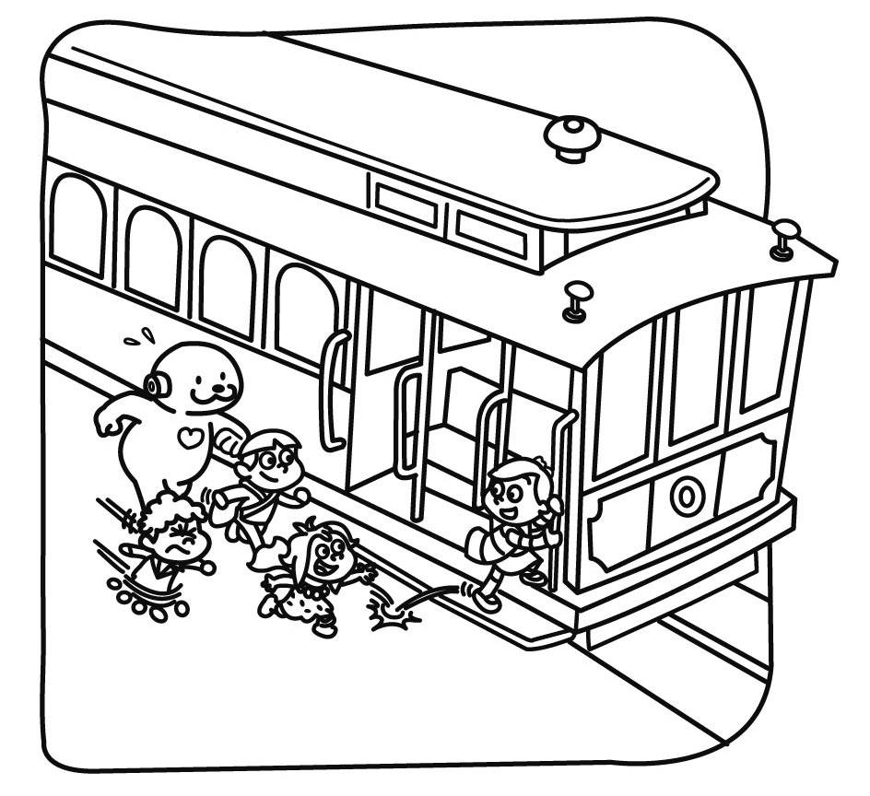 | _______ | 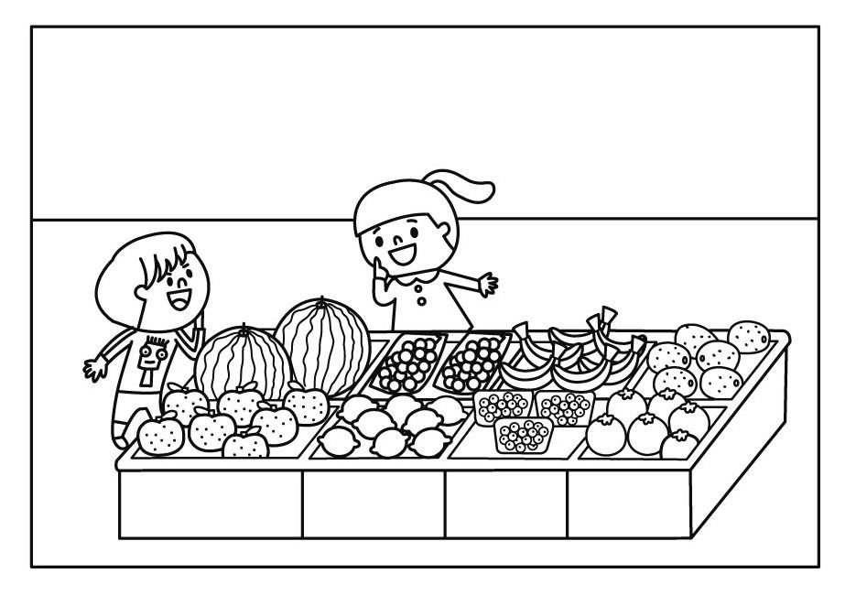 | A: ______  B: ______
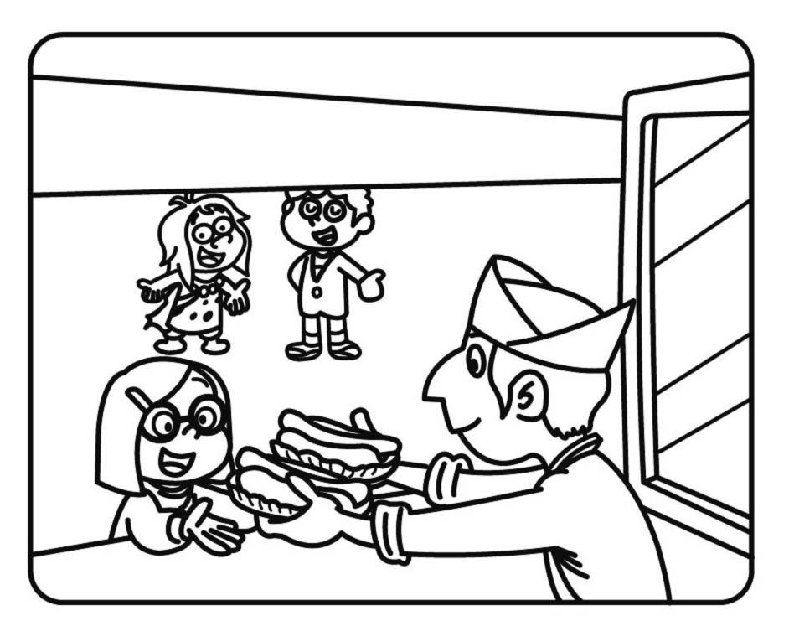 | _______ | 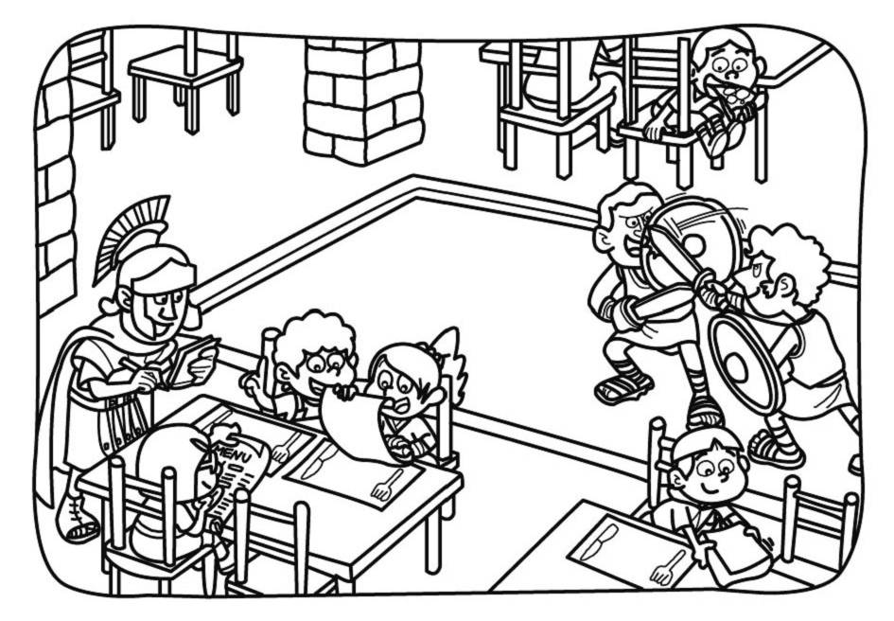 | A: ______  B: ______

- Write the Sentences (23%)（依圖完成句子，請注意單複數、不可數名詞、標點符號）
參考單字：these those don’t do
1.What are _________ __  They’re ___________ __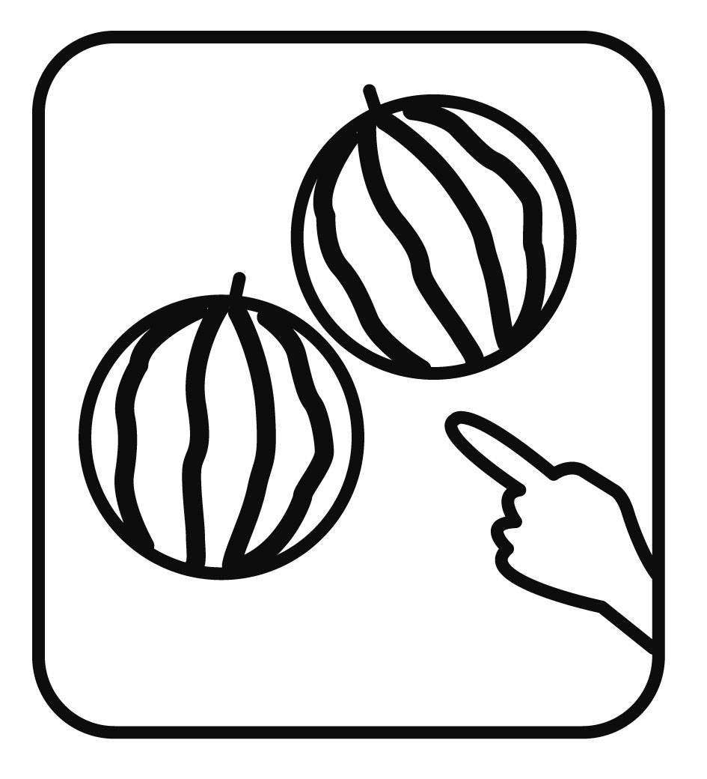 | 2. What are ________ __  They’re ____________ __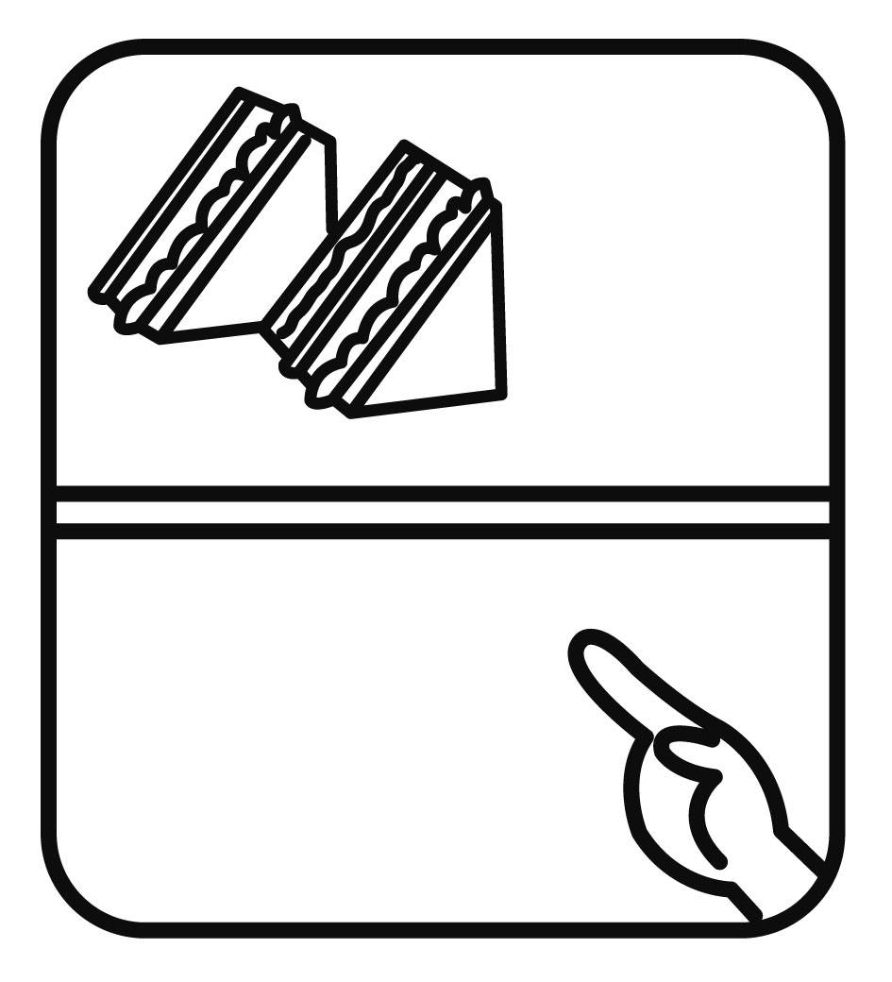
3.Do you want some ______?  Yes, I ____. | 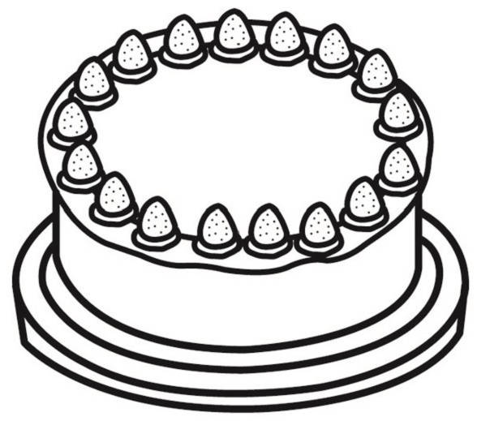  4.Do you want some ______ __  No, we _____.  We want some ________.
- Food/Drinks Guessing (9%)（依提示寫出答案）
1.It’s fast food in Italy,there are three colors in it: red, white and green.
It’s _________.
2.They’re yellow or green. Monkeys love the fruit. They ‘re _____________.
3.A fruit a day, keeps the doctor away. It’s an _________.

