花蓮縣花蓮市明義國民小學113學年度第一學期六年級英語科期中定期評量試卷
Class（班級）：____ 年 班 Name（中,英文姓名）：__________________Seat Number（座號）：_____
A .Listen,circle and write. 仔細聽，圈出正確的圖片並寫出單字。（27%）
分  數 | 100  分 | 90  分 | 80  分 | 70  分 | 60分 | 60  以下 | 家長簽名  Signature
人
數
1. She’s from . | 2. I’m from . | 3.They’re from .    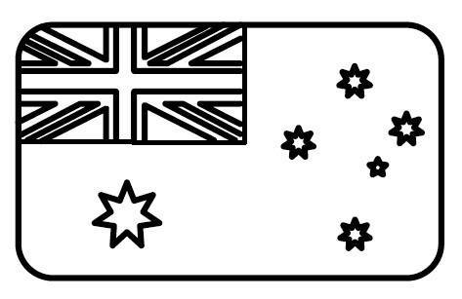  
4. Abu is from .   | 5.Kim and Ian go home .  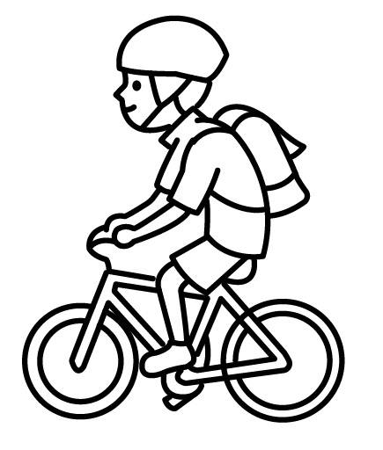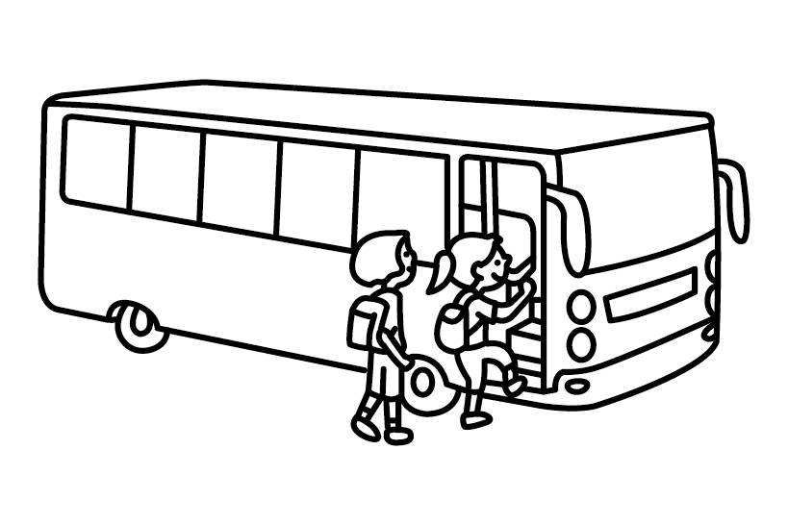 | 6. I go to school .  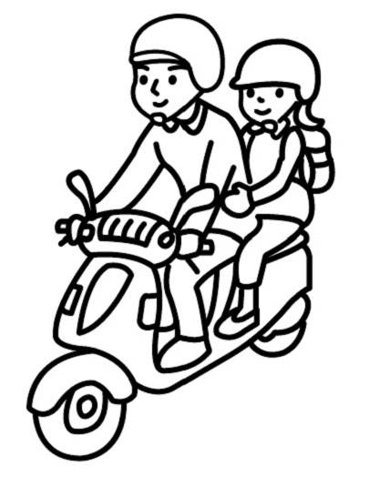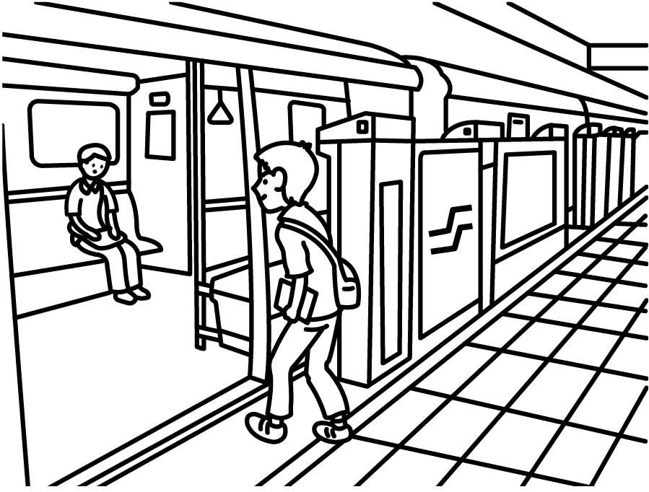
7.We go to the park .  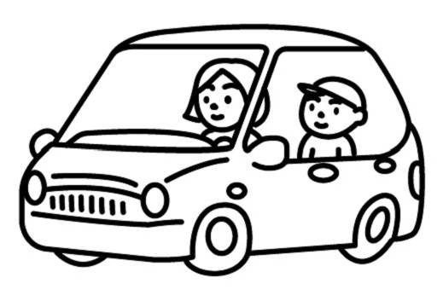 | 8. They go to Taipei .  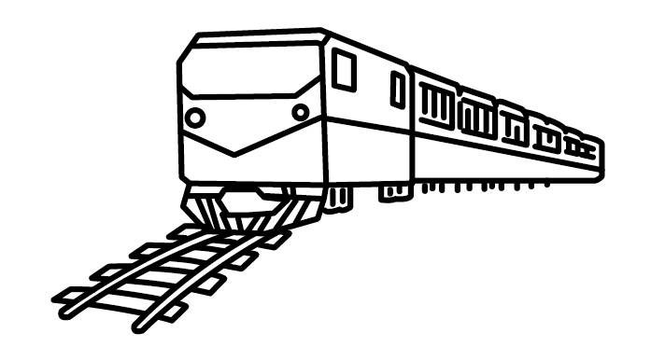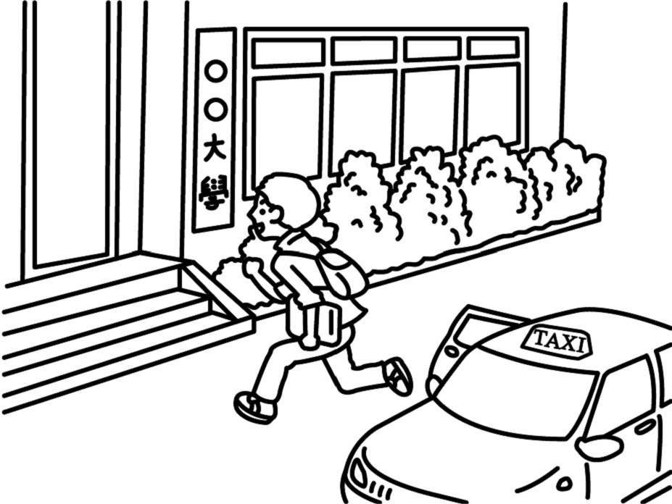 | 9. Happy !  ( Honeymoon / Halloween )
B. Listen , Circle and Write. 仔細聽，圈出並寫出正確的字母發音。（16%）
1. tail  or / ir | 2. b n  or / ur | 3. f m  ar / or | 4. riv  ar / er
5. f k  ar / or | 6. sh t  ir / or | 7. act  ir / or | 8. b k  ar / or
C. Listen and choose. 仔細聽，並選出正確的答案。（4%）
1.( ) (A) She’s from Singapore.  (B) I’m from the USA.  (C) They’re from Spain. | 2.( ) (A) Yes , I do.  (B) I go to school by taxi.  (C) No, I don’t. I go to school by car.
D. Listen and number. 仔細聽，並寫出正確的號碼。（8%）
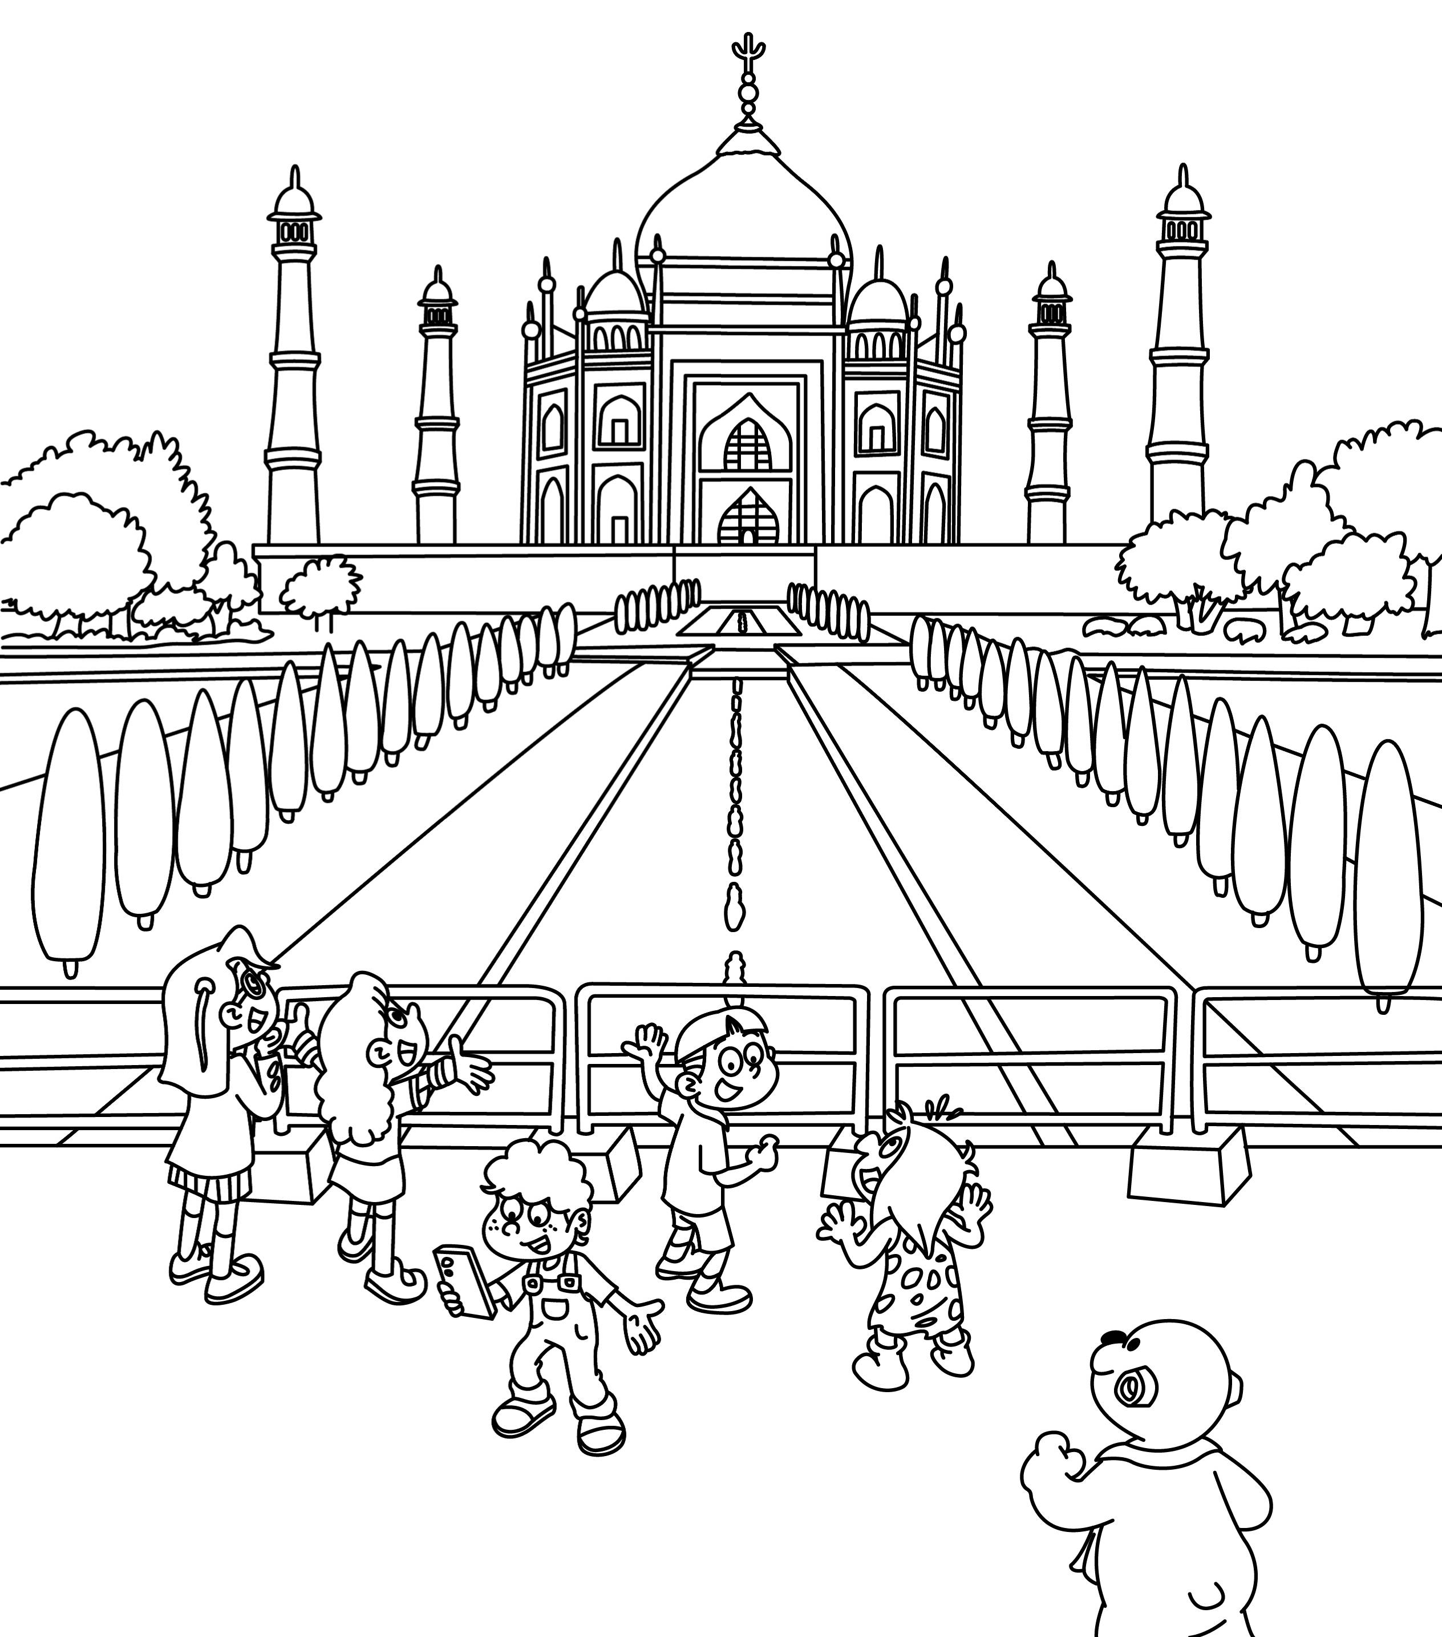 | 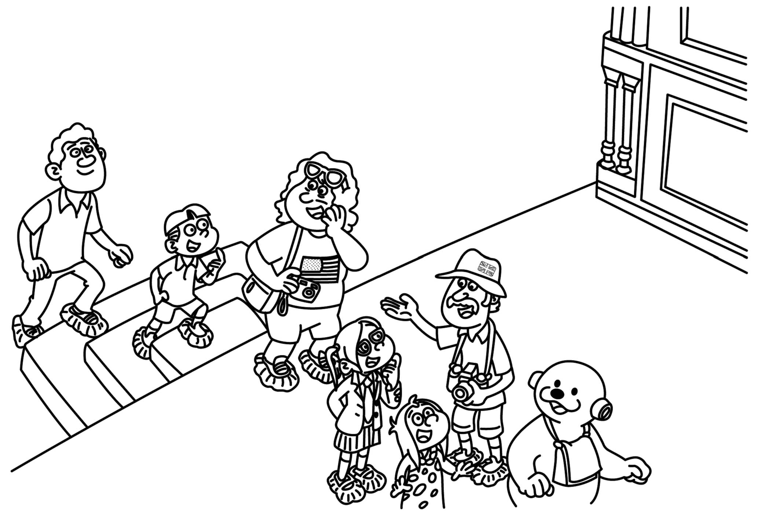 | 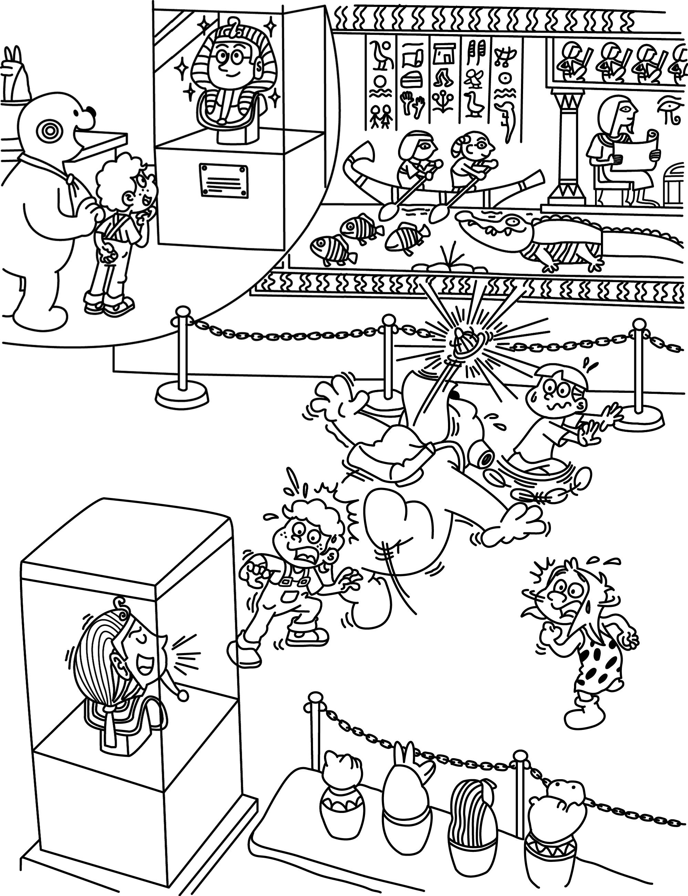 | 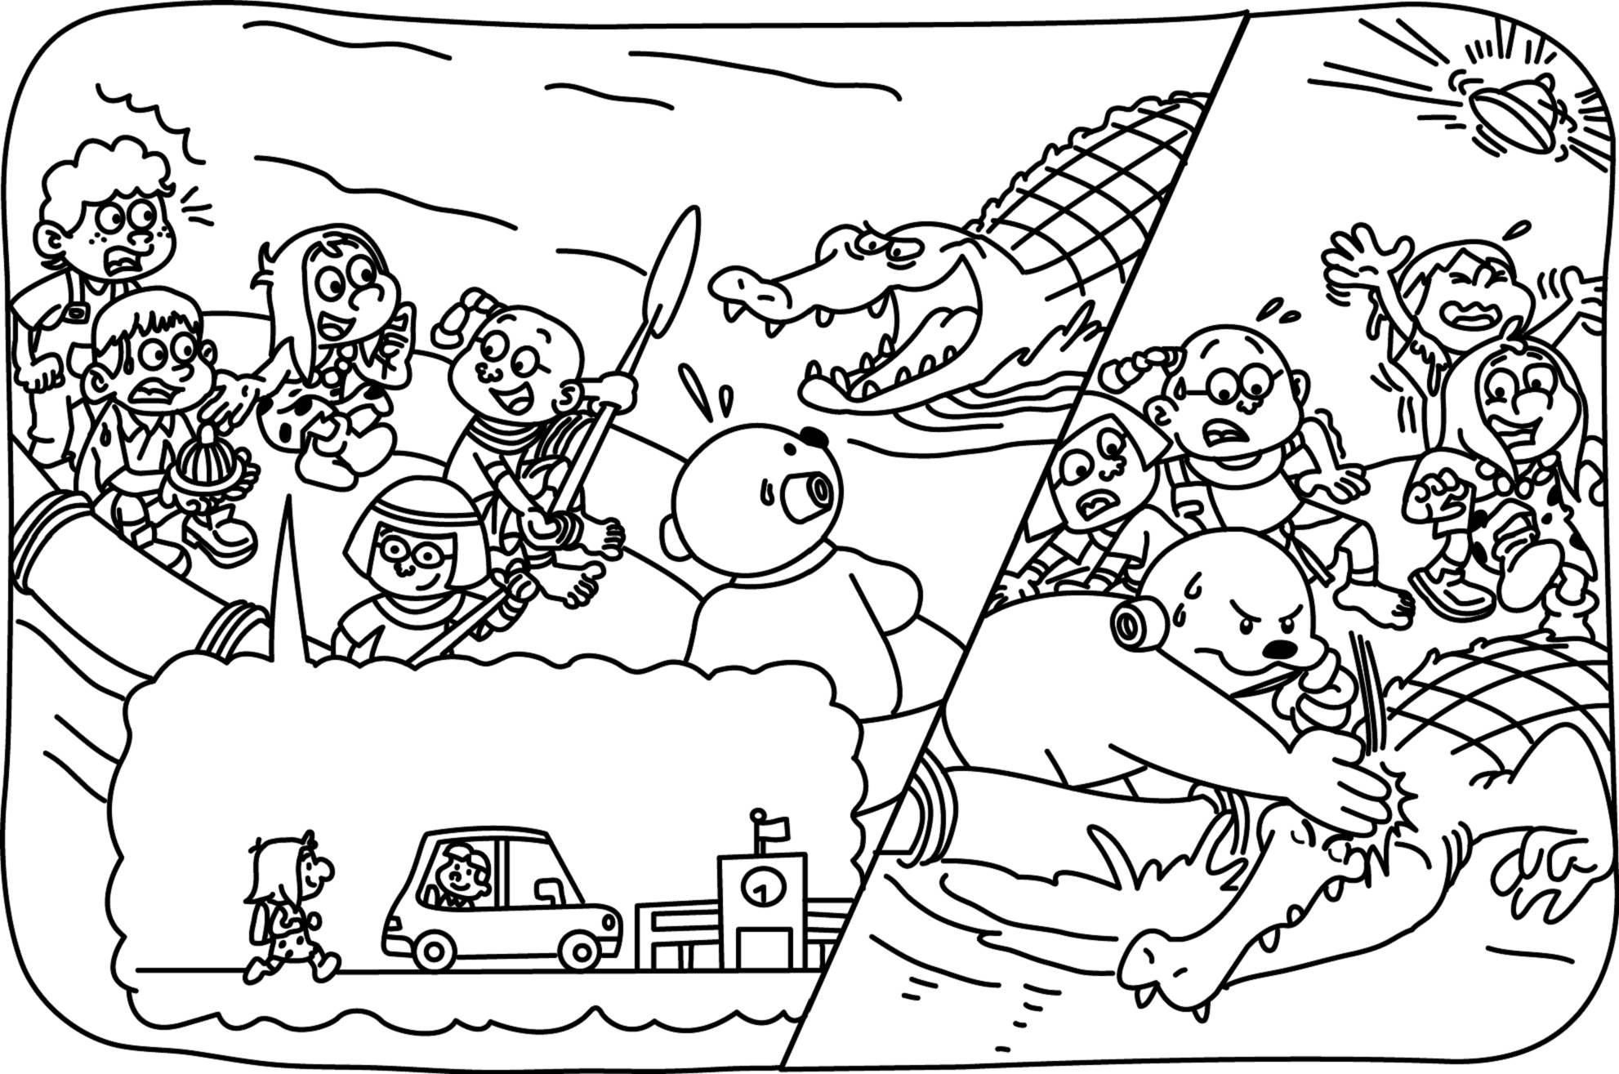
【 】 | 【 】 | 【 】 | 【 】
※※※※※ 請翻到背面繼續做答（Please turn to the next page. ） P.1 ※※※※※
E. Look and Write.看圖，填寫正確的單字 (12%)
Word Bank ( 提示字,不會全用到): I’m I Is is are Are Does Do does do
goes go We We’re Spain Taiwan scooter bike taxi car
 | 1.Where you from ?  from . | 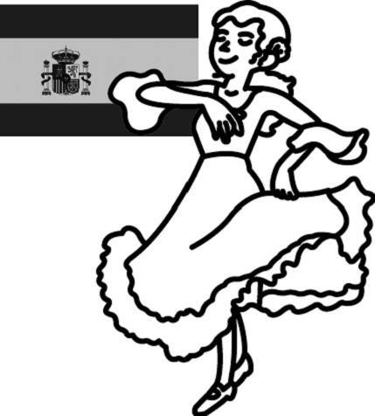 | 2. she from ?  Yes, she .
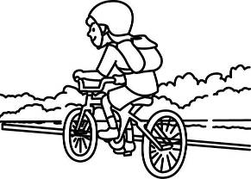 | 3.How you go to school ?  I to school by . | 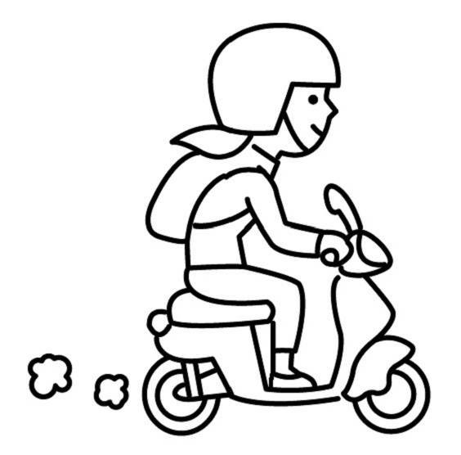 | 4. Eva go home by car ?  No, she doesn’t. She home  by .
F. Find the Right Answer. 請仔細閱讀，並選出適當的代號。(6%)
( )1. A:Where are you from? B: I’m from _______.  (A) Chinese (B) the usa (C) France | ( )2. A: Amy from Canada ? B: Yes, she .  (A) Does, does (B) Are, are (C) Is , is
( )3. A: How Tom go to school ?  B: He to school by motorcycle.  (A) is , goes (B) do , go (C) does, goes | ( )4. A:Where you come from ?  B: I from South Korea.  (A) are , am (B) do , come (C) is , come
( )5. Mia and Eric to the zoo by MRT.  (A) goes (B) go (C) going | ( )6. My friend home by van.  (A) goes (B) go (C) going
G. Unscramble the Sentences. 重組句子。（13%）
is / ? / from / your / Where / brother
by / Does / Lily / ? / go / boat / home
H. Read and Choose.讀一讀並選出正確的代號。（8%）
 |  Tony |  Nina |  Jane |  Alex
Country |  |  | 
go to school | by car | by taxi | by motorcycle | by boat

1. ( A ) Where is Jane from? (A) She’s from Canada. (B) She’s from Spain . (C) She’s from Singapore.
2. ( A ) Does Nina go to school by car ? (A) Yes, she does. (B) No, she doesn’t. She goes to school by metro. (C) No, she doesn’t. She goes to school by taxi.
3. ( C ) Is Alex from Singapore? (A) No, he isn’t. (B) Yes, he is. (C) No. He’s from Spain.
4. ( C ) Does Tony go to school by boat ? (A) No, he doesn’t. He goes to school by car. (B) Yes, he does. (C) No, he doesn’t. He goes to school by motorcycle.

I.Look ,Draw and Write.看圖或畫圖並回答完整的句子。（6%）

1. Where is Max from ? 2. How do you go to school ?

J.Bonus.加分題。（2%）中翻英
1. 我姊姊搭飛機去泰國。
2. 泰姬瑪哈陵
※※※※※※ Don’t forget to check your answer again！ 做答完要再檢查喔 ! P.2 ※※※※※※

