花蓮縣花蓮市明義國民小學113學年度第一學期六年級英語科期末評量試卷
Class（班級） Name（中英文名字） Number（座號）___
分數 | 100分 | 90分 | 80分 | 70分 | 60分 | 60分 | 家長簽名
人數
- Listen and Check
仔細聽勾選適當答案，24分
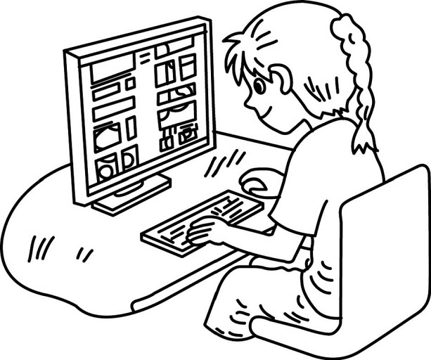  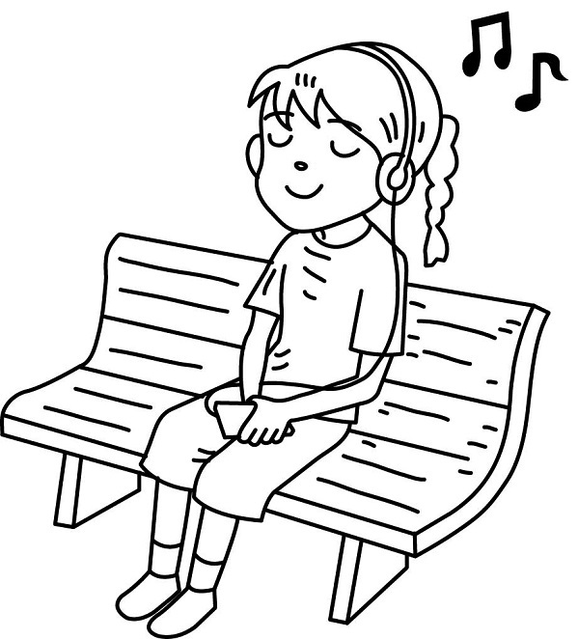  1.  □ □ | 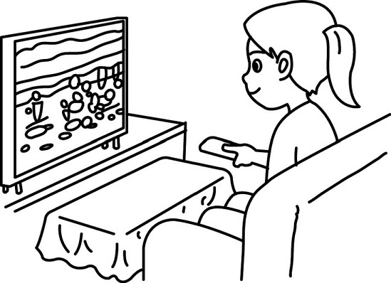  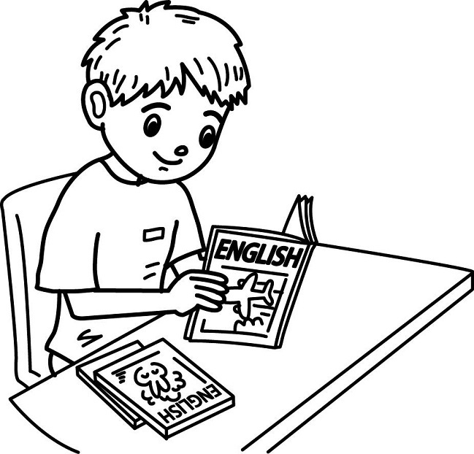  2. | 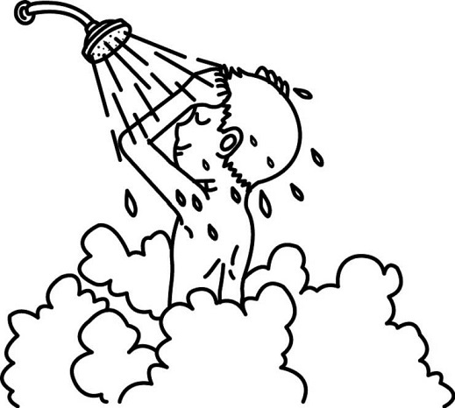  3.  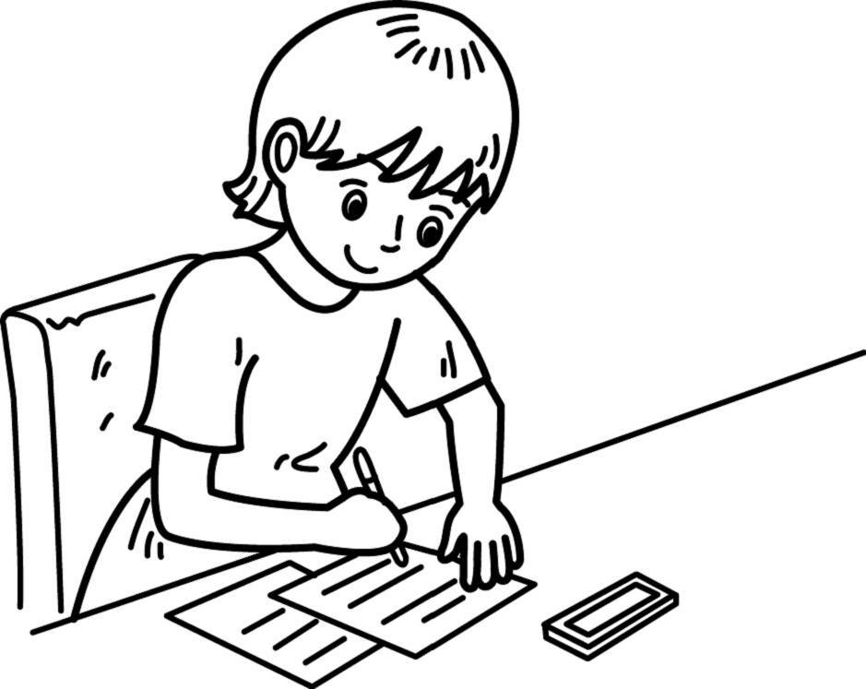 | 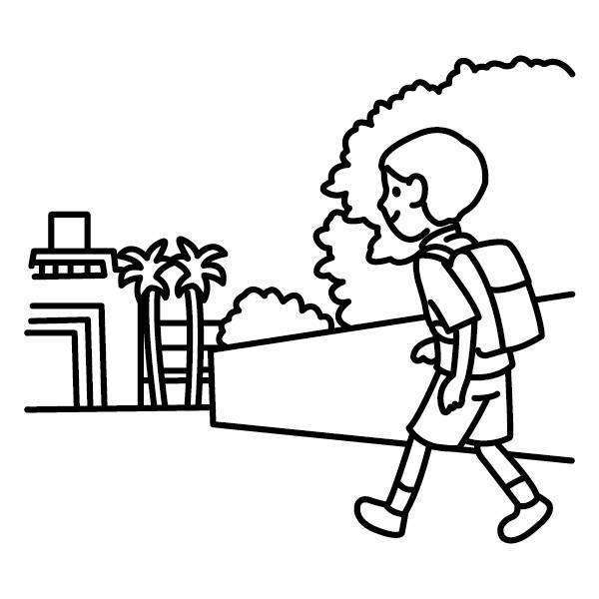  4.
  □ | □
  □ | 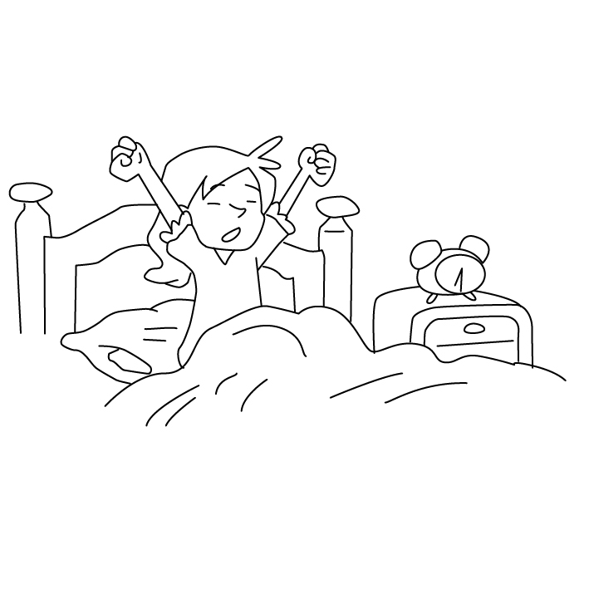  □
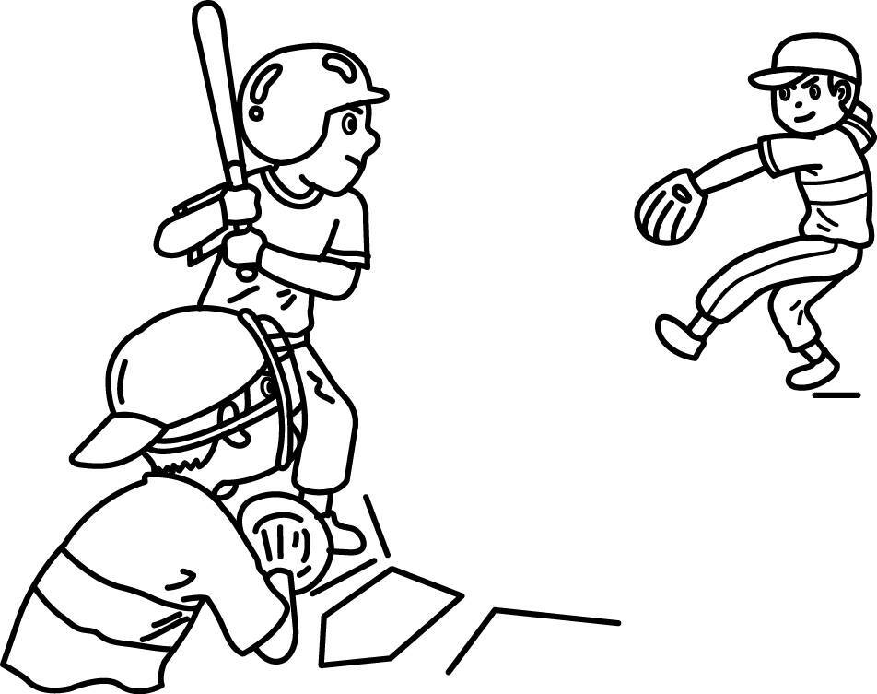  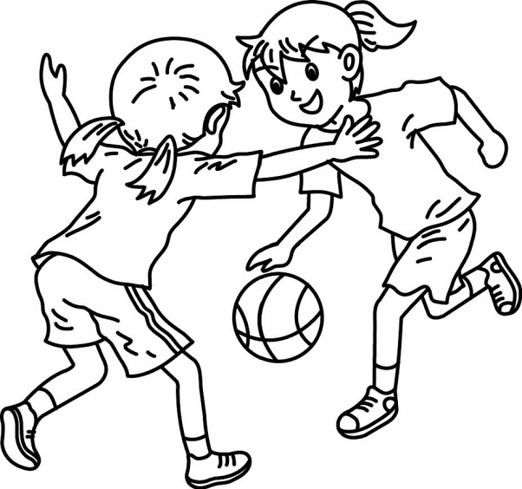  5. | 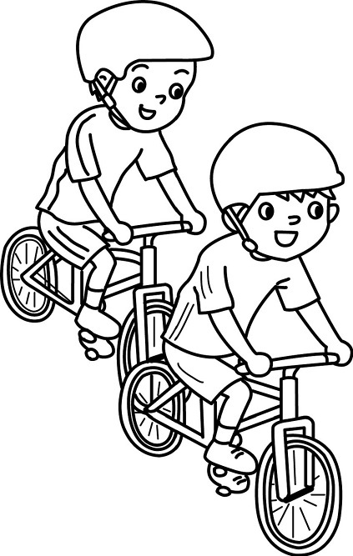  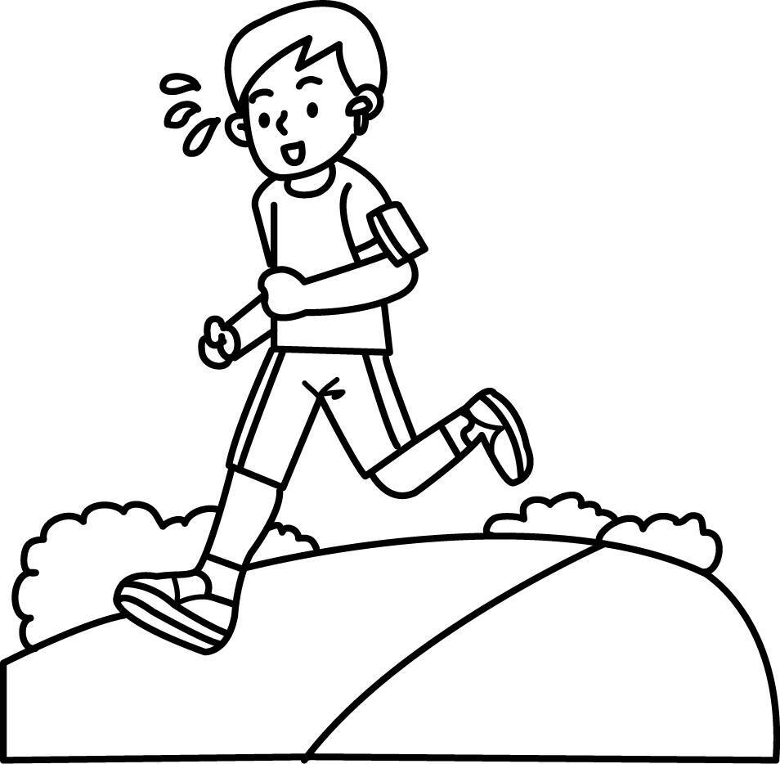  6.  □ □ | 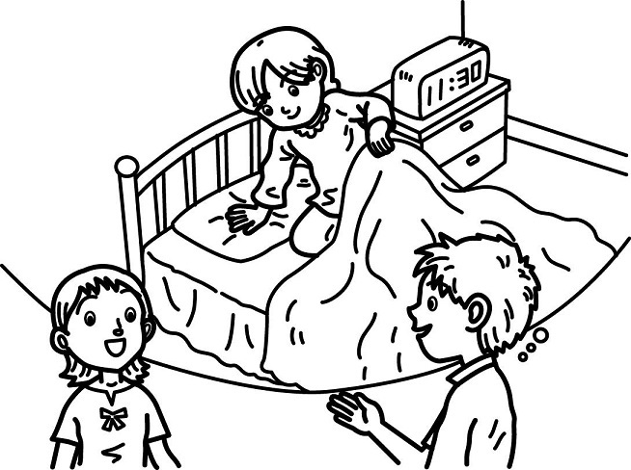  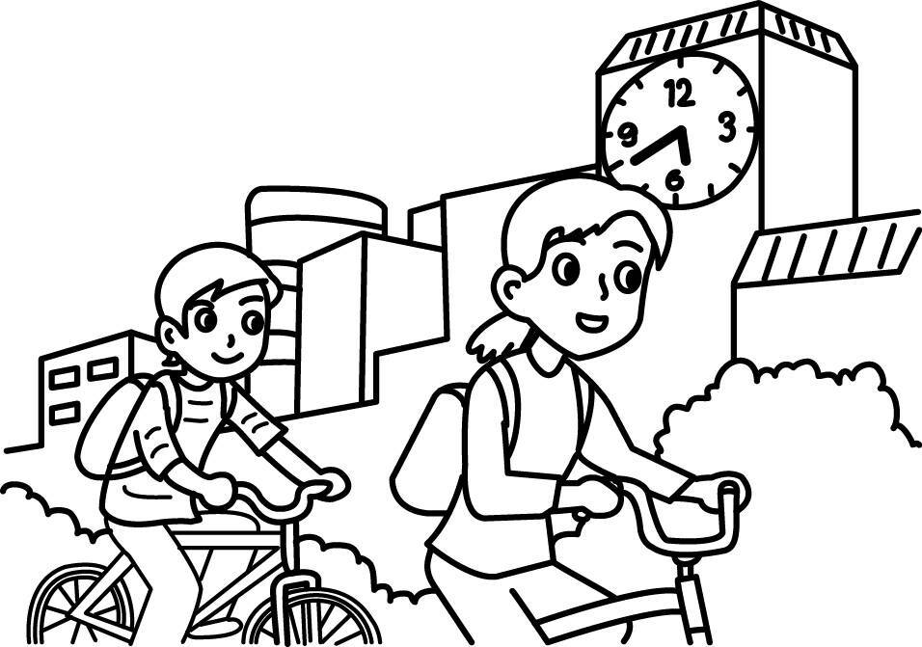  7.  □ □ | 8.  □ □
  □ | □
B. Listen ,Number and Write 仔細聽，並填上數字和英文單字，每題2分，共16分。
I  at seven. ( ) | He at 7:30. ( ) | 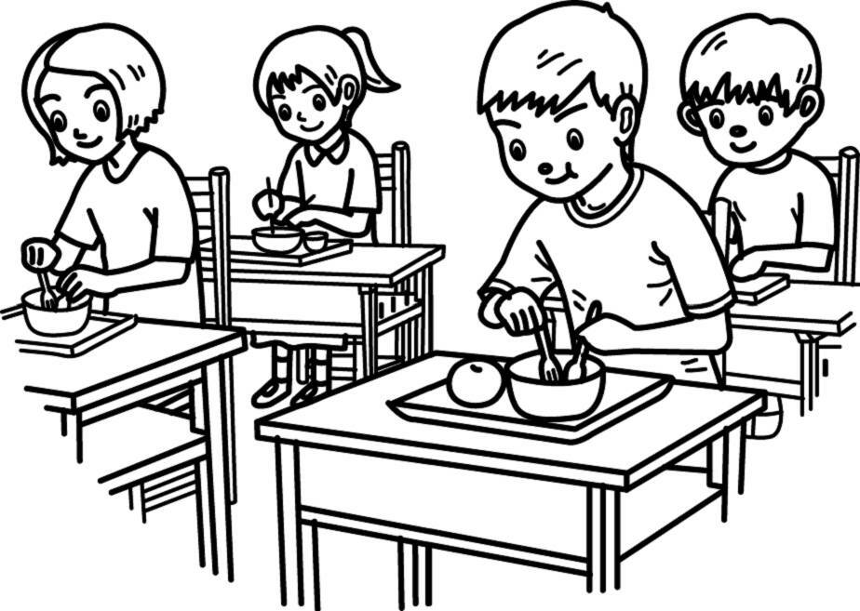  Eden at twelve. ( ) | He at 5:30. ( )
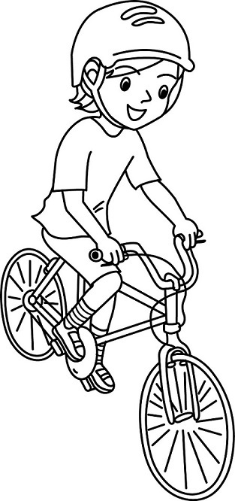  He on Sunday. ( ) | She  after school. ( ) | 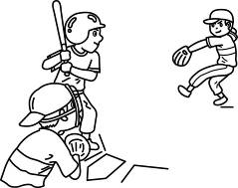  They  together. ( ) | Eason  everyday. ( )
C. Listen and Circle仔細聽，圈選正確的單字，每題1分， 共8分。
1 | oil owl | 2 | clown clone | 3 | crowd cloud | 4 | horse house
5 | point paint | 6 | ink oink | 7 | order oyster | 8 | join June
※※※※ P.1 請翻到背面繼續做答（Please turn to the next page. ） ※※※※※
D. Listen and Number仔細聽，用數字填寫適當的順序，每題2分，共10分。
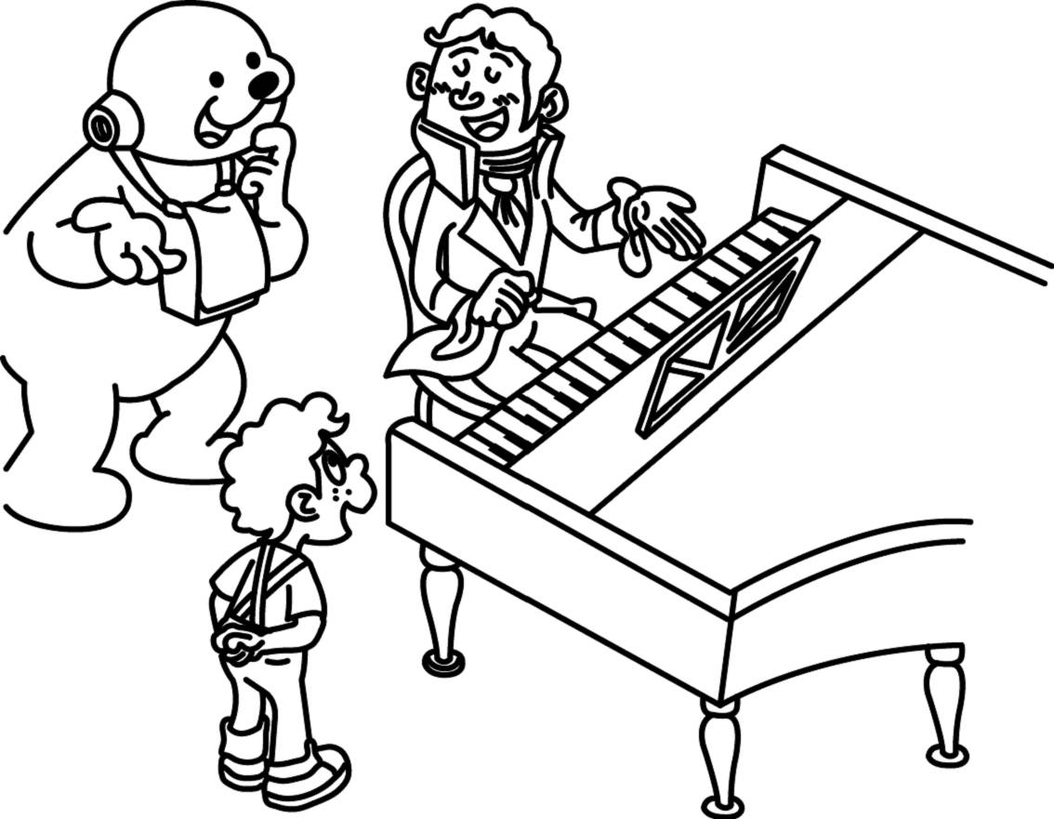 | 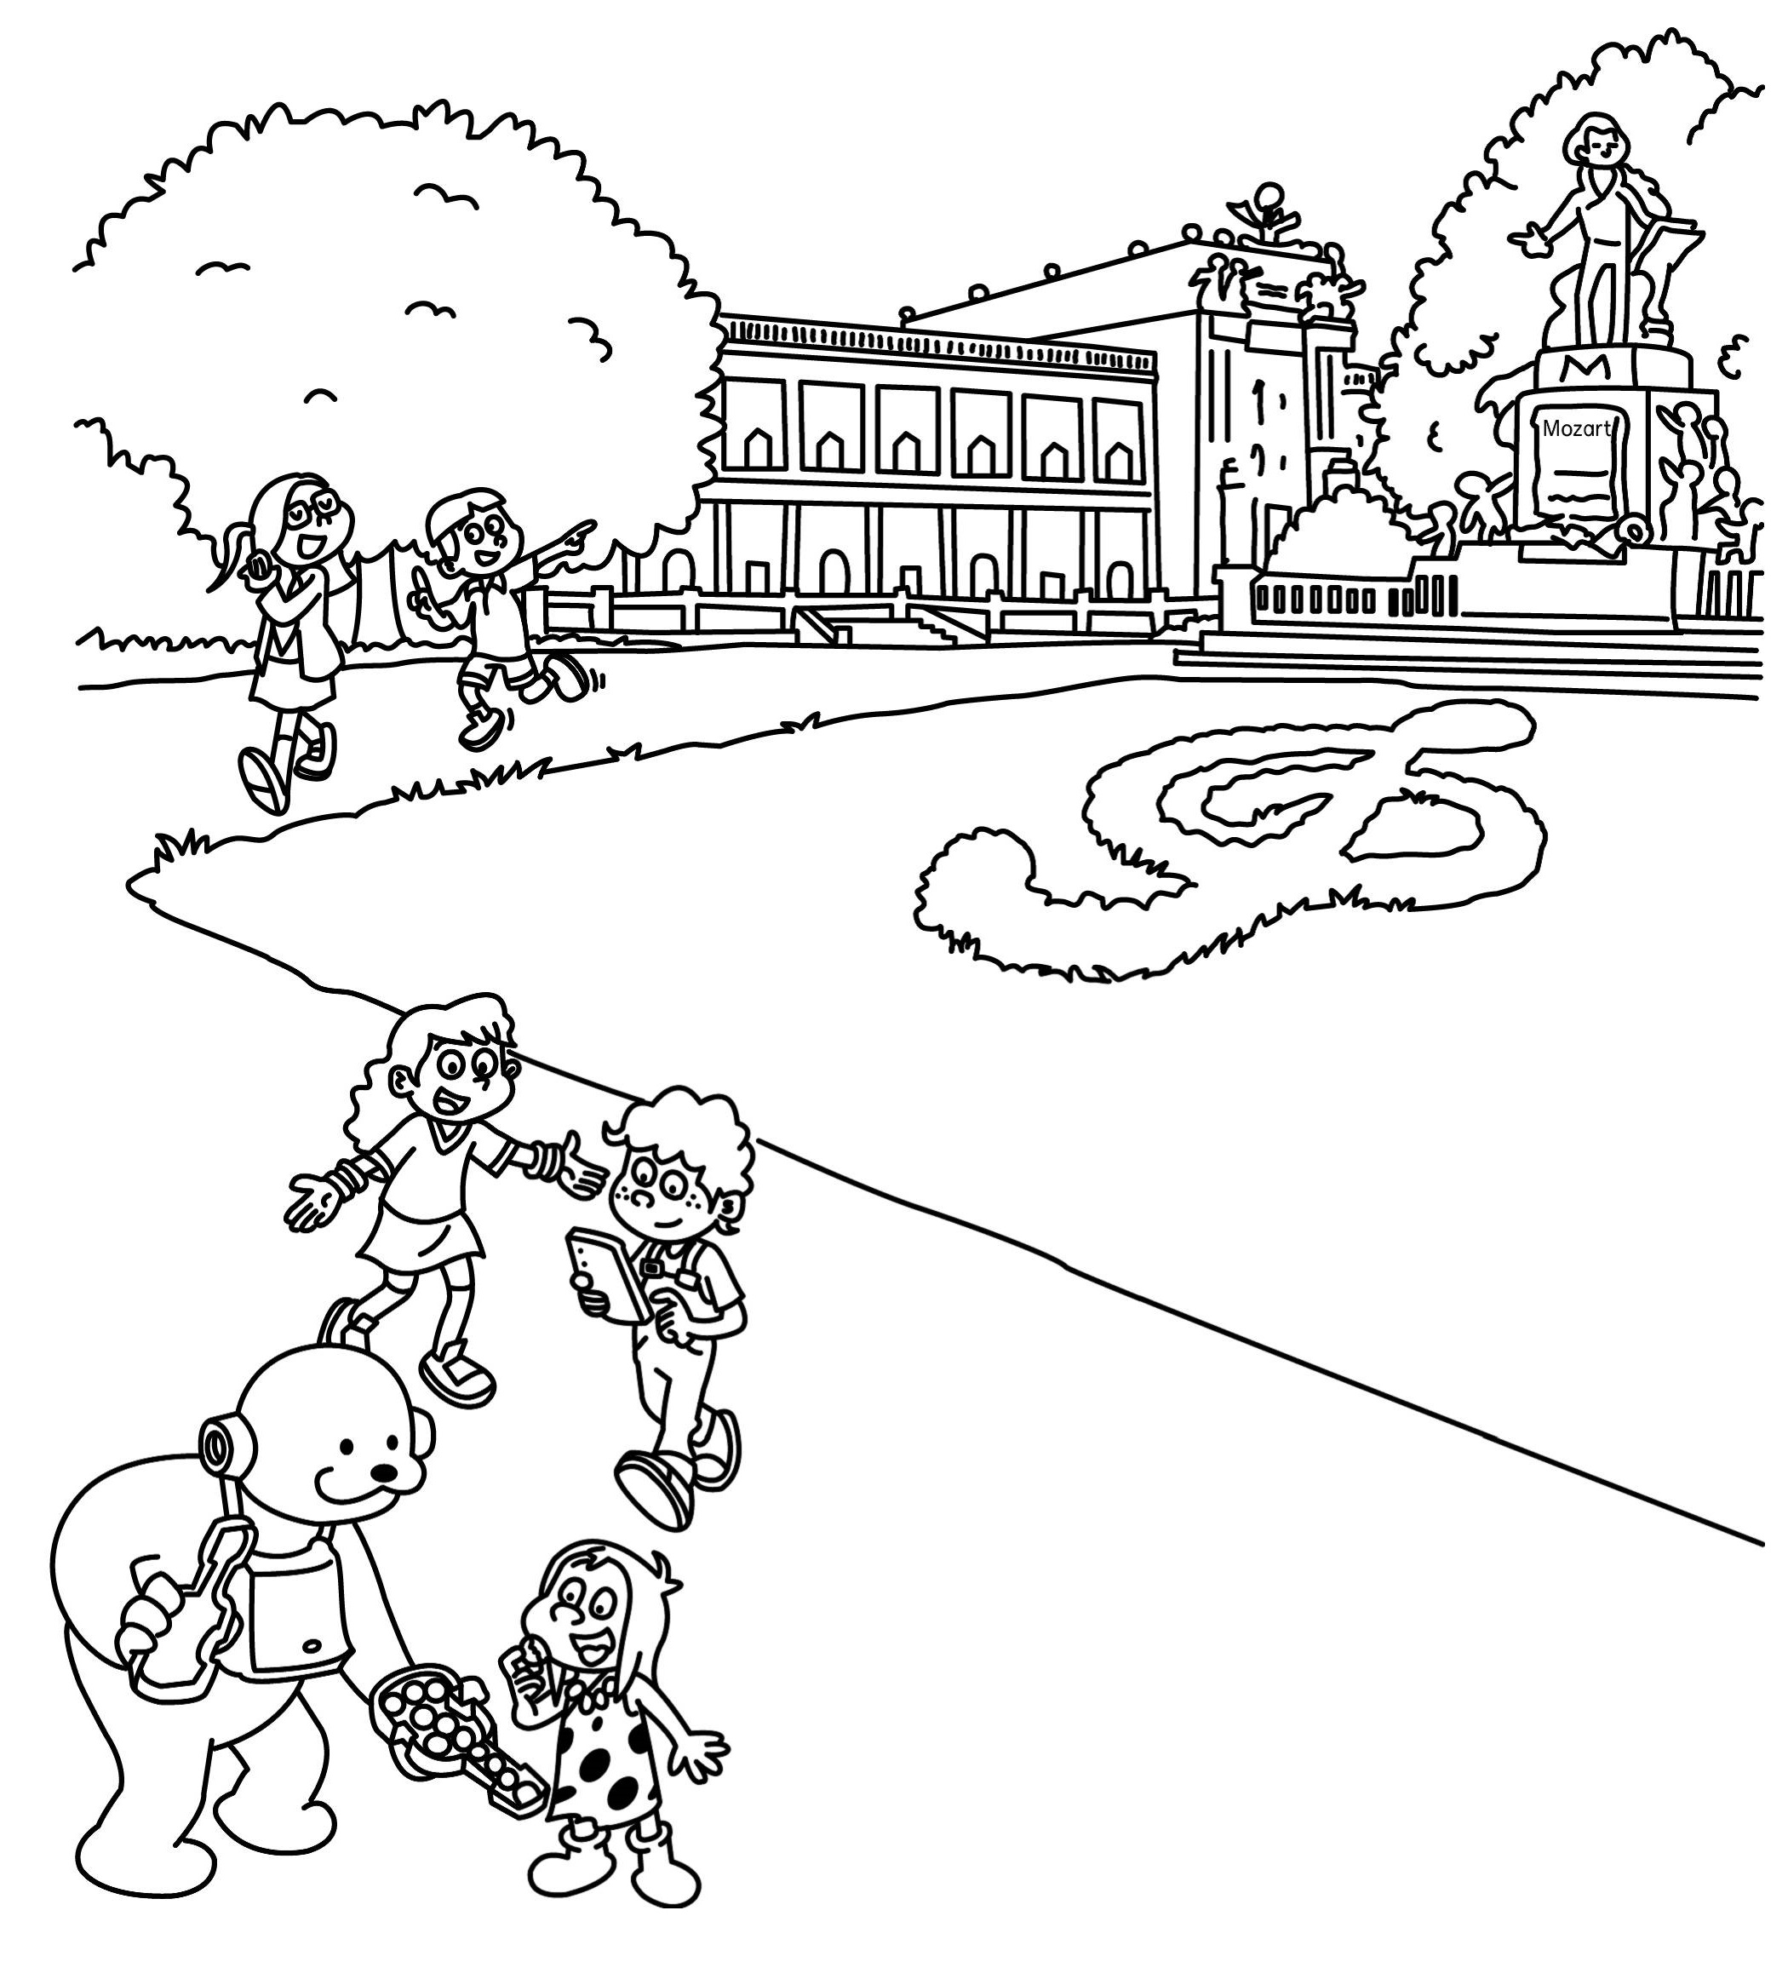 | 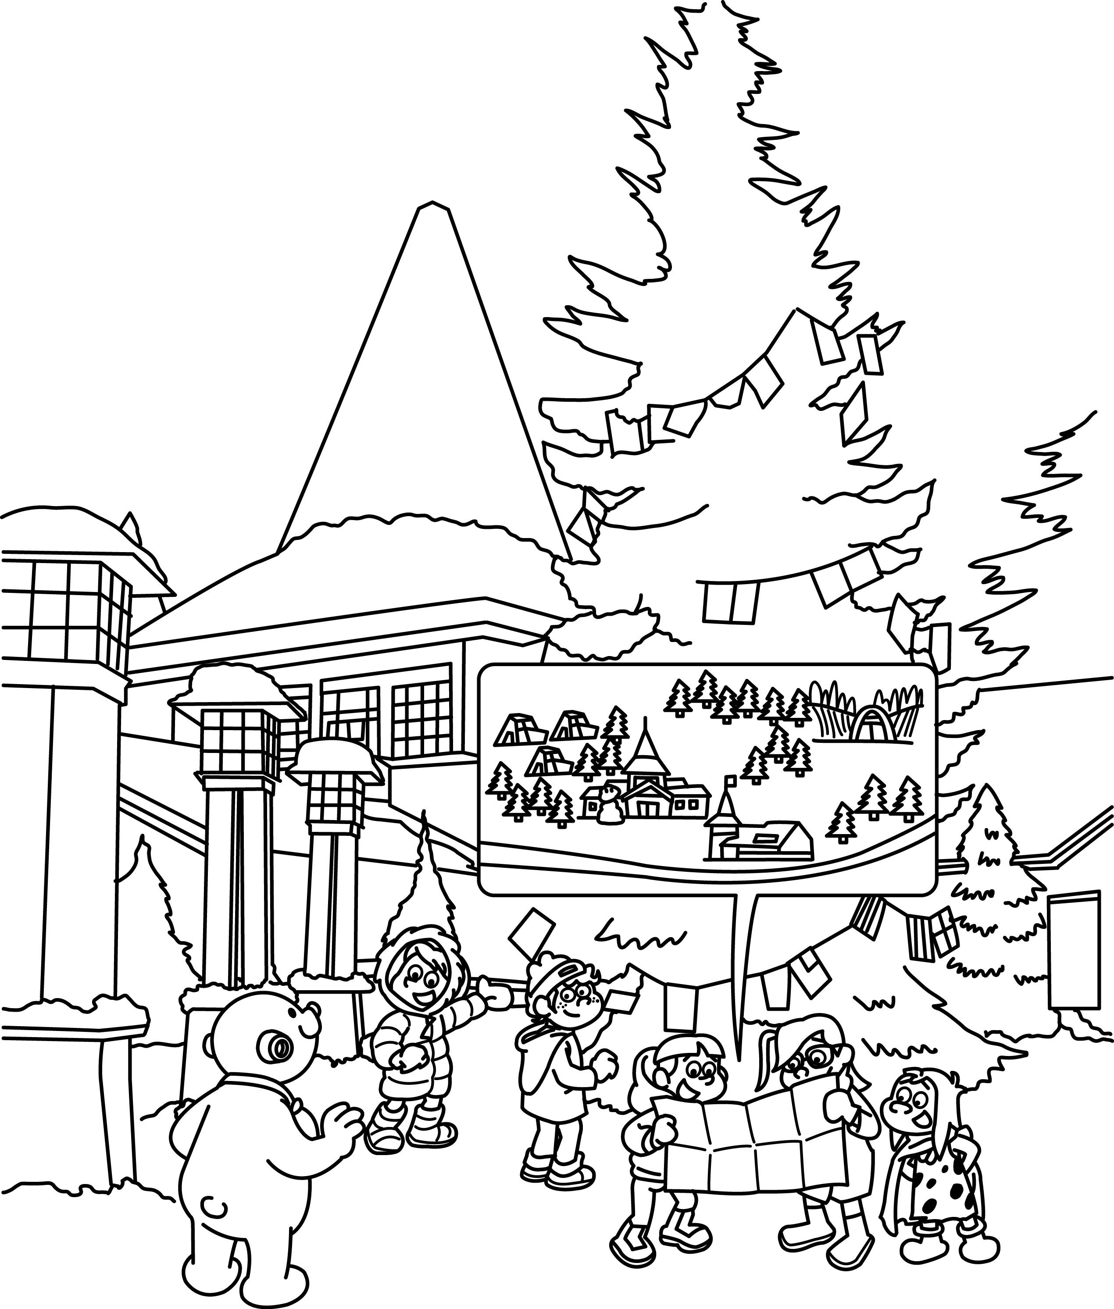 | 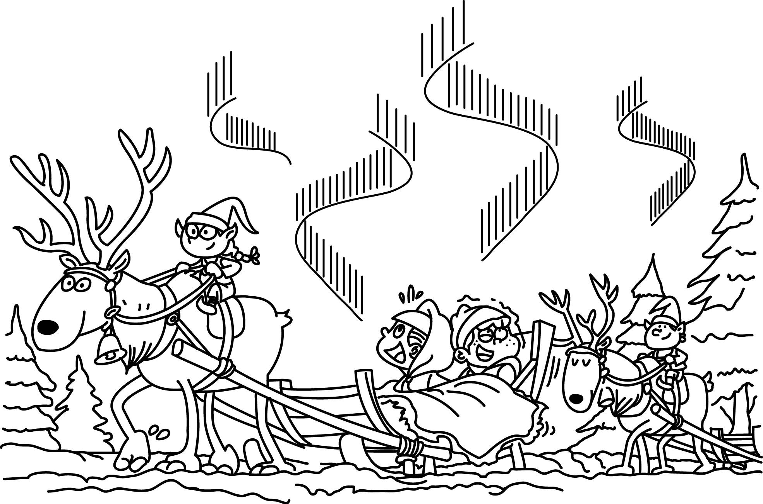 | 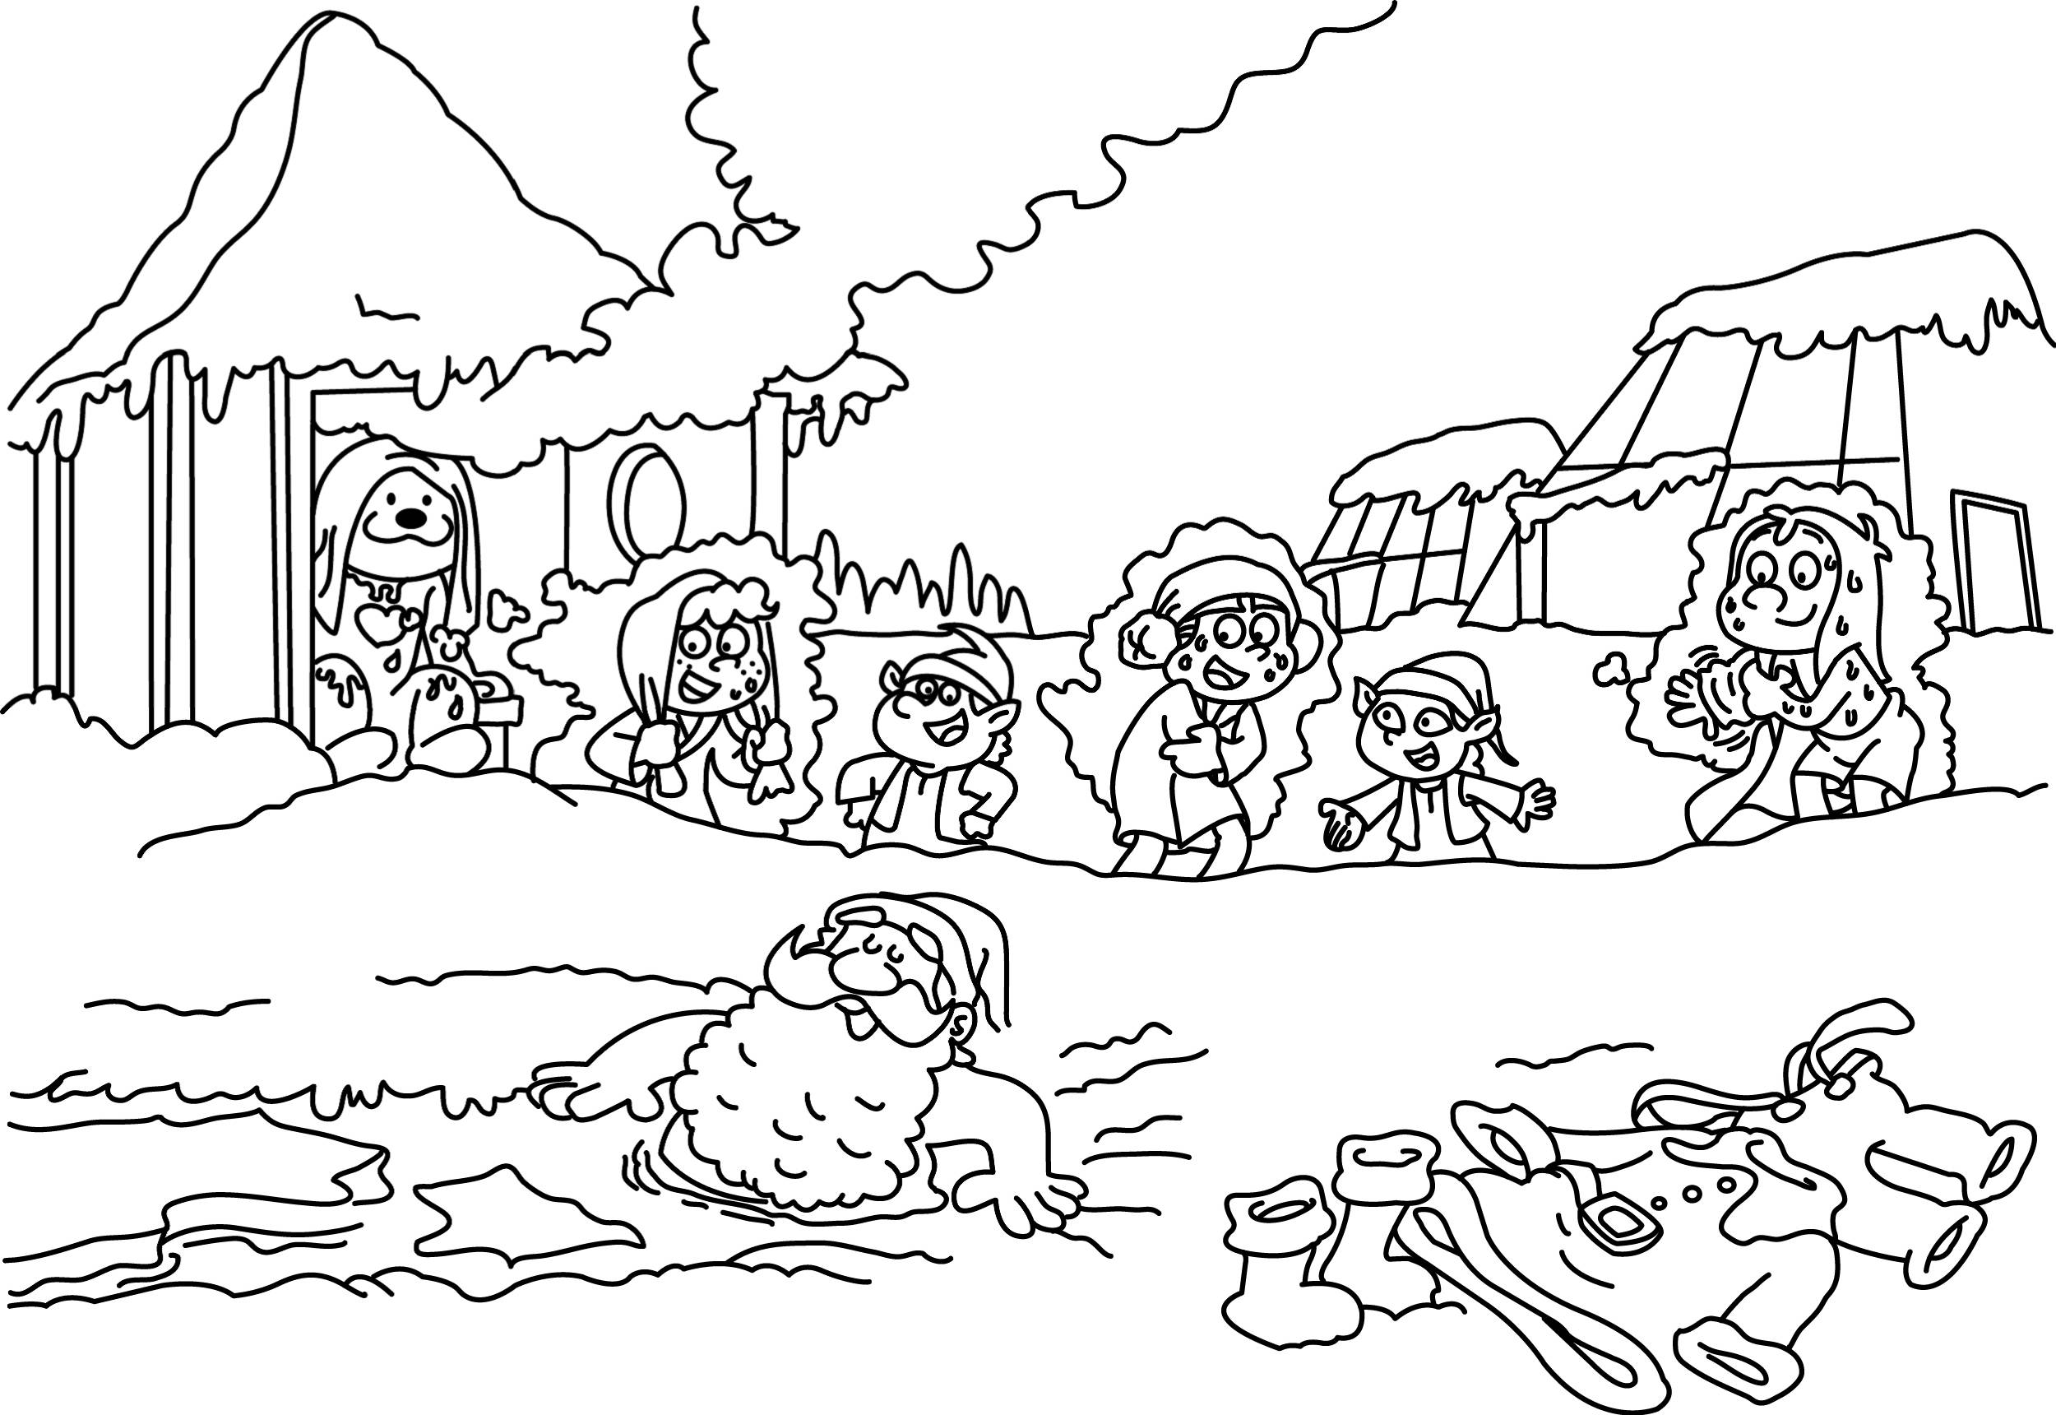
( ) | ( ) | ( ) | ( ) | ( )
E. Unscramble sentences.重組正確的句子，每題5分，共20分。
1 | the/. / at / walk / 3:30pm / I / dog | 2 | to / ! / Merry / you / Christmas
3 | the/She/ at/Internet/ ./surfs/five | 4 | on/ do/weekends/ ?/ What/do/they
F. Read and Write 讀一讀，寫出正確的答案，每格1分，共14分。
1 | A: What time does Lily have dinner ?  B: She dinner six. | 2 | A: What Mia do her free time ? B: She basketball .
3 | A: What time he go home ?  B: He home at 4:30. | 4 | A: What do you(你們) do weekends?  B: go hiking .
5 | A: What does he do after school ?  B: He homework. | 6 | She doesn’t her homework at home.
7 | Can I be elf , too ? | 8 | What time the boys go home ?
G. Look and Answer看圖，寫出正確的回答句子，每題4分，共8分。
1. | A: What time does Eric and Tommy go to bed ?  B:
2. | A: What does Joy(女) do in her free time ?  B:
H.Bonus.加分題(中翻英)共2分。
1.兩個小精靈在午夜12點包裹禮物。
2.聖誕老人喜歡泡冰澡。
※※※ P.2 Don’t forget to check your answer again！做答完要再檢查喔 ! ※※※

