**花蓮縣花蓮市明義國民小學108學年度第一學期六年級英語科期中定期評量試卷**

**Class (班級)： Name(姓名）：_____________Number（座號）：_____家長簽名____________**

1. Listen and check仔細聽，並勾選正確的圖片。16%

|  |  |  |  |
| --- | --- | --- | --- |
| **5-41.**  **課本P5-4 課本P5-5**  □ □ | 2.  **習作P6-3** 習作P6-7  □ □ | **3.**  課本P5-1課本P5-2  □ □ | 4. 習作P29-3習作P6-8  □ □ |
| **5-45.**  **課本P31-8課本P17-7**  □ □ | 6.  **習作P25-2** **習作P25-3**  □ □ | **7.**  習作P6-4習作P5-4  □ □ | 8.  **習作P2-1習作P2-2**  □ □ |

1. Listen and Write仔細聽，並填上正確的單字。(每格2分) 30%

|  |  |  |  |  |
| --- | --- | --- | --- | --- |
| 105(2)FM8課本線條-P59-3**1.**  **課本P14-4** | What time ______ Amy go to __________? | | **2. X**習作P6-3 | A: _________ you like some _______ ___________?  B: No, thank you. |
| 105(2)FM8課本線條-P59-3**3.**  **課本P88-3** | A:Does Frank ______  ____________ at seven?  B:Yes, he _______. | | **4.**習作P6-5 | A: _______ would you like to eat ?  B: I’d ________ some ________, please. |
| 105(2)FM8課本線條-P59-3**5.**9-3 | | They would like some ____________ for dinner. | **6.**  **課本P14-2** | Jenny _______ ____ ___  six thirty. |

1. Listen and Choose仔細聽，並選出正確的答案。8%

|  |  |  |  |
| --- | --- | --- | --- |
| **1.**  ( ) | (A) Yes, pleaes.  (B) I’m sorry.  (C) Let’s go! | 習作P36-5**2.**  ( ) | (A) I have lunch at 12.  (B) He has lunch at 11:50.  (C) They have lunch at 12:30. |
| **3.**  ( ) | (A) Yes, he does.  (B) No, they don’t.  (C) No, thank you.  （請翻面繼續作答） | **4.**  ( ) | (A) No, I don’t.  (B) I play basketball.  (C) He’d like some noodles. |

1. Listen and Circle仔細聽，並圈出正確的字母。16%

|  |  |  |  |
| --- | --- | --- | --- |
| 1. e_e a_e | 2. ea ay | 3. e_e ay | 4. i_e ee |
| 5. ee ai | 6. ai ee | 7. a_e ee | 8. ay y |

1. Read, Number and Write 閱讀短文，寫出正確的順序並回答問題。 18%

Danny goes to bed at nine thirty every day. He is an early bird. He goes to school at seven with his sister, Nina. Danny eats noodles for lunch at school. They go home at four twenty together. They play chess at home after school. After playing chess with Danny, Nina feels very hungry. She says, ”I could eat a horse!” She wants to have dinner early. They have dinner at six twenty.

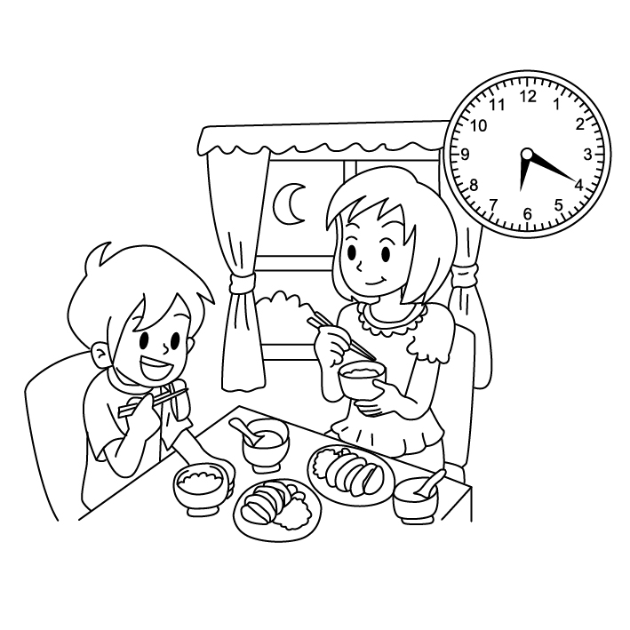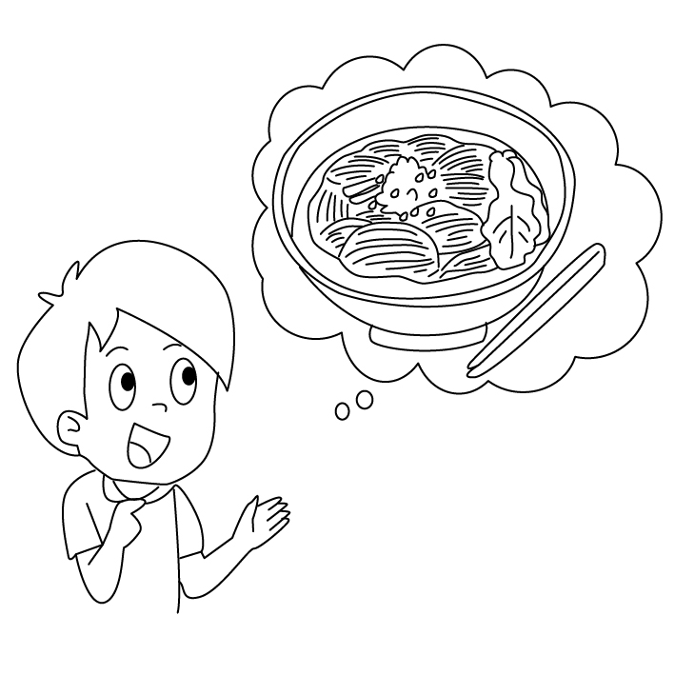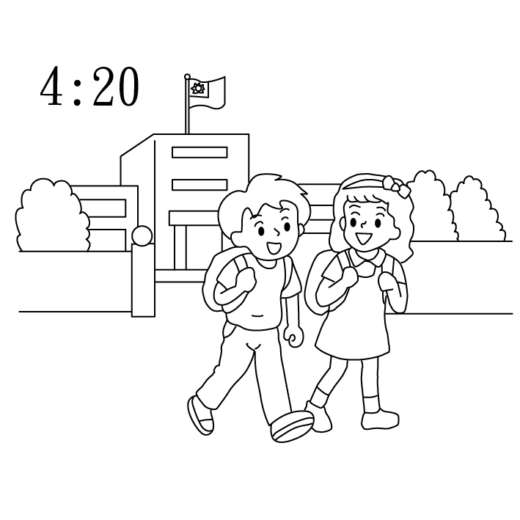習作P12-1

1. What time does Danny go to bed?

____________________________________

1. What do Danny and Nina do after school?

____________________________________

1. Unscramble the Sentences 重組句子。每題3分12%

1. would / eat / they / ? / like / to / What

__________________________________________________

2. Does / bed / go / ? / to / Victor / ten / at

___________________________________________________

3. like / , / We’d / . / noodles / some / please

___________________________________________________

4. you / time / play / ? / the / recorder / What / do

___________________________________________________