**花蓮縣花蓮市明義國民小學113學年度第二學期四年級英語科期中定期評量試卷**

**Class：四年 班 Name（中文姓名）：__________Number （座號）：_____ 家長簽名__________**

1. Listen and Check (16%) (勾選聽到的圖片)

|  |  |  |  |  |  |  |  |
| --- | --- | --- | --- | --- | --- | --- | --- |
| **1** | □ □  35 25 | **2** | □ □  40 50 | **3** | □ □ | **4** | □ □ |
| **5** | □ □ | **6** | □ □ | **7** | □ □ | **8** | □ □ |

1. Listen and Number (10%) (仔細聽並將圖片編號)

|  |  |  |  |  |
| --- | --- | --- | --- | --- |
|  |  |  |  |  |
| ( ) | ( ) | ( ) | ( ) | ( ) |

1. Listen and Write (16%)（把聽到的時間寫下來）

|  |  |  |  |
| --- | --- | --- | --- |
| (1) | (2) | (3) | (4) |
| What time is it ?  _____：______ | What time is it ?  _____：______ | What time is it ?  _____：______ | What time is it ?  _____：______ |

1. Listen, Number and Write (15%)（填入聽到的順序並完成單字）

|  |  |  |  |  |  |
| --- | --- | --- | --- | --- | --- |
| ( ) | ( ) | ( ) | ( ) | ( ) | ( ) |
|  |  |  |  |  |  |
| c_k_ | h_ppy | t_n | k_t | b_k_ | Chin__s__ |

1. Read and Mark (12%)（依圖示填代號完成對話）

(1) May I go to the restroom? (2) What are you doing? (3) What time is it?

(4) It’s nine thirty. (5) Sorry, I’m late. (6) We’re eating ice cream.

|  |  |  |  |
| --- | --- | --- | --- |
|  | **_______** |  | A: ______  B: ______ |
|  | **_______** |  | A: ______  B: ______ |

1. Read and Write (17%)（看圖完成句子）

參考單字：four eight o’clock forty-five riding a bike am are is

|  |  |  |  |
| --- | --- | --- | --- |
| 08:45 | 1. What time is it?   It’s ______________. |  | 1. What ____ they doing?   They ________________ |
| 04:00 | 1. What time is it?   It’s ______________. |  | 1. What’s _____ doing?   She _______________ |
|  | 5. What’s _____ doing?  He _____________ | 加分題 | I_____________ now.  我正在…… |

G. Look , Read , and Match(14%)（看圖寫句子，注意標點符號）

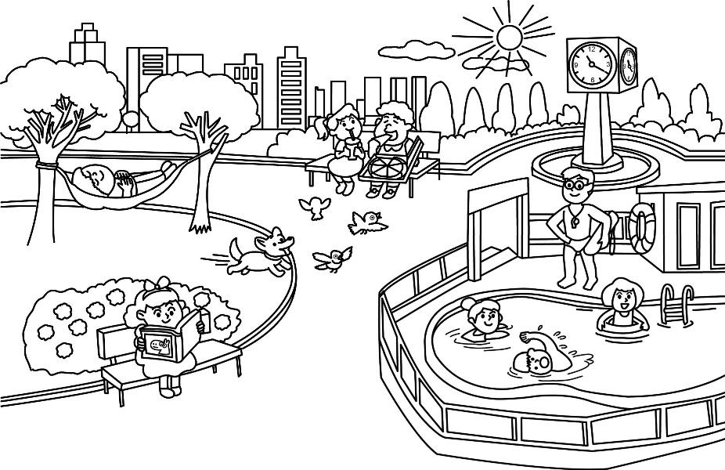①What time is it now? (2分)

It’s ________________________.

②What are they doing in the water(水中)?(4分)

They__________________________

③What is the dog doing? (4分)

It_____________________________

④What is the boy doing under the tree(樹下)? (4分)

He____________________________